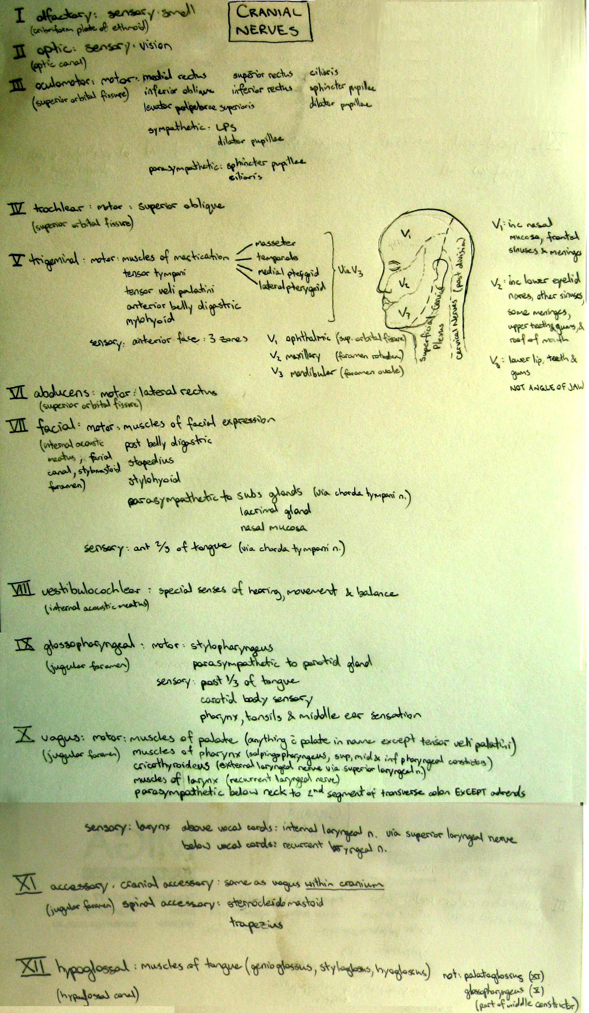
NEUROLOGY CORE CURRICULUM

Contents
A. Global objectives 1
A. Global objectives 8
B. Clinical presentations 8
1. Infections 8
List the common organisms for the following and contrast the clinical presentations, CSF findings and treatment for each: 8
(a) acute bacterial meningitis (list most common organisms for infants, children and adults) 9
(b) acute viral meningitis 11
(c) encephalitis 12
2. Peripheral nervous system (PNS) disorders 12
1. List the components of the motor unit and contrast the common lower motor neurone clinical syndromes of neuropathy, neuromuscular junction disorders, and myopathy. 12
2. For peripheral sensorimotor disorders, describe the following and discuss the localization and causes of each: 13
(a) Radiculopathy 13
(b) Mononeuropathy- including carpal tunnel syndrome 13
(c) Mononeuritis multiplex (multiple mono-neuropathy) 17
(d) Polyneuropathy – including diabetic neuropathy 17
(e) Paraesthesiae 18
(f) Fasciculation 19
(g) Typical clinical findings in root lesions at C-5 and L-5. 19
(h) Herniated nucleus pulposus (HNP) 19
3. Discuss the symptoms, examination, and laboratory findings of carpal tunnel syndrome 19
4. Describe an approach to the workup of a chronic polyneuropathy 20
5. Describe the findings and pathology of acute inflammatory demyelinating polyneuropathy AIDP (Guillain- Barré syndrome) 22
6. Describe the clinical features and differential diagnosis of motor neurone disease 23
7. Describe the pathogenesis and usual clinical presentation of myasthenia gravis 25
8. Describe the common clinical manifestations and pathophysiology of the following myopathies: 26
(a) Duchenne muscular dystrophy 26
(b) Myotonic dystrophy 26
(c) Polymyositis and dermatomyositis 27
3. Disorders of vision 28
1. Assess visual loss and localise the lesion causing the following: 28
(a) Monocular visual loss 28
(b) Enlarged blind spot (scotoma) 28
(c) Central scotoma 29
(d) Bitemporal field defect 29
(e) Homonymous hemianopia 29
2. Assess diplopia 30
(a) Describe the innervation and action of the extra-ocular muscles 30
(b) Name the anatomic location and most common causes for each of the following syndromes: i. internuclear ophthalmoplegia 30
ii. Third cranial nerve palsy (pupil sparing versus non-pupil sparing) 31
iii. Sixth cranial nerve palsy 31
iv. Fluctuating or fatigable ocular muscle paresis sparing the pupil: 32
3. Recognise nystagmus and list its common causes 32
(a) Differentiate peripheral from central forms of nystagmus 33
4. Assess pupillary abnormalities 34
(b) List the components of Horner’s syndrome and the sites where a causative lesion may occur 34
(c) Describe the afferent pupillary defect (Marcus-Gunn pupil) 35
4. Alcohol-related disorders 36
1. Describe the clinical characteristics and emergency management of the following: 36
(a) Wernicke-Korsakoff syndrome 36
(b) alcohol withdrawal seizure 37
2. Describe the clinical features of: 38
(a) alcohol related dementia 38
(b) Chronic alcohol related cerebellar degeneration 38
5. Neurological Considerations in the Indigenous Population 39
Understand the epidemiology of the complications of systemic disease in Australian indigenous populations and the impact of risk factors in this population 39
(a) Diabetic Neuropathy 39
(b) Stroke 39
(c) Alcohol-related neurological disorders 39
(d) Epilepsy 40
6. Spinal cord disorders 40
1. Localize the lesion that gives the following findings on neurologic examination: 40
(a) ipsilateral UMN findings and decreased position sense with contralateral decrease in pain and temperature sensation. 41
(b) dissociated sensory loss, weakness and areflexia of the upper extremities 41
(c) sensory level with paraparesis and bladder incontinence 42
2. Describe the usual clinical presentation of vitamin B12 deficiency 42
7. Cerebrovascular diseases 43
1. List the major risk factors for cerebrovascular disease and understand the degree to which they are modifiable 43
2. Describe the pathophysiology and clinical features of: 43
(a) Asymptomatic carotid bruit 43
(b) Transient ischaemic attack (TIA) 43
(c) ischaemic infarct (arteriogenic embolisation, cardiogenic embolisation, large-vessel thrombus) 44
(d) lacunar infarct 46
(e) haemorrhagic infarct 47
(f) parenchymal haemorrhage 49
(g) subarachnoid haemorrhage (SAH) 52
(h) amaurosis fugax (transient monocular blindness) 52
3. Identify the major clinical features of infarction in the distribution of the: 53
4. Discuss the treatment options for acute stroke 54
5. Understand how to minimise the incidence of stroke and recurrent stroke 55
6. List the causes of intracranial haemorrhage 56
(a) List the most common sites and clinical features for hypertensive parenchymal haemorrhage 56
(b) Describe the typical clinical picture of a subarachnoid haemorrhage (SAH) 56
i. outline the diagnostic workup for a patient with a suspected SAH 57
ii. Discuss the immediate and early medical/surgical management of a patient with a SAH 57
8. Epilepsy 57
1. List the common risk factors for epilepsy: 57
2. Seizure disorders 58
iii. Partial complex seizure iv. Partial simple seizure v. Partial seizure with secondary generalisation 58
vi. Febrile convulsion 59
(b) Describe what is meant by the term non-epileptic (pseudo) seizure 61
(d) Describe Todd’s post-ictal phenomenon 63
(e) Describe the routine evaluation and management of a patient with new-onset seizures 63
(f) List the commonly used anticonvulsants and their indications and side effects 64
(g) Understand the impact of seizure disorders on lifestyle 66
(h) Define status epilepticus and outline the initial evaluation and management of a patient in status epilepticus 66
3. Define the term ‘syncope’ and list the common causes and the clinical features that help to distinguish syncope from seizure and disorders of motor function 67
9. Disorders of motor function 70
1. Differentiate between upper (UMN) and lower (LMN) motor neurone disorders by assessing muscle bulk, muscle strength, the pattern of weakness and reflex changes. 70
(a) Contrast the common UMN clinical syndromes of hemiparesis, paraparesis, and quadriparesis by symptom distribution and discuss the pathophysiology. 70
i. differentiate deep tendon, superficial, and polysynaptic reflexes and how they differ in acute versus established lesions 71
ii. define spasticity and rigidity 72
(b) Differentiate between LMN facial weakness (eg. Bell’s palsy) and UMN facial weakness (eg. post cerebral stroke) 73
(c) Describe the diagnostic features of Motor Neurone Disease and understand the significance of mixed upper and lower motor neurone signs 73
(d) Describe the clinical picture associated with myopathy and define the difference between inflammatory and structural myopathies. 74
2. For disorders of cerebellar function, discuss the clinical findings and pathophysiology of lesions producing midline versus hemispheric cerebellar damage 74
(a) Define ataxia and differentiate cerebellar from sensory ataxia 75
(b) Define dysmetria 76
(c) Define titubation 76
(d) Describe a wide-based gait and discuss its anatomic localisation 76
3. For movement disorders, define and differentiate the following: 77
(b) Athetosis and chorea 77
(c) Asterixis (otherwise known as negative myoclonus) 77
(d) Myoclonus 78
(e) Tics 78
(f) Rigidity 78
(g) Dystonia (including writers’ cramp and torticollis) 79
(h) Discuss the clinical findings, laboratory findings, and treatment of the following: 80
i. Parkinson’s Disease 80
ii. Essential tremor 82
iii. Tardive dyskinesia 82
iv. Huntington’s Disease (not core) 83
v. Wilson’s disease (not core) 84
10. Multiple Sclerosis 86
1. Describe the epidemiological and genetic characteristics of multiple sclerosis 86
2. Discuss the clinical features of MS. 86
3. Describe the typical MRI, CSF and evoked potential findings in MS. 86
4. Describe the natural history of MS and treatments of proven benefit 87
11. Dizziness and disorders of hearing 88
1. Assess dizziness 88
(a) define vertigo and contrast it with other types of dizziness 88
(b) recognize the pattern of presentation of acoustic neuroma 89
(c) recognise the pattern of benign paroxysmal vertigo 90
2. Assess auditory responses 90
(b) discuss the difference between conductive and sensorineural hearing loss 91
12. Disorders of higher cognitive function and communication 91
1. Be aware of the social impact of disorders of cognitive function 91
2. Assess disorders of higher cognitive function 91
(b) List common examples of delirium and outline management principles. 92
(c) Assess dementia 93
i. List the common causes of dementia 93
ii. List the differential diagnosis, including treatable, non-degenerative causes of cognitive dysfunction (eg. B12 deficiency, hypothyroidism) 94
iii. Distinguish dementia from pseudo-dementia secondary to depression 96
(d) Understand the impact of dementia on patients and their families the options for future care of dementia sufferers 96
3. Assess communication disorders 96
ii. dysarthria 96
(b) Define and localise Broca’s (non-fluent, motor) aphasia and Wernicke’s (fluent, receptive) aphasia 96
13 Disorders of altered consciousness 97
1. Define the following terms: 97
(b) Coma 97
(c) Brain death 98
(d) Persistent vegetative state 98
(e) Locked-in syndrome 99
2. Assess the comatose patient 99
(c) Discuss the techniques for eliciting and localising of the following findings on examination of a comatose patient: 100
(2) Conjugate eye deviation and its relationship to the side of the lesion 101
ii. Eye movements (1) Intact versus absent oculo-cephalic response (doll’s eyes): see above 101
iii. Pupillary response (1) Unilateral fixed dilated pupil 102
iv. Respiratory 102
(1) Cheyne-Stokes respiration 102
3. Describe the diagnosis and management of increased intracranial pressure (ICP) (a) List the symptoms and signs of increased ICP 102
(b) List the effects of uncal herniation on 103
i. level of consciousness ii. motor activity iii. extraocular movements iv. pupillary reactivity 103
(c) List the indications for imaging prior to performing a lumbar puncture 103
(d) Distinguish between communicating and non-communicating hydrocephalus 104
14. Headaches and facial pain 104
1. Contrast the clinical features that distinguish between benign versus potentially serious underlying causes of headache. 104
2. Describe the clinical features of migraine headache with aura versus without aura 104
3. Describe the clinical features of trigeminal neuralgia 105
4. Describe the clinical features of the following causes of headaches: 106
(a) subarachnoid haemorrhage 106
(b) meningitis 106
(c) increased ICP/mass 107
(d) temporal arteritis 107
(e) intracranial haemorrhage 108
(f) hypertensive encephalopathy 108
(g) sinusitis 109
(h) temporomandibular joint dysfunction 109
5. Discuss the urgent and non-urgent indications for the following diagnostic tests used to evaluate a headache patient 110
(a) CT 110
(b) Lumbar puncture – also list contraindications 111
(c) Erythrocyte sedimentation rate 111
(d) MRI 111
6. Differentiate the CSF profiles of SAH and meningitis 112
7. Discuss the treatment for common headache syndromes (migraine headache and tension headache), including symptomatic and prophylactic therapy 112
15. Neck and back pain 113
1. Differentiate clinically between myofascial pain, radiculopathy and spinal cord compression 113
2. Discuss the significance of back pain in cancer patients 116
16. Brain tumours 116
1. Discuss the clinical presentation of a primary brain tumour in the following locations: 116
(b) pituitary region 116
(c) cerebral hemisphere 117
(d) Cerebellum 118
2. Differentiate metastatic from primary brain tumour by 119
(e) clinical features (f) imaging: CT or MRI 119
3. List the most common metastatic tumours to the brain in adults 119
17. Disorders of central sensation 120
For central sensory disorders, describe and discuss the localisation of: (a) hemi-sensory disturbance 120
(b) spinal sensory level 120
(c) Brown-Sequard syndrome 121
(d) dissociated sensory loss (as in syringomyelia) 121
C. Trauma 122
1. Head trauma 122
1. Define each of the following sequelae of closed head trauma in terms of (a) temporal profile, symptoms and treatment: i. concussion 122
ii. anterograde and retrograde amnesia 123
iii. diffuse axonal injury 124
iv. subdural haematoma 125
v. epidural haematoma 126
2. Describe the evaluation and management of a patient with a closed head injury admitted for altered consciousness or focal findings. 127
3. Describe the individual and social cost of closed head injury 128
D. Paediatric 128
Develop the skills required to undertake a basic developmental assessment in a child 128
Describe the common Paediatric presentations of: (a) Epilepsy 128
(b) Developmental anomalies 129
(c) Acquired fixed neurological disorders (cerebral palsy) 129
E. Investigations 129
Describe the indications, techniques, normal and abnormal results, contraindications, and risks of the following diagnostic tests: 129
(b) Computed axial tomography (CT) 130
(c) Magnetic resonance imaging (MRI) 130
(d) Carotid ultrasound 131

A. Global objectives

Describe the anatomic and physiologic basis of the neurologic examination
Perform a competent general and neurological history
Perform a competent neurological examination
Synthesize the history and examination findings to localise the neurological lesion to either an anatomical region or physiological site
Develop a differential diagnosis for common presenting problems
Formulate a plan of investigation and management for common neurologic conditions
Recognize common neurological emergencies

B. Clinical presentations

1. Infections

List the common organisms for the following and contrast the clinical presentations, CSF findings and treatment for each:

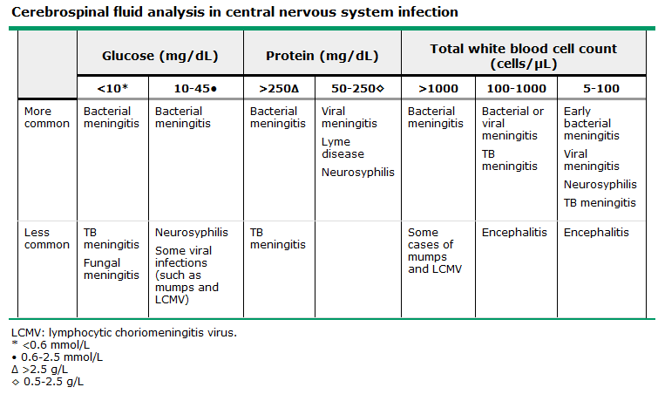

- RBCs raised in:
  - Traumatic tap (consecutive collection tubes should have reduced quantity)
  - HSV encephalitis
  - Intracerebral haemorrhage (xanthochromia)
- Normal CSF values:
  - <50 mg/dL of protein
  - CSF-to-serum glucose ratio >0.6
  - <5 white blood cells/μL
  - Lactate <3.5 meq/L.

(a) acute bacterial meningitis (list most common organisms for infants, children and adults)

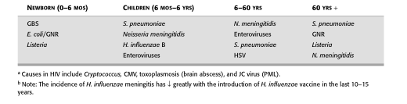

Children:
- Presentation
  - <6 months May present with fever alone, ± poorly rousable, ∴ LP.
  - 6-12months Unreliable presentation, ∴low threshold for LP.
  - >12 months Presentation progressively resembles that seen in adults.
- Management
  - Approach as for adults. Where neither in shock nor dehydrated, institute moderate fluid restriction until SIADH excluded.
- Pathogens: (see table above)
- Empiric Antibiotics
  - <6 months Ampicillin + Cefotaxime (50mg/kg [<2g] Q4hrly of each)
  - >6 months Cefotaxime (50mg/kg [<2g] Q4hrly)
  - ?Pneumococcal Cefotaxime (above ) + Vancomycin (15mg/kg [<750mg] QID)

Adults:
- Presentation
  - Either
    - Acute fulminant illness with rapid progression (hours)
    - Subacute infection with progression over days
  - Classic clinical triad
    - Fever
    - Headache
    - Nuchal rigidity - Kernig and Brudzinski signs
  - Other features
    - ↓level of consciousness (LOC) in >75% - varies from lethargy to coma
    - Nausea, vomiting, and photophobia are common
    - Seizures (~30% at some point in disease)
  - Complications
    - ↑ICP – >90% have a CSF opening pressure >180 mmH₂O; 20% >400 mmH₂O.
      - Signs: ↓LOC, papilledema, dilated poorly reactive pupils, CNVI palsies, decerebrate posturing, and the Cushing reflex (bradycardia, hypertension, and irregular respirations).
      - Complication: cerebral herniation (incidence 1-8%)
    - Other features specific to pathogen, of particular note is the rash of meningococcemia:
      - Begins as a diffuse erythematous maculopapular rash resembling a viral exanthem
      - Lesions rapidly become petechial, especially trunk, lower extremities, mucous membranes, conjunctiva, and occasionally on the palms and soles.
- Management:
  - Perform LP, then immediately commence ABs
    - Where a CT required prior to LP (eg ↑ICP), take blood cultures then commence ABs.
  - Adjunctive dexamethasone: given before or at the same time as the first dose of antibiotics, when indicated (developed world, suspected bacterial meningitis, organism is unknown/Streptococcus pneumoniae confirmed).
Normal Adult
- Pathogens:
  - Streptococcus pneumoniae, Neisseria meningitidis, Haemophilus influenzae and group B streptococcus most common causes in ≤60 y.o.
  - ≥50 y.o. also at risk of Listeria monocytogenes.
- Empiric Antibiotics:
  - 3rd Gen Ceph eg. ceftriaxone (2 g IV every 12 h), cefotaxime (2 g IV every 4-6 h)
+
  - Vancomycin (30-60 mg/kg/d IV two or three divided doses)
+
  - If ≥50 y.o., Ampicillin (2 g IV every 4 h)
Impaired cell-mediated immunity (eg. lymphoma, chemotherapy, or high-dose glucocorticoids)
- Pathogens:
  - Streptococcus pneumoniae, but must also cover for Listeria monocytogenes and gm-ve bacilli (including Pseudomonas aeruginosa).
- Empiric Antibiotics:
  - Vancomycin (30-60 mg/kg/d IV two or three divided doses)
+
  - Ampicillin (2 g IV every 4 h)
+
  - Cefepime OR Meropenem (2 g IV every 8 h – same for both)

Once gram stain obtained (before culture and sensitivity available):
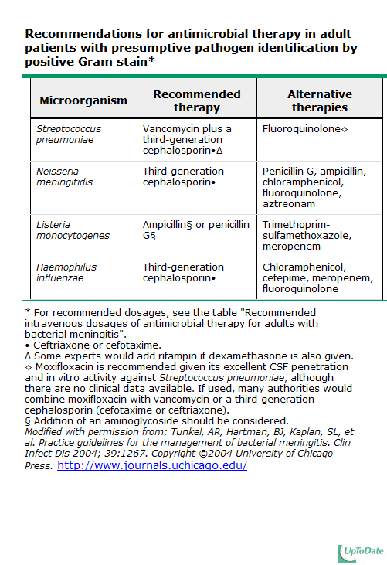

(b) acute viral meningitis

- Presentation:
  - Headache - frontal or retroorbital; often associated with photophobia and pain on eye movement
  - Fever
  - Meningeal irritation – nuchal rigidity (present in most cases) but may be mild and present only near the limit of neck anteflexion.
  - Constitutional signs: malaise, myalgia, anorexia, nausea and vomiting, abdominal pain, and/or diarrhea.
  - Mild ↓LOC – mild lethargy or drowsiness
    - Profound ↓LOC (stupor, coma, marked confusion) are unusual – suggests encephalitis or other diagnoses
    - Seizures, focal signs or neuroimaging abnormalities indicative of brain parenchymal involvement are not typical – suggests encephalitis or another CNS infectious/inflammatory process.
- Pathogens (not required by curriculum):

  - Echoviruses
  - Coxsackieviruses A and B
  - HSV 2
  - HIV
  - Lymphocytic choriomeningitis virus
  - Arboviruses
  - Mumps
  - Poliovirus

  - Less common: CMV, EBV, VZV, HSV1, Adenovirus, Measles, Rubella
- Management:
- Exclude alternative Dx i.e. bacterial meningitis:
  - In elderly, immunocompromised, or ABs prior to presentation, consider empiric antibiotics for 48 h (even if viral cause suspected). Otherwise, the consider observation without ABs.
- Consider causes that need specific Rx:
  - If ?HIV – blood testing for HIV RNA and HIV antibody.
  - If ?HSV (eg, concomitant genital lesions) – empiric therapy with acyclovir (10 mg/kg IV every 8 h) can be administered.

(c) encephalitis

- Presentation:
  - Children and elderly most vulnerable
  - Altered consciousness, headache, fever, seizures. Lethargy, confusion, coma, and focal neurologic deficits (cranial nerve deficits, accentuated deep tendon reflexes)
  - DDx: brain abscess or malignancy, toxic-metabolic encephalopathy, subdural hematoma, and subarachnoid haemorrhage
- Pathogens:
  - Common: HSV and arboviruses
  - Rarer: CMV, Toxoplasmosis, West Nile Virus, VZV, Borrelia, Rickettsia, Legionella, Enteroviruses, Mycoplasma, cerebral malaria
- CSF:
  - Lymphocytic pleocytosis and moderately ↑ protein.
  - RBCs without evidence of trauma suggests HSV encephalitis.
  - ↓Glucose in tuberculous, fungal, bacterial, and amebic infections.
- Management:
  - HSV encephalitis requires immediate IV acyclovir.
  - CMV encephalitis is treated with IV ganciclovir +/− foscarnet (viral DNA pol inhibitor: used for acyclovir/gancyclovir resistant disease).

2. Peripheral nervous system (PNS) disorders

1. List the components of the motor unit and contrast the common lower motor neurone clinical syndromes of neuropathy, neuromuscular junction disorders, and myopathy.

- Motor unit – a single α-motor neuron and all of the corresponding muscle fibres it innervates; all of these fibres will be of the same type (either fast twitch or slow twitch).

Clinical syndromes of weakness

Sign | Upper | Lower Motor Neuron | NMJ | Myopathic
Atrophy | None | Severe | None | Mild
Fasciculations | None | Common: spontaneous discharge of diseased motor unit. | None | None
Tone | Spastic | Decreased |  | Normal/decreased
Distribution of weakness | Pyramidal/regional | Distal/segmental | Fatiguable: occular, bulbar, limb, respiratory, proximal muscle in Myasthenia gravis | Proximal
Tendon reflexes | Hyperactive | Hypoactive/absent : loss of gamma motor neurons | Normal in myasthenia gravis  Decreased in LEMS* | Normal/hypoactive
Babinski's sign | Present | Absent | Absent | Absent

* Recovery of lost deep tendon reflexes or improvement in muscle strength with vigorous, brief muscle activation is a unique aspect of LEMS.
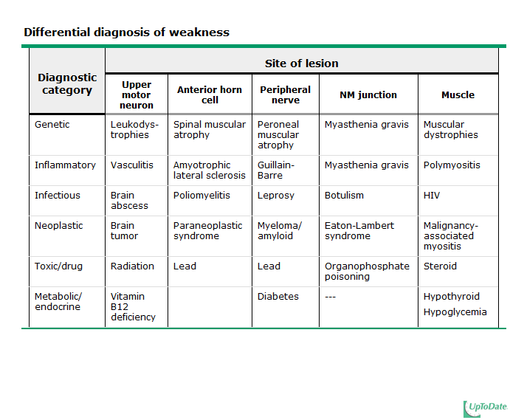

2. For peripheral sensorimotor disorders, describe the following and discuss the localization and causes of each:

(a) Radiculopathy

radiculopathy – a pathologic process affecting the nerve root; most arise from nerve root compression. The relevant clinical radiculopathies occur in the cervical and lumbar spine.
- Cervical radiculopathy: a common cause of both acute and chronic neck pain.
  - Mechanisms
    - Compressive: Cervical spondylosis and disc herniation
    - Noncompressive: Infection (especially herpes zoster and Lyme disease), nerve root infarction, infiltration by tumor, infiltration by granulomatous tissue, root avulsion, and demyelination.
Lower cervical roots, particularly C7, are more frequently affected by compression than higher roots.
- Lumbosacral radiculopathy:
  - Mechanisms:
    - Common: compression by disc herniation or spinal stenosis due to degenerative arthritis (spondylosis).
    - Congenital: abnormalities of the bony spinal column or its contents e.g. tethered cord or diastematomyelia and spina bifida. They may cause radiculopathy via traction of the root.
    - Nonskeletal: e.g. infection, inflammation, neoplasm and vascular disease.
  - Lumbar radiculopathy most commonly involves either the L5 or S1 root.

(b) Mononeuropathy- including carpal tunnel syndrome

Mononeuropathies (only first 3 columns required by core curriculum)

 | Symptoms | Precipitating Activities | Examination | Electro-Diagnosis | Differential Diagnosis | Treatment
Carpal tunnel syndrome | Numbness, pain or paresthesias in fingers | Sleep or repetitive hand activity | - Sensory loss in thumb, second, and third fingers.  - Weakness in thenar muscles; inability to make a circle with thumb and index finger  - Tinel and Phalen signs | Slowing of sensory and motor conduction across carpal tunnel | C6 radiculopathy | Splint  Surgery definitive treatment
Ulnar nerve entrapment at the elbow (UNE) | Numbness or paresthesias in ulnar aspect of hand | Elbow flexion during sleep; elbow resting on desk | Sensory loss in the little finger and ulnar half of ring finger | Focal slowing of nerve conduction velocity at the elbow | Thoracic outlet syndrome | Elbow pads
Ulnar nerve entrapment at the elbow (UNE) |  |  | Weakness of the interossei and thumb adductor; claw-hand |  | C8-T1 radiculopathy | Avoid further injury
Ulnar nerve entrapment at the elbow (UNE) |  |  |  |  |  | Surgery when conservative treatment fails
Ulnar nerve entrapment at the wrist | Numbness or weakness in the ulnar distribution in the hand | Unusual hand activities with tools, bicycling | Like UNE but sensory examination spares dorsum of the hand, and selected hand muscles affected | Prolongation of distal motor latency in the hand | UNE | Avoid precipitating activities
Radial neuropathy at the spiral groove | Wrist drop | Sleeping on arm after inebriation with alcohol—"Saturday night palsy" | Wrist drop with sparing of elbow extension (triceps sparing); finger and thumb extensors paralyzed; sensory loss in radial region of wrist | Early—conduction block along the spiral groove | Posterior cord lesion; deltoid also weak | Splint
Radial neuropathy at the spiral groove |  |  |  | Late—denervation in radial muscles; reduced radial SNAP | Posterior interosseous nerve (PIN); isolated finger drop | Spontaneous recovery provided no ongoing injury
Radial neuropathy at the spiral groove |  |  |  |  | C7 radiculopathy
Thoracic outlet syndrome | Numbness, paresthesias in medial arm, forearm, hand, and fingers | Lifting heavy objects with the hand | Sensory loss resembles ulnar nerve and motor loss resembles median nerve | Absent ulnar sensory response and reduced median motor response | UNE | Surgery if correctable lesion present
Femoral neuropathy | Buckling of knee, numbness or tingling in thigh/medial leg | Abdominal hysterectomy; lithotomy position; hematoma, diabetes | Wasting and weakness of quadriceps; absent knee jerk; sensory loss in medial thigh and lower leg | EMG of quadriceps, iliopsoas, paraspinal muscles, adductor muscles | L2-4 radiculopathy | Physiotherapy to strengthen quadriceps and mobilize hip joint
Femoral neuropathy |  |  |  |  | Lumbar plexopathy | Surgery if needed
Obturator neuropathy | Weakness of the leg, thigh numbness | Stretch during hip surgery; pelvic fracture; childbirth | Weakness of hip adductors; sensory loss in upper medial thigh | EMG—denervation limited to hip adductors sparing the quadriceps | L3-4 radiculopathy | Conservative management
Obturator neuropathy |  |  |  |  | Lumbar plexopathy | Surgery if needed
Meralgia paresthetica | Pain or numbness in the anterior lateral thigh | Standing or walking | Sensory loss in the pocket of the pant distribution | Sometimes slowing of sensory response can be demonstrated across the inguinal ligament | L2 radiculopathy | Usually resolves spontaneously
Meralgia paresthetica |  | Recent weight gain
Peroneal nerve entrapment at the fibular head | Footdrop | Usually an acute compressive episode identifiable; weight loss | Weak dorsiflexion, eversion of the foot | Focal slowing of nerve conduction across fibular head | L5 radiculopathy | Foot brace; remove external source of compression
Peroneal nerve entrapment at the fibular head |  |  | Sensory loss in the anterolateral leg and dorsum of the foot | Denervation in tibialis anterior and peroneus longus muscles
Sciatic neuropathy | Flail foot and numbness in foot | Injection injury; fracture/dislocation of hip; prolonged pressure on hip (comatose patient) | Weakness of hamstring, plantar and dorsiflexion of foot; sensory loss in tibial and peroneal nerve distribution | NCS—abnormal sural, peroneal, and tibial amplitudes | L5-S1 radiculopathies | Conservative follow up for partial sciatic nerve injuries
Sciatic neuropathy |  |  |  | EMG—denervation in sciatic nerve distribution sparing glutei and paraspinal | Common peroneal neuropathy (partial sciatic nerve injury) | Brace and physiotherapy
Sciatic neuropathy |  |  |  |  | LS plexopathies | Surgical exploration if needed
Tarsal tunnel syndrome | Pain and paresthesias in the sole of the foot but not in the heel | At the end of the day after standing or walking; nocturnal | Sensory loss in the sole of the foot | Reduced amplitude in sensory or motor components of medial and planter nerves | Polyneuropathy, foot deformity, poor circulation | Surgery if no external cause identified
Tarsal tunnel syndrome |  |  | Tinel's sign at tarsal tunnel

(c) Mononeuritis multiplex (multiple mono-neuropathy)

- Description: multifocal involvement of individual peripheral nerves. Often associated with constitutional symptoms such as fever and weight
- Localisation:
  - Common peroneal nerve affected in ~75% of patients with vasculitic neuropathy; (Sx: painful foot drop).
  - Ulnar, median, and radial nerves may also be involved
- Causes:
  - Inflammatory cause (classical meaning): multiple nerve infarcts due to affected vasa nervorum.
  - Vasculitis: systemic (67%) and nonsystemic (33%) may present as mononeuritis multiplex (can also present as an asymmetric or distal symmetric polyneuropathy).
- DDx (inflammatory):

  - Polyarteritis nodosa
  - Rheumatoid arthritis
  - SLE
  - Churg-Strauss syndrome
  - Wegener's granulomatosis
  - Hypersensitivity vasculitis

(d) Polyneuropathy – including diabetic neuropathy

- Description: generalized process affecting many peripheral nerves, typically characterized by symmetric distal sensory loss, burning, or weakness. Presentation varies significantly depending upon the underlying pathophysiology, of which there are two broad categories: axonal and demyelinating, though history and exam insufficient to differentiate between these. The pathophysiology determines the abnormalities on exam and testing.
- Localisation: distal worse than proximal.
- Common causes:

  - Diabetes mellitus
  - EtOH
  - HIV
  - Medication side effect

  - Less common: Guillian Barre, rheumatic disease, hypothyroidism
  - Rate of progression and character (axonal or demyelinating) can help identify aetiology.
- The differential for a painful peripheral neuropathy is extensive, and includes:
Diabetic Idiopathic Paraneoplastic HIV-associated
Inherited Amyloid Sarcoid Coeliac
- Diabetic neuropathy
  - Length-dependent diabetic sensorimotor polyneuropathy with mixed small- and large-fiber sensory, autonomic, and motor nerve involvement
  - Features
    - History
      - Sensory and autonomic symptoms are more prominent than motor.
      - Insidious, progressive course
        - Initial symptoms: numbness, tingling, buzzing, burning, or prickling sensation affecting the toes and feet.
          - Ascending stocking-glove distribution – by the time the thigh is involved, usually some involvement of the hand.
        - Progression: gait disturbance and distal weakness.
      - Painful or insensitive extremities predispose to foot ulcers (may lead to amputation)
      - Autonomic symptoms: impotence, nocturnal diarrhea, difficulty voiding, abnormal sweating, abnormal fullness after eating, orthostatic ↓BP.
    - Examination:
      - Distal sensory loss to vibration (often 1st sign), pin, temperature, and touch.
      - Ankle reflexes reduced/absent
      - ± weakness – usually mild, and involves toe movement
  - Proposed diagnostic criteria: ≥2 of
    - Symtpoms/signs of neuropathy
    - Abnormal electrodiagnostic studies - axonal loss and demyelination in a length-dependent pattern
    - Quantitative sensation test abnormalities
    - ↓HR with deep breathing or Valsalva
Other Dx if: rapidly progressive or asymmetric weakness, FHx of neuropathy, exposure to toxins, or prior malignancy..
- Management (not required by curriculum): depends on aetiology; try to treat underlying disorder
  - Diabetic
    - Glycemic control to prevent – once established, few effective treatments exist.
    - Exclude possible contributers to neuropathy:
      - Nutritional – B1, B12 and folate deficiencies
      - Toxic – Et-OH and B6 toxicity
      - Immune-mediated – paraprotein
      - Inherited causes
  - Axonal:
    - reducing exposure to endogenous/exogenous toxins
    - tight blood glucose control in diabetes
    - treatment of rheumatic disease if present
    - thyroid replacement therapy in hypothyroid
  - Demyelinating
    - IVIG for Guillian Barre
  - Treatment of symptoms and prevention of complications
    - Gabapentin for pain relief (others: carbamazepine, phenytoin, topiramate, baclofen, amytriptiline).
    - Analgesia: paracetamol, NSAIDS, opioids
    - Physio
    - OT: orthoses, splints, walking assistance
    - Foot care in diabetic polyneuropathy

(e) Paraesthesiae

- Description: n. a spontaneously occurring tingling sensation, sometimes described as pins and needles.
- Localisation: may be due to partial and/or temporary damage to a peripheral nerve, such as that caused by external pressure on the affected part, but can also result from damage to sensory fibres in the spinal cord or from peripheral vascular disease.
- Causes:
Nerve compression/entrapment Et-OH Hypocalcaemia MS
Spinal lesion Diabetes TIA GBS
Reflex sympathetic dystrophy Migraine Partial seizure Zoster

(f) Fasciculation

- Description: a small, local, involuntary muscle contraction and relaxation visible under the skin, arising from the spontaneous discharge of a bundle of skeletal muscle fibers.
- Localisation: may be visible when they occur on the surface of muscles but are not usually noticed by patients with motor neurone disease (unlike other signs such as weakness)
- Causes: denervated muscle, i.e. sign of LMN damage.

(g) Typical clinical findings in root lesions at C-5 and L-5.

- Description and localisation:

Root | Pain | Numbness | Weakness | Reflex affected
C5 | Neck, shoulder, scapula | Lateral arm (in distribution of axillary nerve) | Shoulder abduction, external rotation, elbow flexion, forearm supination | Biceps, brachioradialis
L5 | Back, radiating into buttock, lateral thigh, lateral calf and dorsum foot, great toe | Lateral calf, dorsum foot, web space between first and second toe | Hip abduction, knee flexion, foot dorsiflexion, toe extension and flexion, foot inversion and eversion | Semitendinosus/semibranosus (internal hamstrings) tendon

- Causes: see radiculopathies

(h) Herniated nucleus pulposus (HNP)

- Description: herniation of the central core of the intervertebral disk, usually into the spinal canal. Inflammatory mediator release may directly cause severe pain, even in the absence of nerve root compression.
- Localisation:
  - Posterol-ateral herniation (vast majority, due to the posterior longitudinal ligament): disrupts the nerve root exiting below the following vertebra (i.e. a L3/4 disc herniation will affect the L4 nerve root)
  - Posterior herniation may affect lower nerves, e.g. cauda equina syndrome.
- Causes: tear in annulus fibrosus of intervertebral disc.

3. Discuss the symptoms, examination, and laboratory findings of carpal tunnel syndrome

See MSK core curriculum
- Symptoms:
  - Pain or paresthesia
    - Median nerve territory (palmar surface of the first three digits and the radial half of the fourth digit; may also be localized to the wrist, involve the entire hand, or radiate proximally to as high as the shoulder.
    - Provoked by activities that involve flexing or extending the wrist or raising the arms
    - Worse at night and characteristically awaken from sleep.
    - Commonly bilateral.
  - Motor involvement (late): weakness or clumsiness when using the hands.
- Examination:
  - Sensory loss in median nerve territory
  - Weakness of thumb abduction and opposition
  - Atrophy of the thenar eminence.
  - Provocative maneuvers:

    - Phalen
    - Tinel
    - Manual carpal compression
    - Hand elevation

sensitivity and specificity of these tests is moderate at best

- Laboratory Findings:
  - Nerve conduction studies (NCS): support the diagnosis. Demonstrate impaired median nerve conduction across the carpal tunnel with normal conduction elsewhere.
  - Electromyography (EMG): rule out other abnormalities such as polyneuropathy, plexopathy, and radiculopathy.
  - Further investigations: e.g. TFTs, BSL, connective tissue disease screen etc. if a secondary cause/comorbidity is suspected.
- Risk factors:
  - Obesity
  - ♀
  - Coexisting conditions (pregnancy, RA, hypothyroidism, connective tissue diseases)
  - Genetic predisposition
  - Aromatase inhibitor use

4. Describe an approach to the workup of a chronic polyneuropathy

- Extensive diagnostic testing not necessary when symptoms mild and patient has a known underlying reason (eg, diabetes mellitus or alcohol abuse).
- Evaluation is warranted in patients with no clear aetiology or in whom symptoms are severe or rapidly progressive.
- History:

  - History of the neuropathy
  - Recent viral illness
  - Systemic symptoms
  - Medications, solvents, heavy metals, toxins
  - Alcohol use
  - FHx of neurologic disease.

- Electrodiagnostic testing (EMG/NCS)
  - Initial diagnostic study in all patients with symptoms and signs of polyneuropathy
    - Determines neuropathy or myopathy
    - Determiness polyneuropathy or another peripheral nerve disorder (eg, polyradiculopathy from lumbar stenosis)
      - If it is a polyneuropathy, will reveal whether axonal or demyelinating.
  - Features of demyelinating disorders:
    - Slowed conduction velocity
    - Dispersion of evoked compound action potentials
    - Conduction block (decreased amplitude of muscle compound action potentials on proximal compared with distal nerve stimulation)
    - Marked prolongation of distal latencies
  - Features of axonal neuropathies
    - Reduced amplitude of evoked compound action potentials
    - Relative preservation of the nerve conduction velocity.
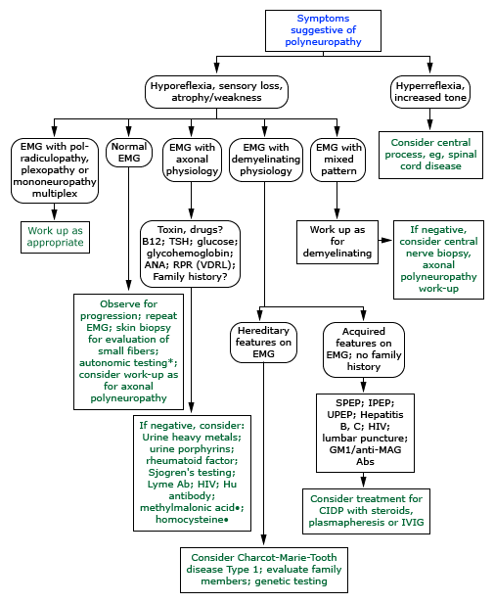
- Lab tests (also see table above)
  - Depends whether due to axon loss or demyelination

    - TFT
    - B₁₂
    - Glucose, HBA1C
    - ANA
    - VDRL
    - RPR for axonal loss

  - Demyelinating:
    - Hep B/C/HIV
    - LP for antibodies and ↑CSF protein with minimal elevation in CSF white cells (albuminocytologic dissociation).

- Nerve biopsy (sural nerve at the ankle): In conditions displaying asymmetry/focality
  - Sometimes helpful for picking up infiltrative diseases e.g. amyloid neuropathy, infectious diseases e.g. leprosy, and inflammatory neuropathies e.g. chronic inflammatory demyelinating polyneuropathy (CIDP), mononeuropathy multiplex due to vasculitis, and sarcoidosis; clinically, all these display some asymmetry/focality.
  - Low yield and avoided in patients with subacute or chronic distal symmetric pattern.
- Skin biopsy
  - Useful test in the diagnosis of polyneuropathy that predominantly affects small, unmyelinated nerve fibres
  - Suggestive Sx of above: distal burning, pain, numbness, paresthesia.
  - In these cases, autonomic testing may also be useful.
- Autonomic testing
  - The composite autonomic scoring scale (CASS), which includes
    - BP: orthostatic and changes with Valsalva
    - HR: response to head tilt, variability with deep breathing
    - The quantitative sudomotor axon reflex test
Measures autonomic function to support Dx of small fibre sensory neuropathy.
- Quantitative sensory testing
  - Measures sensory loss to various modalities, including temperature and vibration. May be useful to identify subtle abnormalities and track disease course.

5. Describe the findings and pathology of acute inflammatory demyelinating polyneuropathy AIDP (Guillain- Barré syndrome)

- The Guillain-Barré syndrome (GBS) – an acute monophasic illness causing a rapidly progressive polyneuropathy with weakness or paralysis.
- Aetiology:
  - Thought to result from an immune response to a preceding infection that cross-reacts with peripheral nerve components (molecular mimicry). The immune response can be directed towards the myelin or the axon of peripheral nerve, resulting in demyelinating and axonal forms of GBS.
  - Precipitants
    - Infections: Campylobacter jejuni (most common), CMV, EBV, HIV.
    - Other (rarer): immunization, surgery, trauma, and bone-marrow transplantation.
- Clinical:
  - Progressive (over about 2 weeks), mostly symmetric muscle weakness and absent or depressed deep tendon reflexes. The weakness can vary from mild difficulty with walking to nearly complete paralysis of all extremity, facial, respiratory (30% need ventillatory support), and bulbar muscles.
  - Variant forms:
    - Acute inflammatory demyelinating polyneuropathy (AIDP) – the most common variant in most of the developed world.
    - The Miller Fisher syndrome (MFS) – characterized by ophthalmoplegia with ataxia and areflexia.
    - Axonal forms: acute motor axonal neuropathy (AMAN), most common in Japan and China, and acute motor and sensory axonal neuropathy (AMSAN).
- Diagnosis:
  - Initial diagnosis of GBS is based upon the clinical presentation, and confirmed by CSF analysis and neurophysiology studies.
  - CSF: ↑protein; N WBC (albuminocytologic dissociation). This is found in ~85% 1 wk after onset of symptoms. Consider alternative Dx if cell count greater than 10 mm³, especially HIV.
  - Clinical neurophysiology studies show evidence of acute polyneuropathy with either predominantly demyelinating (AIDP) or axonal (AMAN, AMSAN) features.
  - Serum IgG antibodies: antibodies to GQ1b is useful for the diagnosis of MFS.
  - DDx:
    - Other acute polyneuropathies
    - Chronic inflammatory demyelinating polyneuropathy
    - Cord, NMJ and muscle diseases
    - For MFS variant: brainstem stroke, Wernicke's encephalopathy, and brainstem encephalitis.

6. Describe the clinical features and differential diagnosis of motor neurone disease

- Clinical features (ALS):
  - Combination of UMN and LMN signs and symptoms – feature of all MND.
    - UMN: weakness, hyperreflexia, and spasticity result from degeneration of frontal motor neurons.
    - LMN: weakness, atrophy or amyotrophy, and fasciculations are a direct consequence of degeneration of brainstem and spinal cord LMNs.
  - Asymmetric limb weakness (80% present with this).
  - Cognitive dysfunction (may preceed or follow motor signs).
    - Often frontotemporal/dysexecutive; 10-50% have frontotemporal dementia.
  - Autonomic symptoms, parkinsonism, supranuclear gaze paresis, and/or sensory loss may occur as part of an ALS-plus syndrome.
  - Eventually neuromuscular respiratory failure and dysphagia.
- Other types of motor neurone disease:
  - Spectrum includes progressive muscular atrophy, primary lateral sclerosis, and progressive bulbar palsy, all of which may be variants of ALS, or represent different patterns of evolution to ALS.
- Differential diagsnoses:
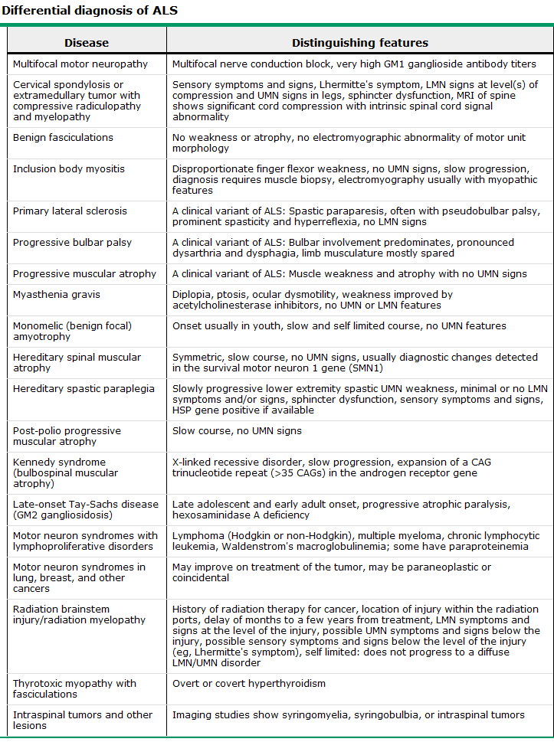

7. Describe the pathogenesis and usual clinical presentation of myasthenia gravis

- Myasthenia gravis – an autoimmune disorder characterized by weakness and fatigability of skeletal muscles due to dysfunction of the neuromuscular junction (NMJ).
- Pathogenesis:
  - Mediated by autoantibodies against:
    - The acetylcholine receptor (AChR) – classically
    - The muscle-specific receptor tyrosine kinase (MuSK) – another target on the surface of the muscle membrane.
  - Seronegative (antibody-negative) myasthenia gravis: patients with myasthenia gravis who have negative standard assays for both AChR antibodies and MuSK antibodies (6-12%); still an autoimmune disorder with most of the same features.
  - T lymphocytes also involved – believed to bind to the acetylcholine receptor and and stimulate of B cell antibody production;
  - Thymus:
    - 10-15% have an underlying thymoma
    - In Ab +ve myasthenia, often have thymic abnormalities and improve with thymectomy (thymus is a potential source of antigen).
- Clinical Presentation:
  - Onset: early peak in the second and third decades (♀ predominance) and a late peak in the sixth to eighth decade (♂ predominance).
  - Fluctuating skeletal muscle weakness, often with true muscle fatigue (reduced contractile force with repeated use).
  - Two clinical forms:
    - Ocular – weakness is limited to the eyelids and extraocular muscles
    - Generalized – often above plus a variable combination of bulbar, limb, and respiratory muscle weakness.
  - Initial presentation:
>50% Ocular symptoms of ptosis and/or diplopia. Of these, ~50% remain purely ocular.
      - Eyelid weakness: ptosis that varies throughout the day.
      - Extraocular muscle weakness: binocular diplopia; disappears with occlusion of one eye.
~15% Bulbar symptoms: fatigable chewing, dysphagia, dysarthria, facial muscles frequently involved and make the patient appear expressionless.
<5%: Isolated proximal limb weakness (resembles other muscle diseases)
  - Other symptoms
    - Neck F/E muscles commonly affected; extensor weakness → "dropped head syndrome"
    - Predominantly distal presentations of otherwise typical myasthenia can occur.
    - Involvement of respiratory muscles: serious symptoms, respiratory insufficiency and pending respiratory failure, called "myasthenic crisis".
  - Progression
    - Early, symptoms are often transient with significant asymptomatic periods (hours to weeks).
    - New symptoms often develop weeks or months later.
    - Maximal extent of the disease is seen in ¾ of patients 3 yrs after onset.

8. Describe the common clinical manifestations and pathophysiology of the following myopathies:

(a) Duchenne muscular dystrophy

- Clinical Manifestations
  - Histologic and laboratory evidence of a myopathy from birth
  - Weakness
    - Onset usually 2-3 yo, sometimes later.
    - Proximal and lower limb muscles affected earlier, ∴problemss with steps, running, jumping, rising from the floor (climb up legs = Gower’s manoeuvre)
    - Waddling gait, lumbar lordosis and calf enlargement observable.
    - Usually wheelchair bound by 12 yo
  - Cognitive impairment
    - Often mild, occasionally average or above-average intelligence.
  - Cardiomyopathy
    - Evidence by teenage years (1/3 at 14, 1/2 at 18; thereafter asymptomatic due to inability to exercise). May go into heart failure in late stages.
    - Primary dilated cardiomyopathy (DCM)
      - Extensive fibrosis, posterobasal progressing to left lateral free wall
      - Involvement of posterior papillary muscle → significant mitral regurg.
    - Conduction abnormalities and arrhythmias (usually supraventricular) – usually in late stages or with intercurrent illness or surgery.
  - Orthopedic complications
    - Limb # common.
    - Nearly all develop progressive scoliosis
(+ muscle weakness → impaired pulmonary f^{n} → resp failure)
- Pathophysiology
  - Defective dystrophin gene (X-linked); vast majority are deletions.
    - Dystrophin – intracellular protein associated with the plasma membrane as a component of a large glycoprotein complex that reinforces the sarcolemma and stabilizes the glycoprotein complex. Deletion leads to digestion of the complex by proteases, degeneration of the muscle fibre and weakness.
  - Where phenotype of DMD or BMD but without a clear X-linked pattern, other defects may be causal, eg dystrophin-associated glycoproteins.

(b) Myotonic dystrophy

- Clinical Manifestations
  - Myotonic dystrophy types 1 and 2 (DM1 and DM2)
  - Multisystem disorders characterized by:

    - skeletal muscle weakness and myotonia
    - cardiac conduction abnormalities
    - cataracts
    - testicular failure
    - hypogammaglobulinemia
    - insulin resistance

  - Diagnosis usually clinical in a patient with the characteristic presentation and FHx.
    - Electromyography will usually demonstrate myotonia if absent or uncertain clinically.
    - Gold standard: genetic testing for gene repeat expansions (see below).
  - NB – no disease-modifying therapy available; treatment is symptomatic.
- Pathophysiology
  - Incompletely understood
  - Leading theory:
      - DM1: trinucleotide (CTG) repeat expansion in the 3'-untranslated region of the DMPK gene.
      - DM2 : tetranucleotide (CCTG) repeat expansion located in intron 1 of the ZNF9 gene.
    - CUG and CCUG RNA repeat expansions mediate a dominant effect on other genes at distant loci by altering RNA binding protein activity.
    - Results in altered splicing and abnormal function of several genes, including the skeletal muscle chloride channel (→ myotonia), the insulin receptor, and cardiac troponin T.

(c) Polymyositis and dermatomyositis

- Disambiguation
  - Dermatomyositis (DM) and polymyositis (PM) are two forms of inflammatory myopathy (myositis).
  - Overlap myositis: the occurrence of myositis in association with another connective tissue disease; eg, scleroderma, SLE, RA, or Sjögren's syndrome.
- Clinical Manifestations
  - Muscle weakness: typically symmetric and predominantly proximal; atrophy with longstanding disease.
    - Oropharyngeal and upper esophageal muscle involvement: dysphagia, nasal regurgitation, or aspiration.
    - Diaphragm and chest wall muscles involvement: respiratory failure
  - Rash (in DM)
    - Gottron's sign: symmetric, roughened, erythematous skin changes over the extensor surfaces
    - Heliotrope rash: violaceous eruption on the upper eyelids, ±edema.
    - Shawl sign: diffuse flat erythema in a shawl-like distribution over the chest and shoulder or in a V-shaped pattern over the anterior neck and chest
    - Erythroderm: a generalized redness eg the malar region and forehead.
    - Periungual abnormalities: capillary nailbeds are erythematous; abnormal capillary nailbed loops.
    - Mechanic's hands: painful roughening and cracking of the skin and lateral aspects of the fingers.
  - Interstitial lung disease may occur (DM and PM and overlap myositis)
  - CK-MB elevation is not unusual, but symptomatic cardiac muscle involvement is uncommon.
- Pathophysiology
  - Muscle fiber necrosis, degeneration and regeneration, and inflammatory cell infiltration.
    - In DM, the cellular infiltrate is perifasicular and perivascular, with B cells.
    - In PM, the cellular infiltrate is within the fascicle, with cytotoxic CD8+ T cells
- For diagnosis and management, see pp.94-5 of MSK core curriculum

3. Disorders of vision

1. Assess visual loss and localise the lesion causing the following:
Normal anatomy:

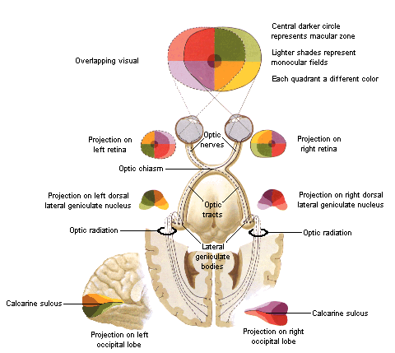
- NB – there are two paths between the lateral geniculate nucleus and the calcarine sulcus:
  - Optic radiation – via parietal lobe, carries information from the inferior visual field on the contralateral side
  - Meyer’s loop – via temporal lobe, carries information from the superior visual field on the contralateral side

(a) Monocular visual loss
- Due to a lesion of the optic nerve (rostral to chiasm) or to unilateral eye disease

(b) Enlarged blind spot (scotoma)
- Due to anything that will cause optic nerve swelling: papilloedema, optic neuritis

(c) Central scotoma
- Suggests a lesion between the retina and the chiasm.
  - Also possible that a midline lesion superficially in calcarine sulcus (tumour/haemorrhage etc.) could cause central visual loss.
- Possible causes include:
  - Macula degeneration – the most common cause of central visual loss
  - MS - unilateral or asymmetrical bilateral scotoma
  - Methyl alcohol - symmetrical bilateral scotoma
  - Nutritional causes, e.g. B12 deficiency
  - Vascular lesions - unilateral scotoma
  - Gliomas of the optic nerve - unilateral scotoma

(d) Bitemporal field defect
- Due to a lesion that affects the centre of the optic chiasm, damaging fibres from the nasal halves of the retina when they decussate. Causes include a pituitary tumour, a craniopharyngioma and a suprasellar meningioma (the pituitary sits immediately caudal to the chiasm).

(e) Homonymous hemianopia

- Due to a lesion that damages the optic tract (between the chiasm and the lateral genigualte body). Also, large unilateral lesions that are either involve both the optic radiation (parietal lobe) and Meyer’s loop (temporal lobe) or the entire visual cortex unilaterally may cause homonymous hemianopia, though these are less likely.

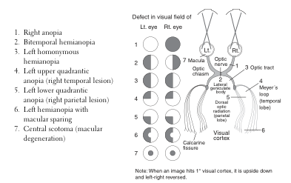

2. Assess diplopia

(a) Describe the innervation and action of the extra-ocular muscles

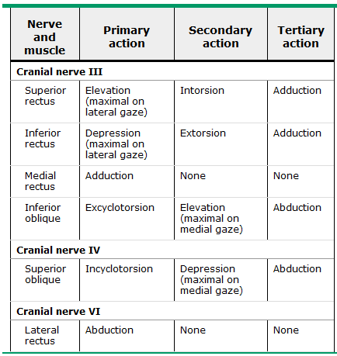

- Extraocular muscles: all by CN III (oculomotor) except for lateral rectus (CN VI; abducens) and superior oblique (CN IV; trochlear)
- Strabismus (‘squint’) comes down to imbalance of muscle contraction/relaxation.
  - Hering's law — Agonist muscles in each eye receive equal innervation to ensure coordinated eye movements. Thus, when the right lateral rectus muscle is activated to abduct the right eye, the left medial rectus muscle is equally activated to adduct the left eye.
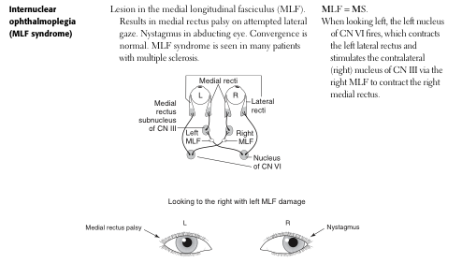
  - Sherrington's law — Agonist/antagonist muscle pairs within each eye receive reciprocal innervation. Thus, when the right medial rectus muscle contracts to adduct the right eye, its antagonist, the left lateral rectus muscle, relaxes.

(b) Name the anatomic location and most common causes for each of the following syndromes:
i. internuclear ophthalmoplegia

- Normal: when looking left, the left CN VI nucleus fires, which contracts the left lateral rectus and, via the MLF, stimulates right CN III to contract the right medial rectus.
- Lesions in the medial longitudinal fasiculus (MLF) result in medial rectus palsy on attempted lateral gaze.
  - Nystagmus occurs the abducting eye.
  - Convergence is normal.
- Most common cause: seen in many patients with MS (‘MLF=MS’)

ii. Third cranial nerve palsy (pupil sparing versus non-pupil sparing)

- CN III innervates the medial, inferior, and superior recti, and the inferior oblique; levator palpebrae superioris, and the sphincter pupillae.
  - Total palsy: eye "down and out" (unopposed action of the lateral rectus); ptosis, and a dilated pupil (respectively).
  - PNS fibres are on the outside, ∴ ischemic lesions more likely to be pupil sparing (as blood to the nerve travels outside to in) while compressive lesion more likely to involve pupil.
- Most common causes (not in order):
  - Vascular disorders, particularly of the posterior communicating artery
  - Space occupying lesions
  - Inflammation/infection
  - Trauma
  - MS
  - Cavernous sinus thrombosis

iii. Sixth cranial nerve palsy

- CN VI innervates the lateral rectus muscle, ∴palsy → horizontal diplopia, worse on gaze to the side of the lesion.
- Nuclear lesions differ:
  - The abducens nucleus contains interneurons that project (via the MLF) to the medial rectus subnucleus of the contralateral oculomotor complex.
  - ∴ abducens nuclear lesion → complete lateral gaze palsy (weakness of both the ipsilateral lateral rectus and the contralateral medial rectus).
- Course: ventral pons → forward along the clivus → pierce the dura and enters the cavernous sinus at the petrous apex.
  - Subarachnoid course: susceptible to meningitis, tumor (meningioma and others), subarachnoid hemorrhage, trauma, and compression by aneurysm or dolichoectatic vessels.
  - Petrous apex: mastoiditis can produce deafness, pain, and ipsilateral abducens palsy (Gradenigo's syndrome).
  - Cavernous sinus: carotid aneurysm, carotid cavernous fistula, tumor (pituitary adenoma, meningioma, nasopharyngeal carcinoma), herpes infection, and Tolosa-Hunt syndrome.
- Most common cause: raised intracranial pressure
  - Mechanism debated; likely rostral-caudal displacement of the brainstem. The same phenomenon accounts for abducens palsy from low intracranial pressure (e.g., after LP, spinal anesthesia, or spontaneous dural cerebrospinal fluid leak).

iv. Fluctuating or fatigable ocular muscle paresis sparing the pupil:

- Ocular myasthenia gravis (OMG) is characterized fluctuating, fatigable weakness causing:
  - Ptosis (often unilateral or asymmetric)
  - Oculomotor paresis (causes binocular diplopia, may be asymmetric)
  - Orbicularis oculi weakness (may be absent, often mild)
- Pupillary involvement is generally NOT seen, and fatigable accommodation/light reflex are signs not usually elicited in practice.
- Most patients note ocular symptoms that worsen as the day progresses or with tasks such as driving; may have mild or no symptoms upon wakening. The examination may elicit signs of fatigable levator and extraocular muscle weakness.
- The nature of the diplopia indicates the muscles involved; prolonged gaze in the direction of activity of an involved muscle may elicit fatigability and weakness; similarly with ptosis.
- Repeated red glass measurements during or after sustained gaze may reveal increasing degrees of strabismus.

3. Recognise nystagmus and list its common causes

- Nystagmus – oscillation of the eyes, occurring physiologically from vestibular and optokinetic stimulation or pathologically in a wide variety of disease.
- Physiologic nystagmus (normal) – the bilaterally symmetric appearance of a few beats of horizontal nystagmus on lateral gaze is normal. Pathologic nystagmus is asymmetric or more pronounced or prolonged.
- ‘Congenital’ sensory nystagmus
  - Complex, searching nystagmus with irregular pendular (sinusoidal) and jerk features.
  - Caused by abnormalities of the eyes or optic nerves, present at birth or acquired in childhood; even in children with congenital lesions, nystagmus does not appear until several months of age.
- Congenital motor nystagmus
  - Looks similar to congenital sensory nystagmus
  - Develops in the absence of any abnormality of the sensory visual system.
  - Visual acuity is reduced, probably by the nystagmus itself, but rarely < 6/60.
- Jerk nystagmus
  - Slow drift off the target, followed by a fast corrective saccade.
  - By convention, the named after the quick phase
    - downbeat, upbeat, horizontal (left or right), torsional.
  - Pattern may vary with gaze position.
  - Symptoms: blurred vision, percieved to-and-fro movement of the environment (oscillopsia) corresponding to their nystagmus, others asymptomatic.
  - Fine nystagmus may be difficult to see upon gross examination of the eyes, ∴ophthalmoscopy used to detect.
  - Subtypes:
Gaze-evoked nystagmus
    - When the eyes are held eccentrically in the orbits, they have a natural tendency to drift back to primary position. The subject compensates by making a corrective saccade to maintain the deviated eye position.
    - The most common form of jerk nystagmus, and often present in normal subjects
    - Caused by
      - drugs (sedatives, anticonvulsants, alcohol)
      - muscle paresis
      - myasthenia gravis
      - demyelinating disease
      - cerebellopontine angle, brainstem, and cerebellar lesions.
Vestibular nystagmus
    - Caused by dysfunction of vestibular system: labyrinth (Ménière's disease), nerve, nucleus.
      - Peripheral:
        - Often discrete attacks, with nausea and vertigo; may be associated tinnitus and hearing loss.
        - Sudden shifts in head position may provoke or exacerbate symptoms.
Downbeat nystagmus
    - Causes:
      - Lesions near the craniocervical junction (Chiari malformation, basilar invagination)
      - Brainstem or cerebellar stroke
      - Lithium or anticonvulsant intoxication
      - Et-OHism
      - MS.
Upbeat nystagmus
    - Associated with damage to the pontine tegmentum (stroke, demyelination, or tumor).
- Opsoclonus
  - Rare and dramatic; consists of bursts of consecutive saccades (saccadomania).
    - When the saccades are only horizontal, the term ‘ocular flutter’ is preferred.
  - Causes: viral encephalitis, trauma, or a paraneoplastic effect of neuroblastoma, breast carcinoma, and other malignancies. It has also been reported as a benign, transient phenomenon in otherwise healthy patients.

(a) Differentiate peripheral from central forms of nystagmus

See above

4. Assess pupillary abnormalities
(a) Trace the sympathetic and parasympathetic pathways that innervate the pupil
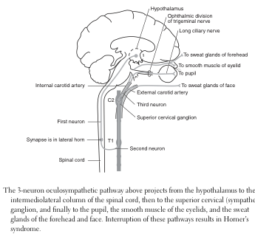
(b) List the components of Horner’s syndrome and the sites where a causative lesion may occur

- Horner’s syndrome = loss of sympathetics to the eye that dilate pupil, open the lids wide, and trigger sweating.
- Classic signs of a Horner's syndrome:
  - Miosis typically mild, associated with dilation lag, most prominent in dim light
  - Ptosis mild, involves upper and lower lids
  - Anhidrosis only occurs with 1st or 2nd-order lesions (central or preganglonic)

(see below for table of sites of causative lesion)
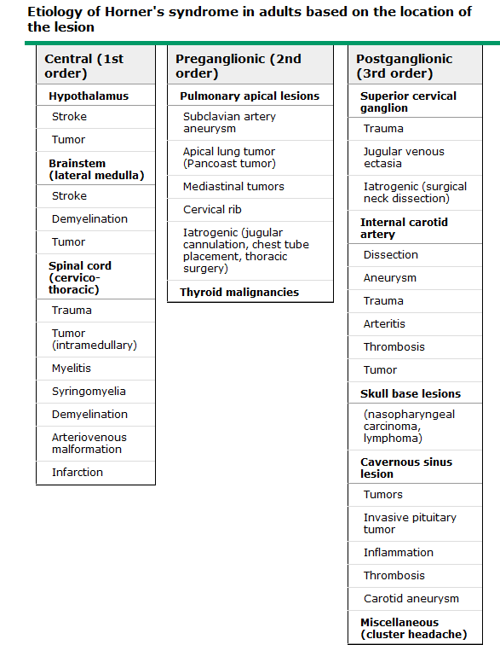

(c) Describe the afferent pupillary defect (Marcus-Gunn pupil)

- Normal pupil
  - Pupillary size is determined by an average of the illumination detected by each eye.
  - The efferent limb of the pupillary reflex is bilateral, i.e. both pupils receive the same command and they are always the same size. They are only unequal when the efferent pathways are not working properly.
- Marcus Gunn pupil (relative afferent pupillary defect)
  - During the swinging-torch test, the patient's pupils constrict less (therefore appearing to dilate) when a bright light is swung from the unaffected eye to the affected eye. The affected eye still senses the light and produces pupillary sphincter constriction to some degree, albeit reduced.
  - Most common causes:
    - Lesion of the optic nerve (proximal to the optic chiasm)
    - Severe retinal disease.

4. Alcohol-related disorders

1. Describe the clinical characteristics and emergency management of the following:

(a) Wernicke-Korsakoff syndrome

Wernicke’s encephalopathy
- Clinical characteristics (Wernicke’s here – Korsakoff later)
  - Associated with
    - Et-OHism (most common)
    - Malnutrition (particularly at the time of refeeding)
    - Dialysis
  - Pathology: petechial hemorrhagic necrosis in midline brain structures and corresponding deficits in mentation, oculomotor function, and gait ataxia.
  - Characterized by 3 classic symptoms/signs:
    - Mentation (encephalopathy)
      - profound disorientation
      - indifference
      - inattentiveness
      - impaired memory and learning (may be difficult to test due to above)
      - sometimes associated with agitated delirium related to Et-OH withdrawal
      - ↓consciousness (<5%)
        - natural history: progress to stupor, coma and death
    - Oculomotor dysfunction (usually occur in combination rather than alone)
      - nystagmus → vestibular nucleus lesion
        - most common finding, evoked by horizontal gaze to both sides
      - lateral rectus palsy → abducens nucleus lesion
        - virtually always bilateral
      - conjugate gaze palsies → oculomotor nucleus lesion
      - Others
        - other palsies (isolated vertical gaze pasy, internuclear ophthalmoplegia, complete ophthalmolplegia) are rare.
        - Pupillary abnormalities (sluggish, unequal, even unreactive pupils in advanced cases)
        - Light-near dissociation sometimes seen
    - Ataxia
      - involves stance and gait
      - due to a combination of polyneuropathy, cerebellar involvement, and vestibular dysfunction.
Present as a complete triad in only 1/3, and as any may appear alone (esp. encephalopathy), any of the above should trigger consideration of Wernicke’s Dx.
  - Investigations: no good diagnostic test, though labs and neuroimaging are often abnormal.
- Emergency management
  - Untreated, WE leads to coma and death; prompt thiamine improves prognosis.
  - Whenever considering Wernicke’s, ADMINISTER THIAMINE rather than confirm Dx.
      - 500 mg IV infused over 30 minutes, TDS for two consecutive days
+
      - 500 mg IV or IM once daily for 5 more days
+
      - Oral thiamine and multivitamin supplementation thereafter
    - Wernicke's encephalopathy may be precipitated by IV glucose in those with thiamine deficiency (thiamine utilized in glucose metabolism).
∴give thiamine 100 mg IV with or before glucose in susceptible individuals.

- Korsakoff’s psychosis:
  - A late, neuropsychiatric manifestation of Wernicke's encephalopathy (WE) characterised by selective anterograde and retrograde amnesia.
  - Can occur in a variety of conditions that damage the medial temporal lobes, most frequently seen in alcohol abusers after WE, and show typical WE lesion.
  - Clinical features
    - Anterograde and retrograde memory deficits
    - Relative preservation of long-term memory and other cognitive skills, attention and social behaviour (may seem normal to an unsuspecting spectator).
    - Apathy (as a rule unaware of their illness)
    - Intact sensorium
    - Sometimes: confabulation
  - Treatment and prognosis: rarely recover, require at least some form of long-term supervision and social support.

(b) alcohol withdrawal seizure

- Clinical characteristics
  - Generalised tonic-clonic seizure
    - Usually singular or occur as a brief flurry over a short period
  - History of chronic alcoholism
    - Usually 12-48 h after the last drink; may be after as little as 2 h.
- Emergency management
  - Recurrent, prolonged, or status epilepticus → investigate possible structural or infectious etiologies ∴cranial CT and/or LP.
    - Benzodiazepines and phenobarbital to treat status epilepticus while investigations proceed. Phenytoin is ineffective (multiple studies).
  - Untreated alcohol withdrawal seizures progress to delirium tremens in ~1/3 patients.

2. Describe the clinical features of:

(a) alcohol related dementia

- Relationship between alcohol use and dementia unclear; some evidence suggests that light to moderate drinking may be protective.
- Alcohol abuse:
  - Wernicke-Korsakoff syndrome
    - See 1.a. above
  - Ventricular enlargement and cognitive dysfunction in alcohol abusers
    - ~60% have cognitive deficits on neuropsych testing.
    - CT and MRI show enlargement of cerebral ventricles and sulci in the majority
      - When corrected for aging, the radiographic indices do not consistently correlate with either the duration of drinking or the severity of cognitive impairment.

(b) Chronic alcohol related cerebellar degeneration

- Some alcohol abusers develop a chronic cerebellar syndrome related to the degeneration of Purkinje cells in the cerebellar cortex.
  - Usually only after ≥10 years of excessive ethanol use.
- Pathology
  - Midline cerebellar structures, especially the anterior and superior vermis, are predominantly affected – a pattern identical to that in Wernicke's.
- Clinical features
  - Cognitive function is usually unimpaired.
  - Usually develops gradually (weeks to months)
    - May be abrupt onset or take years, and mild and apparently stable cases can become suddenly worse.
  - Symptoms
    - Gait – primary complaint of almost all patients
      - weakness, unsteadiness, or incoordination in the legs
      - later, a minority note
        - incoordination and tremor in the arms
        - dysarthria
        - intermittent diplopia or blurred vision.
  - Signs: features of a midline cerebellar lesion, with selective abnormalities of stance, gait, and lower extremity coordination.
    - Ataxia of stance and gait (resembles acute intoxication)
      - Fail to tandem walk, even with mild disease.
    - Heel-knee-shin testing is usually abnormal
    - Finger-nose testing oft only mild abnormalities, often associated with more severe impairment of handwriting
    - Others
      - Mild dysarthria: slow, slurred speech
      - Tremor
        - coarse, rhythmic, 3-5 Hz postural tremor
        - fingers, arms, or thighs

- Marchiafava-Bignami disease (not required by curriculum)
  - Rare; demyelination or necrosis of the corpus callosum and adjacent subcortical white matter
  - Predominantly in malnourished alcoholics; some cases described in non-alcohol abusers, suggesting that alcohol alone is not responsible for the lesion
  - May be associated with lesions of Wernicke's as well as selective neuronal loss and gliosis in the third cortical layer.

5. Neurological Considerations in the Indigenous Population

Understand the epidemiology of the complications of systemic disease in Australian indigenous populations and the impact of risk factors in this population on

(a) Diabetic Neuropathy

- Neuropathy
  - The combination of infection (due to peripheral vascular disease) and peripheral neuropathy can lead to chronic foot problems
    - Diabetics are more susceptible to infections (particularly bacterial) than are non-diabetics.
      - Primary reason for admission in 60% of diabetic cases (~4.6% of all Indigenous admissions) (1980s).
      - ~ 1 in 5 deaths of Indigenous diabetics in Australia were attributed to infection (1995), making them the second most common cause of death of Indigenous diabetics (after renal disease).
  - ~10% of diabetic admissions were for foot complications, with Indigenous people being responsible for slightly more than 90% of these.
    - >1/3 required surgery (debridement)
    - 7% required amputation (toe or higher).

- Other complications (not required by curriculum):
  - Man cause of death in Indigenous diabetics may be renal disease (rather than cardiovascular disease in the rest of the population)
    - Mostly due to end-stage renal disease (in NT indigenous, 20-30 times than that of non-Indigenous)
  - ≥19% of diabetic patients are admitted to hospital for a cardiovascular complication

(b) Stroke

- ATSI comared to non-ATSI
  - Higher mortality (age standardised)
    - ♂ RR 2.4
    - ♀ RR 2.2
  - Affected earlier
  - Greater hospitalisation
    - 4× other Australians (1999), and higher in rural areas.
  - More likely to be transferred to metropolitan centres
    - suggests high level of acuity or a lack of stroke expertise in regional hospitals.

(c) Alcohol-related neurological disorders

- Higher rates of risky and high-risk alcohol consumption by ATSI → higher rates of alcohol-related hospital admissions.
  - Twice the rate of binge drinking (17%) as non-ATSI
  - Twice the rate of absainence (29%) as non-ATSI
- Cognitive abnormalities that suggest frontostriatal abnormalities observed in chronic Et-OHics are seen in ATSI heavy episodic Et-OH users
- Other neurological complications:
  - Legal blindness: ~28% of NT Indigenous people with diabetes had some degree of retinopathy, which was vision-threatening in 13% of cases (1994), in some as young as their 30s.
  - Cerebrovascular disease: 4% of Indigenous diabetics, which was responsible for 2.3% of the hospital admissions of diabetics.
- Foetal alcohol syndrome
  - 48% of indigenous mothers drink while pregnant
  - The prevalence of foetal alcohol syndrome and foetal alcohol spectrum disorder has not been comprehensively established in Indigenous or non-Indigenous communities in Australia
  - In unpublished research quoted in the MJA, work conducted in 2000 found that 540 out of 614 children aged under 12 in an (unnamed) Indigenous community had prenatal exposure to alcohol that exceeded NHMRC recommendationson alcohol consumption during pregnancy.

(d) Epilepsy

- ATSI have similar epilepsy syndromes to the non-ATSI, but present with more serious disease.
  - ? inequitable health care utilisation due to cultural issues or geographic isolation.

6. Spinal cord disorders

1. Localize the lesion that gives the following findings on neurologic examination:

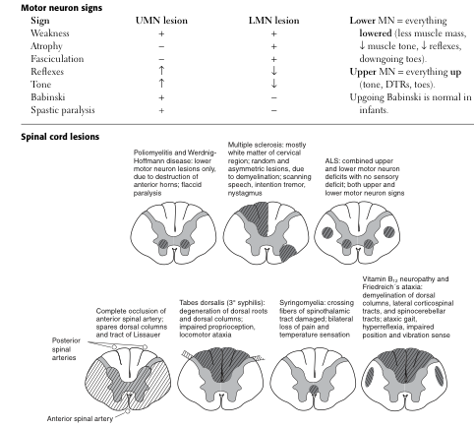

(a) ipsilateral UMN findings and decreased position sense with contralateral decrease in pain and temperature sensation.

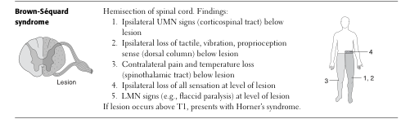

(b) dissociated sensory loss, weakness and areflexia of the upper extremities

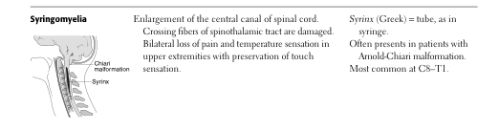

(c) sensory level with paraparesis and bladder incontinence

- Spinal cord transsection

2. Describe the usual clinical presentation of vitamin B12 deficiency

- Two main areas: megaloblastic anaemia and neurologic sympoms
  - NB either may be present alone – always consider even if only one present
- Megaloblastic anaemia
  - Most commonly caused by a deficiency of either:
    - Cobalamin (B12) – from animal products (i.e. concern for vegans)
    - Folic acid – green leafy vegetables (folate from foliage)
  - Pernicious anaemia (autoimmune B12 deficiency)
    - Most common in whites of northern European ancestry
      - occurs as commonly in blacks as in other white Europeans
    - Usually older patients, possibly because of the superimposition of age-related chronic atrophic gastritis.
    - Can occur <30, and can be associated with other autoimmune diseases, e.g. thyroid disease and vitiligo (specific organ cluster)
  - Labs:
    - FBC:
      - Macrocytic anaemia
      - reticulocytes: ↓ to N
      - WBCs and PLT: ↓ to ↓N
      - Film: macroovalocytic anemia, megaloblasts, and hypersegmented Nø
    - Elevated serum bilirubin and LDH levels (↑RBC breakdown, ineffective erythropoesis)
- Neurological symptoms – B12 deficiency (not produced by folate deficiency)
  - Subacute combined degeneration of the dorsal and lateral spinal columns, leading to a symmetrical neuropathy (lower more affected than upper limb)
    - Due to defect in myelin formation (mechanism unclear)
  - Have hard-to-characterize neuropsychiatric problems
Peripheral
    - Loss of vibration and position sense → parasthesias and ataxia
      - Occasionally presents with Lhermitte's syndrome – a shock-like sensation that radiates to the feet during neck flexion
    - Progression may include

      - severe weakness
      - spasticity
      - clonus
      - paraplegia
      - faecal and urinary incontinence

Central

    - irritability
    - loss of dexterity
    - impaired memory
    - personality changes
    - dementia

- Skeletal
  - Appears to be an increased risk of osteoporosis and associated fractures.
    - Mechanism: ? ↓osteoblast activity
- Hyperhomocysteinemia
  - Both B12 and folate are required for the metabolism of homocysteine to methionine, ∴ deficiencies in either → ↑plasma homocysteine → ↑risk atherosclerosis and VTE.

7. Cerebrovascular diseases

1. List the major risk factors for cerebrovascular disease and understand the degree to which they are modifiable

- Non-modifyable risk factors

  - ↑age
  - ♂

  - Genetics
  - Ethnicity (African American, Hispanic, aisian)

- Modifyable risk factors

  - Hypertension
  - Diabetes
  - Obesity
  - Smoking
  - Hypercholesterolemia
  - Heavy alcohol intake
  - Carotid stenosis
  - IVDU
  - Cocaine use
  - Atrial fibrillation

2. Describe the pathophysiology and clinical features of:

(a) Asymptomatic carotid bruit

- Carotid stenosis
  - Pathophysiology
    - Atherosclerotic thickening and plaque deposition, often at the junction of the external and internal carotid.
  - Clinical features
    - Asymptomatic
    - Signs:
      - Most useful sign: carotid bruit heard over the site of the stenosis.
        - Nonetheless, in asymptomatic patients this is a poor predictor for the presence of stenosis and for subsequent stroke.
      - Ocular bruits and abnormalities or asymmetries of facial pulses are not reliable predictors of carotid stenosis.

(b) Transient ischaemic attack (TIA)

- Pathophysiology
  - Transient cerebral ischaemia, falling into one of two main classes: embolic or lacunar.
  - Embolic
    - Diligent search for embolic source is necessary before therapy to prevent future stroke can be initiated
    - Location
      - Anterior circulation
        - Large may occlude MCA → contralateral hemiplegia
          - ischaemia in the deep white matter and basal ganglion/internal capsule lenticulostriate territory.
        - Smaller emboli in MCA branches → more focal symptoms, e.g isolated hand/arm numbness, weakness, and/or heaviness
          - ischemia to the frontal area of the contralateral frontal lobe motor system.
      - Posterior circulation
        - Usually produced by emboli from atherothrombotic disease of:
          - origin of vertebral a.
          - proximal basilar a.
NB also consider aortic arch and heart, dissecting vertebral a.
  - Lacunar
    - Appropriate diagnosis in recurrent stereotyped TIAs
    - Stenosis of one of the intracerebral penetrating vessels arising from the MCA, basilar, vertebral, or the circle of Willis
    - Usually is due to lipohyalinosis from hypertension
      - atherosclerosis at their origin may also cause.
- Clinical features
  - Discrete, usually single episodes of focal neurologic symptoms <24 h duration.
  - Embolic
    - Symptoms vary according to the vertebral or basilar artery branch in which the emboli lodges.
hemianopsia dizziness crossed face and body numbness
quadrantanopsia transient ataxia focal hearing loss numbness
diplopia dysarthria
    - Emboli at the top of the basilar artery: sudden, overwhelming stupor or coma due to bilateral medial thalamic, subthalamus, and medial rostral midbrain reticular activating system ischemia.
    - Emboli in distal PCA: homonymous field defect or in memory loss (inferior medial temporal lobe ischemia).
  - Lacunar
    - Symptoms are similar to the lacunar strokes that are likely to follow.
      - Face, arm, and leg weakness or numbness due to ischemia in the internal capsule, pons, or thalamus.
      - Similar to the symptoms due to ischemia from embolism or large vessel atherothrombotic disease or dissection.

(c) ischaemic infarct (arteriogenic embolisation, cardiogenic embolisation, large-vessel thrombus)

- Pathophysiology
  - Acute occlusion of an intracranial vessel → ↓blood flow to the region it supplies.
    - Magnitude of flow reduction is a function of collateral blood flow, which varies between individuals and brain regions.
    - Rate of tissue death depends on degree of occlusion:
      - Zero flow: 4–10 min
      - <16–18 mL/100 g/min <1 h
      - <20 mL/100 g/min ischemia without infarction unless prolonged (several hours to days)
→ If flow is restored prior significant cell death, symptoms may resolve.
  - Ischemic penumbra – tissue surrounding the core region of infarction is ischemic but reversibly dysfunctional; imaged by using perfusion-diffusion imaging with MRI.
    - Will eventually infarct if no change in flow occur/s
    - Saving the ischemic penumbra is the goal of revascularization.
  - Infarction occurs via two distinct pathways:
1) Necrosis: energy failure of the cell, leading to rapid cytoskeletal breakdown
↓blood flow → ↓G delivery → ↓ATP prod^{n} postsynaptic receptor ← glutamate release
↓ ↓ ↑
ion pump failure → ↑[Ca²⁺]_{cytoplasmv} → membrane depolarisation
↓
Damage of multiple cell f^{n}s ← fee radical prod^{n} (due to mitochondrial dysf^{n} and membrane lipid degradation)
2) Apoptosis: programmed cell death; seen in lesser degrees of ischemia within the ischemic penumbra, causing cells to die days to weeks later.
  - Fever and hyperglycaemia (glucose > 11.1 mmol/L) dramatically worsen ischaemia
∴suppress fever and prevent hyperglycemia
- Clinical features:
  - Sudden onset of any of the following should prompt suspicion of stroke:
    - Unilateral sensory and/or motor loss (hemiparesis in 85% of ischemic stroke)
      - tends to migrate slowly across a limb over minutes
    - Change in vision, gait, or ability to speak or understand
    - Sudden, severe headache
  - To differentiate ischaemic from haemorrhagic: non-contrast CT head.
    - Haemorrhagic – hyperdense lesion.
    - Ischaemic – no finding early, may have hypodense region.
  - Specific syndromes
    - Lateral medullary (Wallenberg's) syndrome: vertigo, numbness of the ipsilateral face and contralateral limbs, diplopia, hoarseness, dysarthria, dysphagia, and ipsilateral Horner's syndrome.
      - Due to occlusion of any of five vessels may be responsible—vertebral, posterior inferior cerebellar, superior, middle, or inferior lateral medullary arteries.

    - Medial medullary syndrome (rare): contralateral hemiparesis of the arm and leg, sparing the face; if the medial lemniscus and emerging hypoglossal nerve fibers are involved, contralateral loss of joint position sense and ipsilateral tongue weakness.
      - Due to occlusion of vertebral artery or of branch of vertebral or lower basilar artery.
    - Complete basilar artery occlusion – easy to recognize as a constellation of bilateral long tract signs (sensory and motor) with signs of cranial nerve and cerebellar dysfunction
      - Multiple pontine syndromes are described with various regions of the basilar artery and its branches are occluded to varying degrees.
    - Locked-in syndrome – a state of preserved consciousness with quadriplegia and cranial nerve signs; suggests complete pontine and lower midbrain infarction.
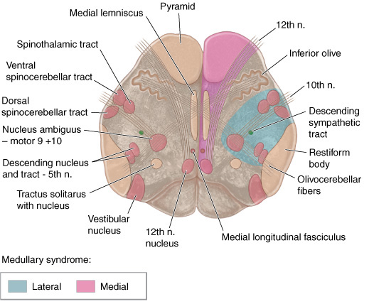

(d) lacunar infarct

- Lacunar infarction (preferred term now is small vessel stroke) – infarction following atherothrombotic or lipohyalinotic occlusion of a small artery (30–300 μm) in the brain; ~20% of strokes.
- Pathophysiology
  - The MCA stem, the arteries comprising the circle of Willis, and the basilar and vertebral arteries all give rise to 30- to 300-μm branches that penetrate the deep gray and white matter of the cerebrum or brainstem.
    - These may occlude either by
- atherothrombotic disease at its origin
- lipohyalinotic thickening.
    - Thrombosis causes small infarcts that are referred to as lacunes (Latin for "lake" of fluid noted at autopsy).
      - infarcts range are 3 -20 mm in diameter.
    - Hypertension and age are the principal risk factors. Treat the former to ↓risk.
- Clinical features
  - Common lacunar syndromes:
- Pure motor hemiparesis – posterior limb of the internal capsule or basis pontis; the face, arm, and leg are almost always involved.
- Pure sensory stroke – ventral thalamus.
- Ataxic hemiparesis – ventral pons or internal capsule;
- Dysarthria and a clumsy hand/arm – ventral pons or in the genu of the internal capsule.
  - Small vessel TIAs may herald a small-vessel infarct
    - May occur several times a day and last only a few minutes (‘stuttering’ course)
  - Recovery tends to be more rapid and complete than recovery from large-vessel strokes; in some cases, however, there is severe permanent disability.
  - Often combined antithrombotic treatments in stuttering stage does not prevent eventual stroke.
  - A large-vessel thrombotic or embolic source may manifest initially as a lacunar syndrome with small-vessel infarction, ∴still look for a source.

(e) haemorrhagic infarct

- Unable to discriminate from ischaemic on clinical signs
  - Clasically sudden onset of symptoms to maximal deficit ± headache, but very unreliable
  - CT brain required

Locating a lesion other than those in the brainstem (not required by curriculum)

Anterior circulation (downstream of the caritid arteries)
MCA – face and arm involvement (+speech if in dominant side)
ACA – leg involvement
Posterior circulaiton (downstream of vertebral and basilar arteries)
PCA – vision

Higher function (all may get seizures):
Parietal lobe:
Non-localising:astereognosis
Dominant: dysphasia, acalculia*, agraphia*, right-left disorientation*, finger agnosia* (*Gerstmann’s syndrome)
Non-dominant:sensory and visual inattention, construction and dressing apraxia, spacial neglect and inattention, lower quadrantanopia.
Temporal lobe:
Memory loss, upper quadrantanopia, dysphasia (receptive if dominant)
Frontal lobe:
Δpersonality, primitive reflexes, anosmia, optic nerve compression, gait apraxia, leg weakness (parasagittal), loss of micturition control, expressive dysphasia, dysgraphia
Occipital lobe:
Homonymous hemianopia, alexia (word blindness, inability to read), seizures with flashing light aura

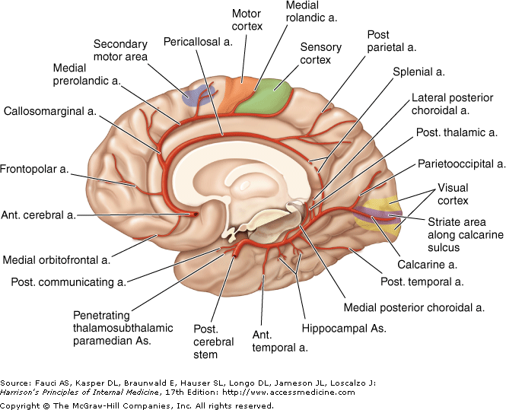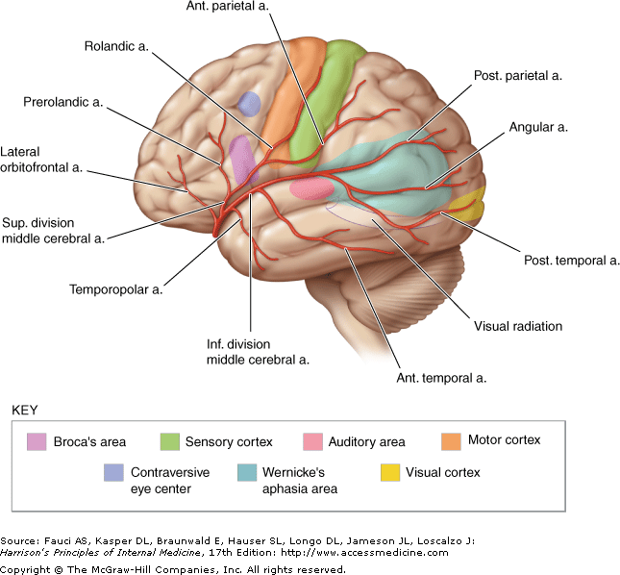

(f) parenchymal haemorrhage

- Intraparenchymal hemorrhage
  - The most common intracranial hemorrhage (~10% of strokes, 50% fatality rate).
  - Hypertension, trauma, and cerebral amyloid angiopathy cause the majority.
    - RFs: ↑age, ↑Et-OH, cocaine; more common in Asians and African Americans
- Pathophysiology
  - Hypertensive: usually from spontaneous rupture of a small penetrating artery deep in the brain, commony in the basal ganglia (esp. putamen), thalamus, cerebellum, and pons.
  - If hypertension is absent, consider:
    - hemorrhagic disorders
    - neoplasms
    - vascular malformations
  - Anatomical characteristics
    - hemorrhages may be small or a large
    - clot formation may compress adjacent tissue, causing herniation and death
    - blood may dissect into the ventricular space → ↑morbidity, hydrocephalus.
  - Progression:
    - Development: hypertensive evolve for 30-90min, those from anticoagulation evolve for 24-48h.
    - 48h: Mø phagocytose haemorrhage at its outer surface
    - 1-6/12: slit-like orange cavity lined with haemosiderin-laden Møs and glial scar
- Clinical Manifestations
  - Almost always occur while the patient is awake and sometimes when stressed.
  - Presents as the abrupt onset of focal neurologic deficit. Seizures are uncommon.
    - Putamen: most common site, usually with internal capsule involvement
      - ∴ contralateral hemiparesis is the sentinel sign
        - Face sags on one side
        - Eyes deviate away from hemiparetic side
        - Slurred speech
        - Arm and leg weakness
          - Progression to flaccidity or rigid extension
      - Deficit typically worsens steadily over 30–90 min
      - Associated
        - ↑ICP signs (headache, vomiting)
        - ↓consciousness with brainstem compression (drowsiness → coma)
          - With progression to coma:
            - deep/irregular/intermittent respiration
            - dilated fixed ipsilateral pupil
            - decerebrate rigidity
      - Milder cases may deteriorate over 12-72 h due to edema in adjacent brain tissue.
    - Thalamic:
      - Contralateral hemiplegia or hemiparesis (from pressure on, or dissection into, the adjacent internal capsule) + prominent sensory deficit involving all modalities.
        - Domnant thalamus: aphasia, often with preserved repetition
        - Nondominant thalamus: constructional apraxia or mutism
      - Ocular (due to extension inferiorly into the upper midbrain)
        - Homonymous visual field defect
        - Deviation
          - Ocular deviation of the eyes downward and inward (appear to be looking at the nose)
          - Skew deviation with the eye opposite the hemorrhage displaced downward and medially
        - Pupils
          - Unequal
          - Absent light reaction
          - Ipsilateral Horner's
        - Movement
          - Absence of convergence
          - Paralysis of vertical gaze
          - Retraction nystagmus
      - Patients may later develop Déjerine-Roussy syndrome, a chronic, contralateral pain syndrome.
    - Pontine: deep coma with quadriplegia over a few minutes; death often occurs within a few hours
      - Prominent decerebrate rigidity
      - "pin-point" (1 mm) pupils that react to light.
      - Impairment of reflex horizontal eye movements evoked by head turning (doll's-head or oculocephalic maneuver) or by irrigation of the ears with ice water.
      - Hyperpnea, severe hypertension, and hyperhidrosis are common.
    - Cerebellar hemorrhages: develop over hours
      - Occipital headache, repeated vomiting, ataxia of gait (may be only sign in mild cases), dizziness/vertigo.
      - Ocular:
        - Often one of the following:
          - Paresis of conjugate lateral gaze toward the side of the lesion
          - Forced deviation of the eyes to the opposite side
          - Ipsilateral sixth nerve palsy
        - Less common: blepharospasm, involuntary closure of one eye, ocular bobbing, and skew deviation.
      - Dysarthria and dysphagia.
      - Progression over hours to stupor and coma from brainstem compression or obstructive hydrocephalus
        - ∴Immediate surgical evacuation may be lifesaving.
          - Hydrocephalus from 4th ventricle compression can be relieved by external ventricular drainage
          - Definitive hematoma evacuation is essential for survival.
          - If the deep cerebellar nuclei are spared, full recovery is common.
    - Lobar haemorrhage: develop over several minutes.
      - Most are small, resulting in a syndrome resembling an embolus to an artery supplying one lobe.
        - occipital → hemianopia
        - left temporal → aphasia and delirium
        - parietal → hemisensory loss
        - frontal → arm weakness
      - If large & compress the thalamus or midbrain → stupor or coma.
      - Most have focal headaches, and also vomit or are drowsy.

  - Other causes of intracerebral haemorrhage
    - Cerebral amyloid angiopathy – a disease of the elderly; arteriolar degeneration and amyloid deposition in the walls of cerebral arteries.
      - Causes both single and recurrent lobar hemorrhages
      - Most common cause of lobar hemorrhage in the elderly, and accounts for some intracranial hemorrhages associated with thrombolysis in MI.
      - Suspect in patients who present with multiple hemorrhages (and infarcts) over several months or years, or in patients with "micro-bleeds" seen on brain MRI sequences sensitive for hemosiderin
        - Dx: Congo red staining of amyloid in cerebral vessels.
        - Associated with certain alleles of apolipoprotein E gene
      - No specific therapy; avoid antiplatelet and anticoagulating agents.
    - Trauma: common sites for intracerebral are temporal and inferior frontal.
      - Consider in any patient with an unexplained acute neurologic deficit, particularly if the deficit occurred in the context of a fall.
    - Anticoagulation: haemorrhages can occur at any location; often lobar or subdural.
      - May evolve slowly (24–48 h)
      - Skin and mucous membrane bleeding is usually evident (diagnostic clue)
      - Assoc. with leukaemia, aplastic anaemia and thrombocytopaenia
      - Rapidly everse coagulopathy and thrombocytopenia.
    - Neoplasm: may be 1st sign.
      - Most common neoplasms causing intracerebral haemorrhage:

choriocarcinoma
malignant melanoma
renal cell carcinoma
bronchogenic carcinoma
glioblastoma multiforme (adults)
medulloblastoma (paeds)

    - Hypertensive encephalopathy: a complication of malignant hypertension, in which severe hypertension is associated with headache, nausea, vomiting, convulsions, confusion, stupor, and coma.
      - Focal or lateralizing neurologic signs are uncommon.
      - Clinical characteristics
        - Hypertensive retinopathy
          - retinal hemorrhages
          - exudates
          - papilledema
        - Renal disease
        - Cardiac disease
        - ↑ICP
        - ↑CSF protein
      - ↓BP reverses the process, but if occurs too rapidly may cause stroke.
      - Pathology:
        - Diffuse cerebral edema and hemorrhages (petechial to massive).
        - Arteriolar necrosis, minute cerebral infarcts, and hemorrhages.
    - Primary intraventricular hemorrhage (rare)
      - Usually begins within the substance of the brain and dissects into the ventricular system without leaving signs of intraparenchymal hemorrhage, or may arise from periependymal veins.
    - Other causes:
      - Vasculitis (polyarteritis nodosa or SLE)
        - Due to hypertension or disruption of the vessel wall.
      - Sepsis
        - Small petechial hemorrhages throughout the white matter.
      - Moyamoya disease
        - an occlusive arterial disease that causes ischemic symptoms
        - occasionally produces intraparenchymal hemorrhage (esp. in the young)
      - Spinal cord haemorrhages
        - AV malformation or metastatic tumor.
        - Present with sudden back pain and some manifestation of myelopathy.
        - Epidural spinal hemorrhage produces a rapidly evolving syndrome of spinal cord or nerve root compression.

(g) subarachnoid haemorrhage (SAH)

- Pathophysiology
  - Most common causes:
1) Head trauma
2) Rupture of saccular aneurysm
3) Bleed from AV malformation or dural AV fistula
4) Extension of 1’ intracerebral haemorrhage into subarachnoid space
  - Aneurysm rupture
    - Releases blood into the CSF under arterial pressure.
      - Spreads quickly within the CSF
      - Rapid ↑ICP
      - Bleeding usually lasts only a few seconds
    - Rebleeding is common and occurs more often within the first day.
- Clinical manifestations
  - Symptoms begin abruptly, at night in 30 percent of cases, and may be triggered by physical exhertion.
  - 97%: thunderclap headache
    - sudden, severe, "worst headache ever"
    - lateralized in 30%, predominantly to the side of the aneurysm.
    - onset may be accompanied by a brief loss of consciousness, seizure, N/V, and meningismus.
  - ~40%: minor hemorrhage or "warning leak"
    - sudden and severe headache preceding SAH by 6-20 d.

(h) amaurosis fugax (transient monocular blindness)

- Underlying causes of transient visual loss range from benign to serious.
  - Transient
    - Diagnosis is guided by historical features:
      - Monocular and binocular (most important feature, but often unclear)
      - Symptom duration
      - Character at onset
      - Positive visual phenomena
      - Precipitating factors
      - Associated symptoms
    - Causes of transient monocular visual loss (TMVL)
      - Carotid artery disease (causing ischaemia)
        - Common
        - Serious implications for future stroke risk ∴carotid endarterectomy.
        - Suggestive features:
          - rapid onset
          - altitudinal pattern (visual loss descending over the field of vision like a curtain or shade)
          - < 10 min duration
      - Giant cell arteritis (≡ temporal arteritis)
        - Not common, but is treatable
        - Clinically indistinguishable from that due to carotid disease except for frequent accompanying headache.
      - Other causes of TMVL: ischemia from cardioembolic disease, some ocular conditions, retinal vasospasm (in young), idiopathic.
        - Migraine typically binocular with positive phenomenology and a characteristic build-up, lasting 10 to 30 minutes, and associated with or followed by migraine headache
    - Causes of binocular visual loss
      - Uusually isolated to one visual field, can also occur during vertebrobasilar ischemia or seizure.
      - Unless symptoms are very typical for migraine, some diagnostic testing is required.
    - Investigation/management
      - ESR and CRP in all >50 yo with transient monocular or binocular loss.
      - Ophthalmologic examination and carotid duplex ultrasound for all with TMVL.
      - Other tests according to clinical picture, eg. cardiac workup, hypercoagulable testing, MRI, EEG.

3. Identify the major clinical features of infarction in the distribution of the:
(a) anterior cerebral artery
(b) middle cerebral artery
(c) lenticulostriate arteries
(d) basilar artery
see following page

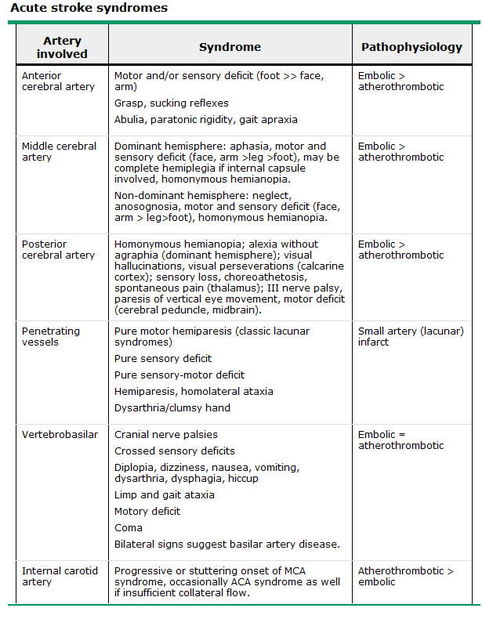

4. Discuss the treatment options for acute stroke

- Goals
  - Stabilise
  - Reverse contributing conditions
  - Determine pathophysiology
    - Ischaemic: determine if a candidate for thrombolysis.

- Important aspects of acute stroke management include the following:
  - Primary survey: vitals, ensure airway protection, prevent aspiration, assess breathing.
  - Diagnose haemorrhage (intracerebral or subarachnoid) ASAP
  - History and examination – rapid but accurate to help distinguish DDx of brain ischemia.
- Management
  - Head of bead
    - Elevate to 30° if
      - At risk of ↑ICP
      - At risk of aspiration
      - Has comorbid cardiopulmonary disease
    - If none of the above, keep head of the bed flat (0-15° elevation)
  - Investigations
    - Urgent imaging: noncontrast CT → haemorrhagic or ischaemic?
    - Glucose – correct hypo or hyper >10 mmol/L
  - Cardiac monitoring for 1st 24 h
  - Maintain normothermia – i.e. treat fever if present for first several days
  - Anti-clotting agents in ischaemic stroke
    - Consider thrombolysis (tissue plasminogen activator [TPA])
    - Reduced disability, complications, or stroke recurrence with
      - Antithrombotic therapy within 48 h of onset
      - DVT & PE prophylaxis (stroke = high risk group)
      - Continuing statin in those already taking one
  - BP management – depends on the type of stroke
Ischaemic:
    - If not thrombolysed – only treat HT if extreme (i.e. systolic >220 mmHg or diastolic >120 mmHg) or other clear indication, e.g.

      - active ischemic coronary disease
      - heart failure
      - aortic dissection
      - acute renal failure
      - pre-eclampsia/eclampsia
      - hypertensive encephalopathy

    - If thrombolysed – treat HT to maintain systolic ≤185 mmHg and diastolic ≤110 mmHg.
Haemorrhagic (ICH or SAH):
    - Weigh up risks (i.e. reducing cerebral perfusion) versus benefits (reducing further bleeding)

5. Understand how to minimise the incidence of stroke and recurrent stroke

- Treat any identified embolic source (e.g. AF causing mural thrombus)
- Modifiable CV risk factors:

  - poor diet
  - smoking
  - dyslipidemia
  - physical inactivity
  - obesity
  - diabetes mellitus
  - alcohol use
  - hypertension

→ reducing multiple risk factors (with drugs/lifestyle) is likely to have at least additive effects
→ treat those with TIA/stroke with all available risk reduction strategies
- Medications
  - Antiplatelet – clinical judgement based on ↓cardiovascular risk and ↑bleeding risk.
    - Aspirin
    - Aspirin + extended-release dipyridamole all acceptable (aspirin alone
    - Clopidogrel cheapest, others more effective)
  - ↓Blood pressure
  - Statins ↓cardiovascular events in those with stroke/at high risk of stroke

6. List the causes of intracranial haemorrhage
Cause | Location | Comments
Head trauma | Intraparenchymal: frontal lobes, anterior temporal lobes; subarachnoid | Coup and contracoup injury during brain deceleration
Hypertensive hemorrhage | Putamen, globus pallidus, thalamus, cerebellar hemisphere, pons | Chronic hypertension produces hemorrhage from small (~100 μm) vessels in these regions
Transformation of prior ischemic infarction | Basal ganglion, subcortical regions, lobar | Occurs in 1–6% of ischemic strokes with predilection for large hemispheric infarctions
Metastatic brain tumor | Lobar | Lung, choriocarcinoma, melanoma, renal cell carcinoma, thyroid, atrial myxoma
Coagulopathy | Any | Uncommon cause; often associated with prior stroke or underlying vascular anomaly
Drug | Lobar, subarachnoid | Cocaine, amphetamine, phenylpropranolamine
Arteriovenous malformation | Lobar, intraventricular, subarachnoid | Risk is ~2–4% per year for bleeding
Aneurysm | Subarachnoid, intraparenchymal, rarely subdural | Mycotic and nonmycotic forms of aneurysms
Amyloid angiopathy | Lobar | Degenerative disease of intracranial vessels; linkage to Alzheimer's disease, rare in patients <60
Cavernous angioma | Intraparenchymal | Multiple cavernous angiomas linked to mutations in KRIT1, CCM2, and PDCD10 genes
Dural arteriovenous fistula | Lobar, subarachnoid | Produces bleeding by venous hypertension
Capillary telangiectasias | Usually brainstem | Rare cause of hemorrhage

(a) List the most common sites and clinical features for hypertensive parenchymal haemorrhage
See 2.b) (above)

(b) Describe the typical clinical picture of a subarachnoid haemorrhage (SAH)

- Subarachnoid hemorrhage (SAH): considered in any patient complaining of severe headache of sudden onset.
  - Acute onset intensely painful headache
  - Often neck stiffness and other signs of meningeal irritation
  - Fever
  - Nausea/vomiting
  - Fluctuating level of consciousness

i. outline the diagnostic workup for a patient with a suspected SAH

- Emergency CT head if SAH being considered
  - If high suspicion with –ve CT for blood in the subarachnoid space, perform LP
    - LP findings: RBCs, xanthochromia, and ↑ICP)
- While CT can detect SAH, cerebral angiography is required to exclude aneurysmal bleeding.
- Basic investigations:

  - FBC
  - Coags
  - Serum chemistry (EUC, MCP)
  - ECG

ii. Discuss the immediate and early medical/surgical management of a patient with a SAH

- Perimesencephalic SAH (i.e. around the midbrain): treated as though an aneurysm is present until this has been satisfactorily excluded
- Admit to ICU
  - Monitoring
    - hemodynamic and cardiac
    - neurological status
    - serum chemistry
  - ↓hemodynamic fluctuations & ↓rebleeding risk
    - stool softeners
    - analgesia
    - bedrest
  - Maintain BP, prevent vasospasm and further surgical complications
    - Ca²⁺ channel blockers
    - IV fluids
  - DVT prophylaxis: pneumatic compression stockings while immobile.
  - Seizure prophylaxis: more relevant in aneurismal SAH
- Surgical treatment: open clipping or endovascular coiling of vascular abnormalities

8. Epilepsy
1. List the common risk factors for epilepsy:
(a) complex febrile convulsions
(b) meningitis
(c) encephalitis
(d) head injury
(e) family history

- Medications: certain medications associated with iatrogenic seizures
  - Partial-onset seizures are less likely to be drug-induced than generalized tonic-clonic.
- Past medical: risk factors for epileptic seizures

  - Head injury
  - Stroke
  - Alzheimers
  - Intracranial infection
  - Et-OH or drug abuse.

- Family history: a positive family history of seizures is highly suggestive of epilepsy
  - Absence seizures and myoclonic seizures in particular may be inherited.
  - Occasionally, a family member does not have seizures but has an abnormal EEG.
- Examination: generally unrevealing, but important when central nervous system infection or hemorrhage are diagnostic possibilities. Focus on lateralizing abnormalities (e.g. weakness, hyperreflexia, or a positive Babinski) that may point to a contralateral structural brain lesion.

2. Seizure disorders
(a) Outline the classification of common forms of seizures. Distinguish among the following:
i. generalised convulsive seizure
ii. generalised non-convulsive seizure (absence)
Generalized seizure – arise from both cerebral hemispheres simultaneously (though currently impossible to exclude rapid generalization of initial focal seizure).
- Generalized convulsive seizure: ‘tonic-clonic seizure’, though pure tonic and pure clonic variants.
  - Main seizure type in ~10% of epilepsy and most common seizure resulting from metabolic derangements
  - Abrupt without aura (occasionally vague Sx in hour or so preceeding)
  - Onset: contraction of muscles = tonic phase
    - Expiration and contraction of larynx → ‘ictal cry’
    - Impaired respiration → cyanosis
    - Pooling of secretions in oropharynx
    - Biting of tongue
    - ↑sympathetic tone
      - ↑HR, ↑BP, papillary dilation
  - 10-20s: superimposition of periods of muscle relaxation = clonic phase
    - Periods of relaxation progressively increase to end of seizure
  - <60s: end of seizure
    - Unresponsive
    - Muscle flaccidity
    - ↑salivation → stridor, partial airway obstruction
    - Bladder/bowel incontinence
    - Regain consciousness (min – h) with period of confusion
      - May be many hours if underlying CNS disease or long seizure
- Generalized absence seizure: sudden brief lapse of consciousness without loss of postural control
  - Main seizure type in 15-20% of children with epilepsy
  - Typically lasts only seconds, and may occur hundreds of times per day
    - Often picked up by teachers – ‘daydreaming’ and ↓performance
  - Accommpanied by subtle bilateral motor signs e.g. rapid blinking, chewing
  - Consciousness returns as fast as it was lost
  - No postictal confusion
  - Aggravated by hyperventilation
  - Respond well to anticonvulsants; 60-70% spontaneous remission during adolescence

iii. Partial complex seizure
iv. Partial simple seizure
v. Partial seizure with secondary generalisation
Partial seizure – a seizure occurring within a discrete region of the brain
- Simple partial seizure: consciousness maintained
  - One discrete brain region involved, e.g. right motor cortex causing involuntary left hand movements (typically clonic at ~2-3 Hz)
    - Somatic sensory, visual, equilibrium or autonomic seizures may also occur
    - Temporal lobe/frontal cortex – manifest as changes in hearing, olfaction, or higher cortical function (psychic symptoms)
  - “Jacksonian march” – spread of seizure activity over a progressively larger region of the motor cortex (e.g. beginning in the fingers and spreading to involve arm)
  - Todd’s paralysis – patient may have paresis in the involved region for min – h following the seizure
- Complex partial seizure: consciousness impaired
  - Frequently preceding aura
  - Ictal period
    - Behavioural arrest (often accompanied by automatisms) or motionless stare
    - Inability to respond to visual or verbal commands, and impaired memory.
  - Often postictal confusion (seconds to an hour)
    - Postictal examination: anterograde amnesia or, if dominant hemisphere, postictal aphasia
- Partial seizure with secondary generalisation: begin as a partial seizure then spread diffusely throughout the cortex
  - Frequently seen following simple partial seizures, particularly frontal lobe.
  - May be difficult to distinguish from primary generalized as bystanders focus on dramatic secondary event, ∴ must ask about aura (i.e. simple partial seizure)

vi. Febrile convulsion

- Common cause of convulsions in young children (2-4% of paeds <5yo, higher – up to 15% – detected in some groups e.g. when families have close living arrangements)
- Diagnostic criteria:
  - A convulsion associated with temp >38ºC
  - <6yo
  - No history of previous afebrile seizures
  - The following exclude:
    - CNS infection or inflammation
    - Acute systemic metabolic abnormality that may produce convulsions
- Two clinical categories
  - Simple (benign)
    - Most common
    - Seizure <15 min (<30 min if a series of seizures) with no focal features
  - Complex
    - Seizure >15 min (>30min if a series) with focal features or postictal paresis
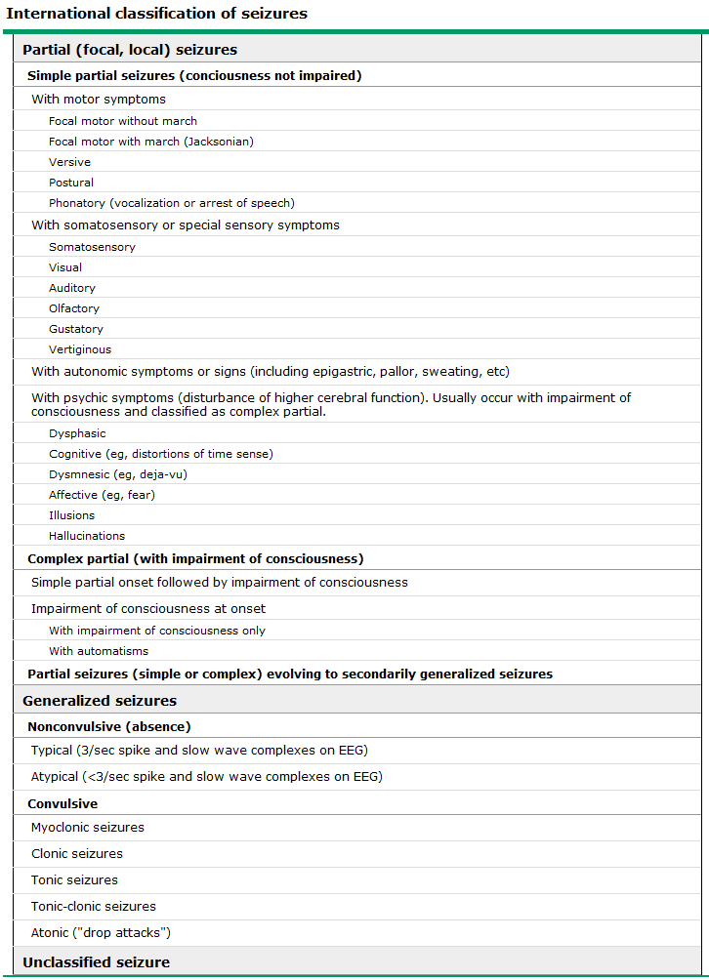

(b) Describe what is meant by the term non-epileptic (pseudo) seizure

- Psychogenic nonepileptic seizures (PNES) – paychogenic events that clinically mimic epileptic seizures, but without physiological CNS dysfunction.
- Frontal lobe seizures can have atypical clinical features and a normal ictal EEG and can be confused with PNES. Features suggestive of frontal lobe seizures
  - short duration
  - stereotyped features
  - occurrence during physiologic sleep.
- Dx:
  - Video-EEG monitoring: events are examined in conjunction with EEG activity.
    - Most patients with PNES will have an event within a few days of monitoring.
    - The use of techniques to induce events is somewhat controversial
  - Other tests are not diagnostic but can aid in evaluation
    - interictal EEG
    - neuroimaging
    - neuropsychological testing
    - laboratory studies
- Prognosis:
  - Many patients will continue to have seizure-like events
  - May have substantial psychiatric morbidity and functional limitations on follow-up.
- Consider other non-epileptic paroxysmal disorders:
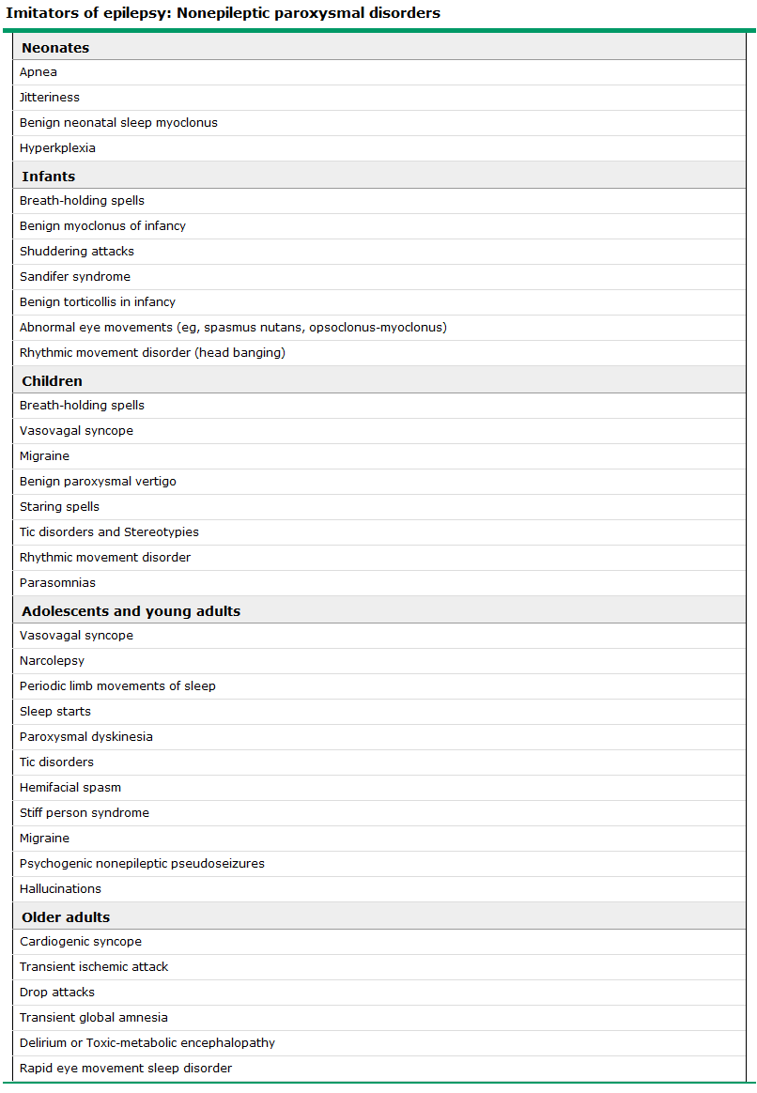
(c) List the common causes of seizures as related to age group

Neonates  (<1 month) | Perinatal hypoxia and ischemia  Intracranial hemorrhage and trauma  Acute CNS infection  Metabolic disturbances (hypoglycemia, hypocalcemia, hypomagnesemia,pyridoxine deficiency)  Drug withdrawal  Developmental disorders  Genetic disorders
Infants and children  (1 month –  12 yrs) | Febrile seizures  Genetic disorders (metabolic, degenerative, primary epilepsy syndromes)  CNS infection  Developmental disorders  Trauma  Idiopathic
Adolescents  (12–18 yrs) | Trauma  Genetic disorders  Infection  Brain tumor  Illicit drug use  Idiopathic
Young adults  (18–35 yrs) | Trauma  Alcohol withdrawal  Illicit drug use  Brain tumor  Idiopathic
Older adults  (>35 yrs) | Cerebrovascular disease  Brain tumor  Alcohol withdrawal  Metabolic disorders (uremia, hepatic failure, electrolyte abnormalities, hypoglycemia)  Alzheimer's disease and other degenerative CNS diseases  Idiopathic

(d) Describe Todd’s post-ictal phenomenon

- Postictal paresis (Todd's paralysis) – a transient neurologic deficit that lasts for hours (rarely days) after an epileptic seizure.
  - Deficit: weakness of a limb following a focal motor seizure activity involving one limb or side of the body.
  - Degree of weakness: usually moderate (occasionally severe).
  - Cause: unknown; may involve prolonged neuronal hyperpolarization due to activation of metabolic pumps or transient inactivation caused by NMDA receptor activation and excessive calcium influx.

(e) Describe the routine evaluation and management of a patient with new-onset seizures

- Evaluate and manage ABCs
- Hospitalization

  - Prolonged postictal state
  - Incomplete recovery
  - Status epilepticus
  - Systemic illness requiring treatment
  - Hx head trauma
  - Compliance issues

- Medical evaluation
  - Was the event was a seizure?
    - Nonepileptic events e.g. syncope, ψ disorders and TIAs can be mistaken for epilepsy.
    - Detailed description from witness
      - Lead up
      - Ictal behaviour
      - Postictal state
  - If so, correctable cause?
    - Acute symptomatic seizures: seizures that occur in the setting of acute medical (eg, hypoglycemia, hyponatremia) or neurologic illness or injury (eg, stroke, traumatic brain injury, meningitis, anoxic encephalopathy) → not necessarily ‘epilepsy’.
    - Diagnostic studies:

      - EUC
      - Glucose
      - CMP
      - FBC
      - LFT
      - Tox screen
      - EEG
      - Neuroimaging
      - LP

  - What is the risk of further seizures (epilepsy)?
    - If the event is believed to be unprovoked (ie, not an acute symptomatic seizure), epileptic seizure, then driving may need to be restricted.

(f) List the commonly used anticonvulsants and their indications and side effects

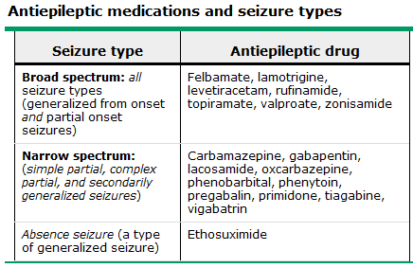
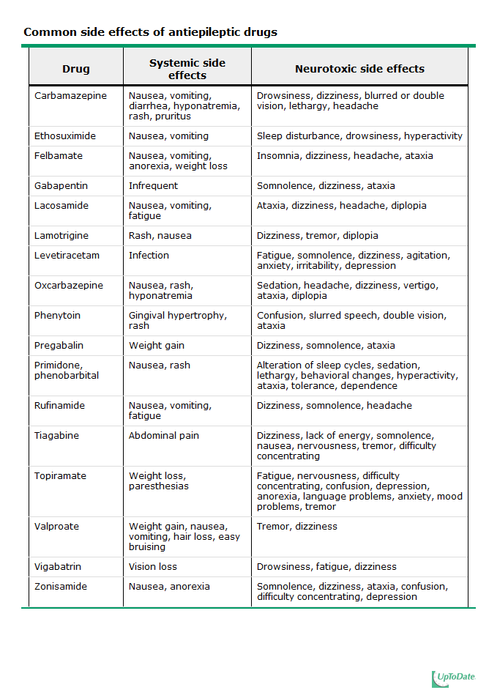

(g) Understand the impact of seizure disorders on lifestyle
- Psychosocial Issues
  - Cultural stigma (slowly declining in societies with effective health education).
  - Patients harbor fears, e.g. fear of becoming mentally retarded or dying during a seizure.
  - Addressed by patient, family, teacher and colleague education.
- Employment, Driving, and Other Activities
  - Difficulty obtaining or maintaining employment, even when seizures are well controlled.
    - Federal and state legislation is designed to prevent discrimination.
    - Patients should be encouraged to understand and claim their legal rights.
    - Benefical when health providers act as strong patient advocates.
  - Loss of driving privileges: one of the most disruptive social consequences.
    - Considerable variability among states and countries.
    - Physician's responsibility to warn patients of the danger to themselves and others if driving with poor seizure control.
    - Most states allow patients to drive after a seizure-free interval (on or off medications) of between 3 months and 2 years.
- Incompletely controlled seizures may lead to risk of being in situations where an impairment of consciousness or loss of motor control could lead to major injury or death, e.g. heights, use of machinery, bathing and swimming.

(h) Define status epilepticus and outline the initial evaluation and management of a patient in status epilepticus

- Status epilepticus – the occurrence of a single unremitting seizure with a duration longer than 5 to 10 minutes, or frequent clinical seizures without an interictal return to the baseline clinical state.
- Aetiology (common):
  - Noncompliance
  - Drug or alcohol withdrawal syndromes
  - Acute brain injury or infection
  - Metabolic disturbances
- Diagnosis
  - Careful neurologic examination
  - EEG – especially important in situations where high risk of nonconvulsive status epilepticus or diagnostic uncertainty.
- Tretment:
  - Proceeds simultaneously with evaluation
  - Hemodynamic and respiratory monitoring to avoid side effects of therapy.
  - Pharmacological:
1) Lorazepam 0.02 to 0.03 mg/kg IV
      - Repeated as needed up to 0.1 mg/kg.
2) Loading dose of phenytoin or fosphenytoin
      - Maintain anti-seizure effect.
- Prognosis:
  - Depends most strongly on the aetiology; some evidence that status is independently associated with mortality and neurologic sequelae.
- See table below for details:

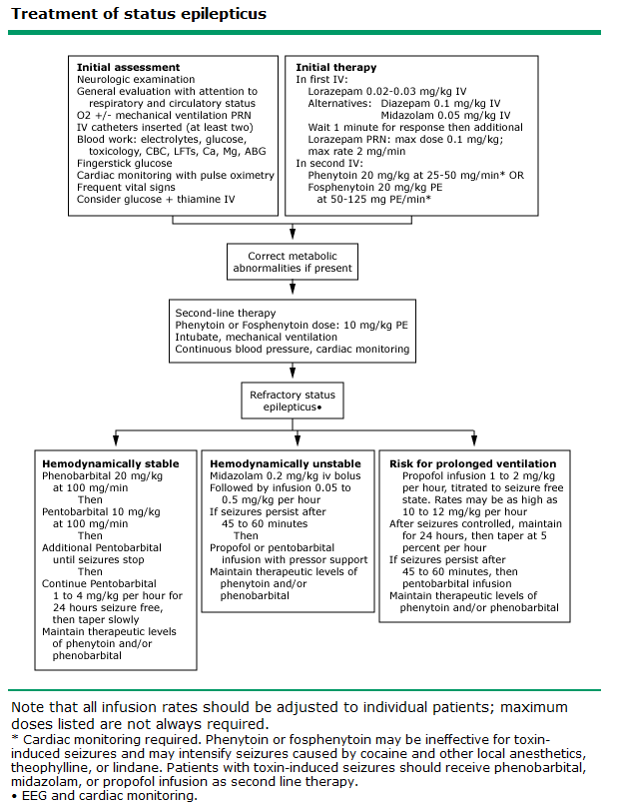

3. Define the term ‘syncope’ and list the common causes and the clinical features that help to distinguish syncope from seizure and disorders of motor function

- Syncope – the abrupt and transient loss of consciousness associated with absence of postural tone, followed by complete and usually rapid spontaneous recovery.
- Distinguishing syncope from seizures:
  - Seizures cause ~10% of apparent syncopal episodes
    - Mimic syncope when the seizure is
      - atypical and not associated with tonic-clonic movements
      - seizure is not observed
      - complete history cannot be obtained
  - Syncope may be mistaken for seizures when syncope present with myoclonic or other involuntary movements which are actually due to cerebral hypoxia.
  - Distinguishing feature:
    - Syncope: rapid and complete recovery
    - Seizure: slow and complete recovery

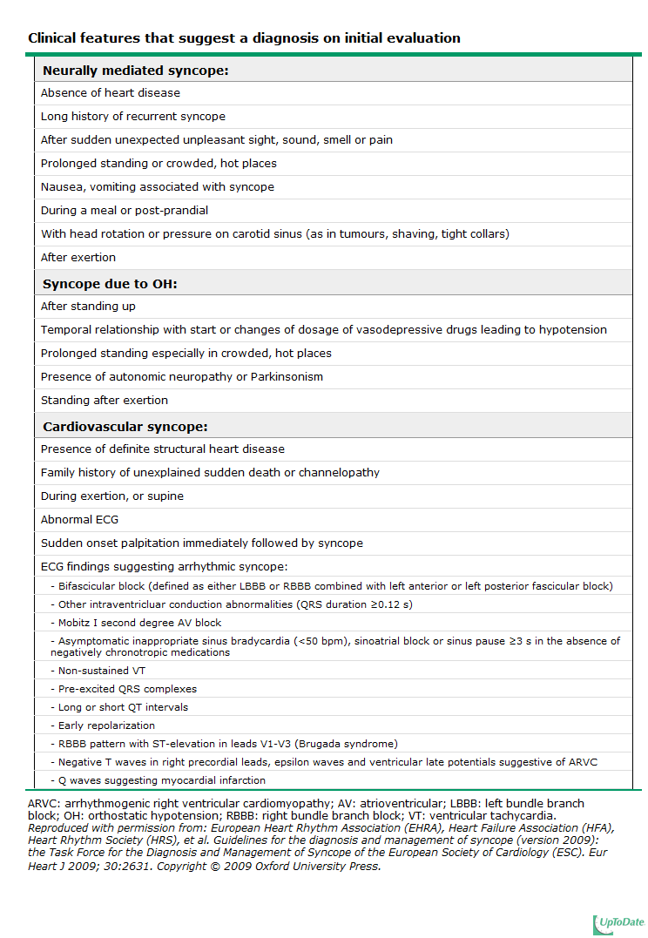

9. Disorders of motor function

1. Differentiate between upper (UMN) and lower (LMN) motor neurone disorders by assessing muscle bulk, muscle strength, the pattern of weakness and reflex changes.
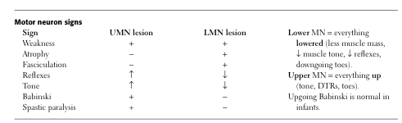
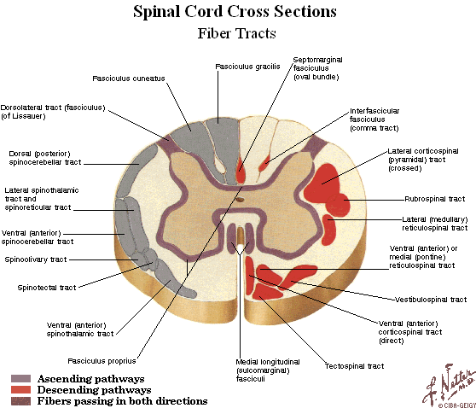

(a) Contrast the common UMN clinical syndromes of hemiparesis, paraparesis, and quadriparesis by symptom distribution and discuss the pathophysiology.

- Hemiparesis – hemisection of the cord on same side of the lesion below pyramidal tract decussation (in the medulla) or on the contralateral side above the pyramidal decussation, leading to unilateral motor loss.
- Paraparesis: thoracolumbar spinal pathology causing bilateral lower limb motor loss.
- Quadriparesis (AKA tetraparesis): C-spine involved, causing motor loss in all four limbs.

i. differentiate deep tendon, superficial, and polysynaptic reflexes and how they differ in acute versus established lesions
- Deep tendon (stretch) reflexes
  - When a skeletal muscle with an intact nerve supply is stretched, reflexive contraction occurs.
  - Spinal; monosynaptic reflexes
  - Stimulus (stretch of the muscle) → sensed by muscle spindle → conduction by fast sensory fibers → directly synapse (glutaminergic) with motor neurons for the same muscle → muscle contraction
  - Examples:
    - Ankle jerk (S1-2)
    - Knee jerk (L3-4)
    - Biceps jerk (C5-6)
    - Brachioradialis jerk (C6)
    - Triceps jerk (C6-7)
- Superficial reflexes
  - Motor responses to scraping of the skin
  - They are graded simply as present or absent (though marked asymmetry abnormal)
  - Must ascend the cord to reach the brain; polysynaptic reflexes.
  - Abolished with destruction of
    - Sensory pathway from the skin
    - Communication between spinal cord and brain (main utility)
      - Ascending pathways
      - Descending pathways
    - LMN
  - Examples:
    - Abdominal reflex
      - Stimulus: scraping the skin tangential to or toward the umbilicus.
      - Response: contraction of abdominal muscles in the quadrant that is stimulated, seen as a movement of the umbilicus towards the stimulus.
→ Not reliably present when obese, abdominal scars, or multiparous, and poorly elicited in elderly
    - Cremaster reflex
      - Stimulus: scratch the skin of the medial thigh (afferent: ilioinguinal n.).
      - Response: brisk elevation of the testis on that side (efferent: genital branch of genitofemoral n.).
→ Afferent branch often damaged in inguinal surgery
    - Plantar response
      - Stimulus: scratching the sole of the foot in an arc from the heel along the lateral aspect, across the ball of the foot to the base of the great toe.
      - Response: flexion of the great toe ("down-going toe") .
→ Upgoing toe normal <1yo, if present after suggests UMN lesion
    - "anal wink"
      - Stimulus: scratching the skin near the anal opening.
      - Response: contraction of the external anal sphincter.
→ Often abolished in spinal cord damage
- Lesion effects
  - Muscle
    - Stretch: depressed proportional to loss of strength.
  - Neuromuscular junction
    - Stretch: depressed proportional to loss of strength.
  - Peripheral Nerve
    - Stretch: depressed usually out of proportion to weakness (which may be minimal) because the afferent arc is involved early in neuropathy.
  - Nerve root
    - Stretch: depressed in proportion to the contribution of that root.
    - Superficial: rarely depressed exept when widespread damage (dermatome or myotome), as extensive overlap in the distribution of individual nerve roots of the skin and muscle tested in the superficial reflexes.
  - Spinal cord and brain stem
    - Stretch: hypoactive at the level of the lesion; hyperactive below.
      - During the initial state of spinal shock: spinal reflexes below the lesion are also hypoactive or absent.
    - Superficial: hypoactive at and below the level of the lesion and normal above.
      - Do not place great emphasis on isolated depressed abdominal reflexes
      - An upgoing plantar response is abnormal (UMN lesion)
  - Cerebellum
    - Stretch: clasically hypoactive and pendular. When detected this is a reliable sign, though often no visible abnormality
  - Basal ganglia
    - No consistent deep-tendon or superficial reflex changes.
    - "primitive reflexes" may appear (e.g., the glabellar, oculocephalic, grasp, and feeding reflexes) associated with some diffuse cerebral dysfunction (dementia).
  - Cerebral cortex
    - Unilateral motor cortex (UMN pattern)
      - Stretch: hyperactive on contralateral side
      - Superficial: depressed or absent on the contralateral side, ± Babinski response.
    - Bilateral motor cortex
      - As above but bilateral ± "primitive reflexes" due to release of cortical inhibition
      - Emotional expression reflexes: inhibitory control of these complex reflexes (usually modulated by the neocortex) becomes defective, particularly when the corticobulbar system is heavily affected. Bilateral damage may release these responses in a pattern that is termed "pseudobulbar": individuals cry or laugh with minimal emotional provocation, and often do not understand why they are crying or laughing.

ii. define spasticity and rigidity

- Spasticity – n. resistance to the passive movement of a limb that is maximal at the beginning of the movement and gives way as more pressure is applied. Also known as clasp-knife rigidity, it is a symptom of damage to the pyramidal system in the brain or spinal cord. It is usually accompanied by weakness in the affected limb (spastic paralysis).
- Rigidity – n. resistance to the passive movement of a limb that persists throughout its range. It is a symptom of parkinsonism. The smooth resistance through the whole range of movement is also known as lead-pipe rigidity; with superimposed tremor, as in parkinsonism, it is called cogwheel rigidity.

(b) Differentiate between LMN facial weakness (eg. Bell’s palsy) and UMN facial weakness (eg. post cerebral stroke)
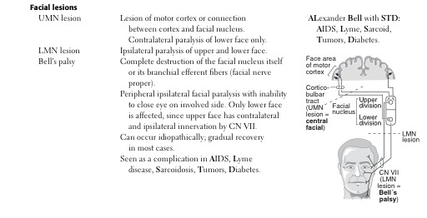

(c) Describe the diagnostic features of Motor Neurone Disease and understand the significance of mixed upper and lower motor neurone signs

- The diagnosis of amyotrophic lateral sclerosis (ALS) is made based on Hx and PE supported by electrodiagnostic studies, and not excluded by neuroimaging and labs.
- Diagnostic criteria:
  - Presence of upper and lower motor neuron signs
    - May impair limb, bulbar, axial and respiratory function
  - Progression of disease
  - Absence of an alternative explanation, ∴ consider and exclude:

    - multifocal motor neuropathy
    - cervical radiculomyelopathy
    - benign fasciculations
    - inflammatory myopathy
    - post-polio syndrome
    - monomelic amyotrophy
    - myasthenia gravis

  - Cognitive change (frontotemporal dysfunction) – presenting symptom in a small subset
- Electrodiagnostic testing with nerve conduction studies and electromyography in all patients with suspected ALS.
  - Nerve conduction studies
    - Usually normal in ALS, though severly atrophic and denervated muscle may show reduced compound motor action potential amplitudes
  - Electromyography
    - In ALS, typically reveals combined features of acute and chronic denervation.
- Neuroimaging (MRI)
  - Usually normal in ALS; ∴ used to exclude other possible diagnoses
  - Evaluation of all segments rostral to the UMN clinical findings
- Labs
  - Bloods
  - Urine
  - LP – if suspicion of demyelinating polyneuropathy, Lyme disease, HIV, lymphoma, or when rapidly progressive isolated lower motor neuron syndrome.
- Genetic testing is not routine, but can aid Dx in 4 genetic disorders that mimic ALS
  - Kennedy syndrome
  - Adult-onset Tay-Sachs disease
  - Hereditary spastic paraplegia
- Muscle biopsy is not routine – performed if suspicion of inflammatory myopathy.
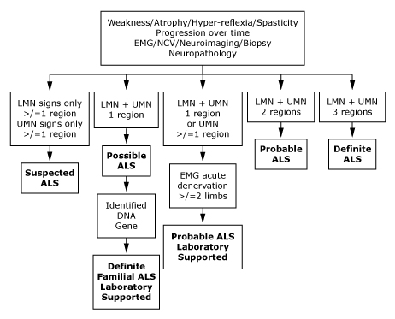

(d) Describe the clinical picture associated with myopathy and define the difference between inflammatory and structural myopathies.

- Common clinical findings of myopathy:
  - Proximal, symmetric limb weakness (arms or legs) with preserved reflexes and sensation.
→ Associated sensory loss suggests injury to peripheral nerve or the central nervous system (CNS) rather than myopathy.
- Inflammatory myopathies:
  - Includes: polymyositis, dermatomyositis, and inclusion body myositis.
  - Clinical: weakness and soreness of muscles
  - Labs: elevated CK and erythrocyte sedimentation rate.
  - Pathology: myonecrosis and mononuclear inflammatory infiltrates
- Structural myopathies.
  - Includes: muscular dystrophies
  - Clinical: inexorably progressive weakness; pattern, tempo and evolution varies.
  - Labs: elevated CK in many; genetic testing (>30 genes currently known)
  - Pathology: degeneration and loss of myofibers

2. For disorders of cerebellar function, discuss the clinical findings and pathophysiology of lesions producing midline versus hemispheric cerebellar damage

- Midline cerebellar syndromes
  - Clinical findings
    - Imbalance & unsteadiness
      - Unable to stand in Romberg with eyes open or closed
      - Tandem gait difficulty
    - Eye movements
      - Nystagmus
      - Ocular dysmetria
      - Poor pursuit
    - Severe
      - "trunkal ataxia" – unable to sit without steadying themselves
      - "titubation" – bobbing motion of the head or trunk
  - Pathophysiology
    - Includes Et-OH, stroke, infiltrative tumour and MS.
- Hemispheric cerebellar syndromes
  - Clinical findings
    - Incoordination of the limbs
      - Decomposition of movement
      - Rebound.
      - Dysdiadochokinesis
      - Dysmetria
      - Intention tremors detected on finger-to-nose & heel-to-knee tests
      - Kinetic tremor
    - Reflexes: may be depressed initially
    - Speech: dysarthria, scanning, or irregular emphasis on syllables (British constitution, West Register Street, Royal Irish Constabulary)
  - Pathophysiology
    - Include stroke, tumour, and MS.

(a) Define ataxia and differentiate cerebellar from sensory ataxia

- Ataxia – n. the shaky movements and unsteady gait that result from the brain’s failure to regulate the body’s posture and the strength and direction of limb movements.
- Cerebellar ataxia – clumsiness of willed movements; difficulty walking with associated speech difficulty ± nystagmus.
  - Common causes:
Et-OH Paraneoplastic syndromes MS
Drugs (e.g. phenytoin) Hereditary degenerative conditions Friedreich’s ataxia
→ Bilateral, symmetric and progressive symptoms: suggests a biochemical, metabolic, immune, or toxic etiology.
→ Unilateral, focal symptoms with headache with ↓LOC and contralateral CN palsies: space occupying lesion
NB Rarely, weakness of proximal leg muscles mimics cerebellar disease (but absence of other cerebellar signs)
- Sensory ataxia – unsteady movements caused by disease of the sensory nerves (proprioceptive or vestibular/labyrinthine); unsteadiness is exaggerated when the patient closes his eyes (Romberg’s sign).
  - Vestibular nerve or labyrinthine disease results in a disorder of gait associated with significant dizziness, light-headedness, or the perception of movement (not present in cerebellar ataxia)

(b) Define dysmetria

- Dysmetria – n. impaired coordination due to disorders of the cerebellum or its connections within the brainstem. In the finger–nose test, the patient’s finger over- or undershoots or passes the target because of failure to control the movement accurately. Movement is typified by the undershoot or overshoot of intended position with the hand, arm, leg, or eye; e.g. saccadic dysmetria in cerebellar disease

(c) Define titubation

- Titubation - n. a rhythmical nodding movement of the head, sometimes involving the trunk. It is seen in patients with parkinsonism and cerebellar disorders. Occasionally the use of this term is extended to include a stumbling gait (i.e. difficulty maintaining truncal position)

(d) Describe a wide-based gait and discuss its anatomic localisation

- Wide based gait: present in cerebellar ataxia as well as frontal gait disorder.
Features of Cerebellar Ataxia, Sensory Ataxia, and Frontal Gait Disorders

 | Cerebellar Ataxia | Sensory Ataxia | Frontal Gait
Base of support | Wide-based | Narrow base, looks down | Wide-based
Velocity | Variable | Slow | Very slow
Stride | Irregular, lurching | Regular with path deviation | Short, shuffling
Romberg | +/– | Unsteady, falls | +/–
Heel-shin | Abnormal | +/– | Normal
Initiation | Normal | Normal | Hesitant
Turns | Unsteady | +/– | Hesitant, multistep
Postural instability | + | +++ | ++++; Poor postural synergy rising from chair
Falls | Late event | Frequent | Frequent

- Cerebellar gait ataxia (extra detail):
  - Features
    - Unsteadiness when turning (early feature)
    - Wide base of support
    - Lateral instability of the trunk (sway with narrow base/tandem)
    - Erratic foot placement
    - Decompensation of balance with tandem gait
    - Variable tendency to fall
  - Causes (in older population):

    - Stroke
    - Trauma
    - Tumor
    - Neurodegenerative disease

  - Investigations
    - MRI demonstrates the extent and topography of cerebellar atrophy.
      - Et-OHic cerebellar degeneration can be confirmed by MRI.
    - Fragile X pre-mutation has been associated with gait ataxia in older men.

3. For movement disorders, define and differentiate the following:
(a) Resting versus action tremor

- Resting tremor – n. a form of tremor characterized by fine, quick quavering movements that tend to disappear during purposeful movements, this type of tremor being characteristic of parkinsonism (the most common cause of resting tremor). Also called passive tremor.
  - Evident with the affected body part supported and completely at rest
  - Temporarily dampens or disappears during voluntary activity
    - Less disabling than many other tremors, but reappears with new resting posture ∴may still interfere with use of cutlery, handwriting etc.
    - Usually increase with walking
  - Usually fluctuate in amplitude
- Intention tremor – n. a form of tremor characterized by fine rhythmic movements that tend to increase during voluntary movements, as in some cases of alcohol dependence, cerebellar syndrome, and senile dementia. Also called movement tremor.
  - Elicited with the arms suspended against gravity in a fixed posture or and during the course of goal-directed activity (e.g. finger-nose test).

(b) Athetosis and chorea

- Chorea – n. a jerky involuntary movement particularly affecting the head, face, or limbs. Each movement is sudden but the resulting posture may be prolonged for a few seconds; brief, quasi-purposeful, irregular contractions that are not repetitive or rhythmic, but appear to flow from one muscle to the next.
  - Usually due to basal ganglia disease, but but may result from drug therapy for parkinsonism or phenothiazines.
  - Characteristic of Huntington’s (and associated with progressive dementia).
- Athetosis – n. an involuntary writhing movement especially affecting the hands, face, and tongue.
  - Usually a form of cerebral palsy, impairing the child’s ability to speak or use his hands; intelligence is often unaffected.
  - Other causes:
    - Drugs (for parkinsonism or the phenothiazines)
    - Lesions of the corpus striatum

(c) Asterixis (otherwise known as negative myoclonus)

- Asterixis – jerky, irregular flexion-extension movement at the wrist and MCP joints, often accompanied by lateral movements of the fingers. Bilateral but asynchronous side-to-side, and usually absent at rest. Rhythmical lapses of postural muscle tone brought on by sustained posture, sometimes involving the arms, neck, tongue, jaw and eyelids (can be demonstrated on sustained forceful eye closure or tongue protrusion).
- Causes:
  - Liver failure – characteristic and early sign. Due to encephalopathy (interference with the inflow of joint position sense information to the reticular formation)
  - Respiratory failure – with severe CO₂ retention (usu. due to COPD) – late and unreliable sign.
  - Other causes:
Cardiac failure Hypomagnesaemia
Renal failure Hypokalaemia
Barbiturate intoxication Hypoglycaemia

(d) Myoclonus

- Myoclonus – a brief, rapid (<100 ms), shocklike, jerky movement consisting of single or repetitive muscle discharges. Myoclonic jerks differ from tics in that they interfere with normal movement and are not suppressible.
  - Can be focal, multifocal, segmental, or generalized
  - Can occur spontaneously, in association with voluntary movement (action myoclonus), or in response to an external stimulus (reflex or startle myoclonus).
- Negative myoclonus consists of a twitch due to a brief loss of muscle activity (e.g., asterixis in hepatic failure).
- Pathology
  - Anatomy: cortical, subcortical or spinal
  - Aetiology:
    - Innocent - commonly observed in normal people when waking or falling asleep
    - Essential (benign familial) – multifocal lightning-like movements
    - Hypoxic damage (esp. post cardiac arrest)
    - Encephalopathy
    - Neurodegenerative disorders
    - Metabolic disturbances (reversible)
      - e.g. renal failure, hypocalcaemia, Δelectrolytes
    - Toxins
    - Medications (many)

(e) Tics

- Tics – repeated, sudden, brief, individually recognizable, intermittent movements or movement fragments that are almost always briefly suppressible and are usually associated with awareness of an urge to perform the movement. These may be movements (motor tics) or utterances (vocal or phonic tics).
  - Tics cease during sleep (dyskinetic movements and dystonias do not)
  - Can be voluntarily controlled for short periods, but difficult to sustain for longer periods
  - Transient
    - Common during childhood (up to 25% of normal children); most with simple motor tics do not require treatment.
  - Persistent motor and phonic tics
    - Features of Tourette syndrome.
    - Consider secondary causes (esp. where begin abruptly/persistent/problematic)
      - Stimulant medications (dopaminergic agonists)
      - (controversial) pediatric autoimmune neuropsychiatric disorder associated with group A streptococci (PANDAS)

(f) Rigidity

- Spasticity – position and velocity-dependent tone, classically resulting in a "clasp-knife phenomenon" when the limb is moved rapidly. The limb moves freely for a short distance, but then there is a "catch" and you must use progressively more force to move the limb until at a certain point there is a sudden release and you can move the limb freely again.
  - Due to increased tone being detected by muscle spindles, leading to reflexive inhibition of that muscle
  - Described as greatest in the flexors of the upper extremity and the extensors of the lower extremity
    - Actually a result of the relative strength of these muscle groups, the more affected being the stronger, anti-gravity muscles of the limb.
- Rigidity – in contrast to spasticity, is characterized by increased resistance throughout the movement. Rigidity is usually accentuated by distracting the patient.
  - Lead-pipe rigidity: resistance uniform throughout the movement.
  - Cogwheel rigidity: rhythmic interruption of resistance, producing a ratchet-like effect.

(g) Dystonia (including writers’ cramp and torticollis)

- Dystonia – a movement disorder characterized by involuntary, sustained muscle contractions that result in twisting and repetitive movements or abnormal postures.
  - Writer’s cramp – action-induced dystonic contraction of hand muscles; the most common task-specific dystonia. An idiopathic focal dystonia, likely to have a heritable component (¼ have a positive family Hx).
  - Torticollis (wryneck) – an irresistible turning movement of the head that becomes more persistent, so that eventually the head is held continually to one side; a form of dystonia, and the spasm of the muscles is often painful. It may be caused by a birth injury to the sternomastoid muscle.
- Classified anatomically:
  - Focal (involving a single body area)
  - Segmental (involving contiguous body areas)
  - Multifocal (involving two or more noncontiguous body areas)
  - Hemidystonia (involving one side of the body)
  - Generalized (involving at least one leg, the trunk, and another body area)
→ Focal dystonia ≅ 10 × generalized
- Clinical features
  - Vary according to anatomic location, age of onset, and etiology.
  - Early onset dystonia
    - Presents at <26yo
    - Usually begins in a leg, often as intorsion of the foot; spread from one leg to other body areas occurs in >50%, usually within 5 yrs.
  - Late onset primary focal dystonia
    - Presents at >26yo
    - Often begins in the neck, arm, or face and tends to remain focal or segmental.
  - Common and/or important types of focal dystonia include:
    - Cervical dystonia (torticollis)
    - Blepharospasm (eyelid enclosure)
    - Oromandibular dystonia and facial dystonia
    - Spasmodic dysphonia
    - Arm dystonia
    - Occupational or task-specific dystonia (e.g. writer's cramp)
    - Genetic causes (numerous)
- Aetiology (not required by curriculum)
  - Pathogenesis of most forms of primary dystonia is largely unknown (suspect cellular dysfunction as inconsistent neuropathologic features)
  - Dopa-responsive dystonia (DYT5): focal dystonia with onset in early childhood, usu. an autosomal dominant mutation in the GCH1 gene
  - Myoclonus-dystonia (DYT11, DYT15): alcohol-sensitive myoclonic jerks, primarily affecting the arms and axial muscles, combined with variable features of dystonia. Autosomal dominant.
  - Genetic forms of dystonia with parkinsonism include
    - X-linked dystonia-parkinsonism (DYT3)
    - Rapid onset dystonia-parkinsonism (DYT12)
    - Early onset dystonia-parkinsonism (DYT16).
  - Several rare genetic forms of dystonia are characterized by paroxysmal dyskinesia (DYT8, DYT9, DYT10).
- Management (not required by curriculum)
  - Focal or generalized dystonia of unknown etiology: trial of levodopa to confirm or exclude the diagnosis of dopa-responsive dystonia.
  - Early onset dystonia, or those with late onset who have an affected relative with early onset dystonia, we suggest TOR1A genetic testing for DYT1 dystonia.
→ Focal dystonias are difficult to treat as pharmacologic interventions have systemic effects, and botox injection often results in limitation of function (e.g. Writer’s cramp)

(h) Discuss the clinical findings, laboratory findings, and treatment of the following:

i. Parkinson’s Disease

- Clinical findings:
  - Cardinal features:
1) tremor
2) bradykinesia
3) rigidity
→ postural instability sometimes considered a cardinal feature, but occurs late.
  - Other abnormalities:
    - Craniofacial: masked facial expression, hypophonia
    - Visual: hypometric saccades, eyelid opening apraxia
    - Musculoskeletal: micrographia, stooped posture
    - Gait: shuffling, short-stepped gait, freezing
  - Neuropsychiatric/nonmotor manifestations
    - Cognitive dysfunction
    - Psychosis
    - Mood disorders (depression, anxiety, and apathy/abulia)
    - Sleep disturbances
    - Fatigue
    - Autonomic dysfunction
    - Pain and sensory (inc. olfactory) disturbances
    - Dermatologic (seborrhea)
  - DDx (not required by curriculum)
    - Primary Parkinson’s or secondary (neuroleptics or antiemetics)
    - The various parkinsonian diseases can usually be clinically differentiated from Parkinson’s disease within 3-4 years. Suggestive features:
      - Falls at presentation and early in disease
      - Poor response to levodopa
      - Symmetry at onset
      - Rapid progression
      - Lack of tremor
      - Dysautonomia
    - Look for ‘VODKA’ signs to look for alternatives to Parkinson’s disease
      - Vascular events → vascular causes of parkinsonism
      - Orthostatic hypotension and bladder atonia → multiple system atrophy
      - Dementia and vertical gaze paralysis → progressive supranuclear palsy
      - Kayser-Fleisher rings → Wilson’s disease
      - Apraxic gait → communicating hydrocephalus
- Laboratory findings
  - No specific diagnostic tests
  - Bloods: B12, Thyroid hormone, Testorsterone, Infections (VDRL, HIV)
  - Imaging
    - MRI may help rule out differentials (hydrocephalus, vascular or mass lesion)
    - PET may aid in Dx though does not differentiate from mimickers.
- Treatment
  - Symptomatic therapy: levodopa or a dopamine agonist (DA). Find the lowest effective dose (single or combination)
    - Dopaminergic agents:
→ Good for bradykinesia, tremor and rigidity
→ No effect on cognitive symptoms, ANS dysfunction or imbalance
      - Levodopa (combine with a peripheral decarboxylase inhibitor, ie, Sinemet, Madopar, or Prolopa)
        - The most effective symptomatic therapy for Parkinson disease
        - Associated with ↑risk of dyskinesia than the dopamine agonists.
        - Use in >65 yo
      - Dopamine agonists (use as mono or combination EXCEPT pergolide and cabergoline)
        - Ineffective in patients who show no response to levodopa.
        - Use in <65 yo (unless Sx severely affect lifestyle)
    - MAOB (-giline)
      - Selegiline: mild symptomatic benefit in early PD, insignificant in more advanced disease.
      - Rasagiline: newer, with RCT statistical benefit as monotherapy in PD, but questions whether a clinically meaningful benefit to patients.
    - Cholinergic and glutamatergic agents
      - Anticholinergic drugs: useful for tremor/dystonia younger patients; avoid in elderly or demented.
      - Amantadine: relatively weak mild glutaminergic antagonist with low toxicity. Most useful in early or mild PD (can reduce drug-induced dyskinesia in 70%). May ↑aggression and psychosis in older patients.
    - Other symptoms
      - Depression: SSRI/ECT
      - Psychosis: dopaminergic dose reduction and clozapine
  - Surgery: bilateral deep brain stimulation of the subthalamic nucleus
    - For intractable tremor and drug induced motor fluctuations/dyskinesias on a background of dopa responsive parkinsons with dementia/psychotic comorbidities.
    - ↓motor manifestations; same effects as medical Rx but without the fluctuations

ii. Essential tremor

- Clinical findings
  - Most common cause of postural or action tremor; ~5% prevalence (↑ with age)
  - Divided into
    - Familial tremor – FHx present (~50% have autosomal dominant pattern, though genetically heterogeneous), younger at onset
    - Benign essential tremor – sporadic form
  - Onset
    - Usually affects hands/arms, though can affect any part
    - Increased at the very end of goal-directed movements
      - Compare to ceerebellar outflow tremor - ↑steadily before arriving at the target
    - May have superimposed psychologic tremor due to anxiety or adrenergic activity.
    - Worsens with caffeine, improves with small amounts of Et-OH
    - By definition, no other neurological manifestations
      - May have mild: ↓cognition, ↓memory, and cerebellar signs
- Laboratory findings
  - Pathology seems to be in the locus ceruleus of the brainstem
- Management
  - Propranolol (β-blocker)
  - Primidone (barbiturate)
→ use either as monotherapy; use dual therapy of above if monotherapy suboptimal
  - Refractory: β-blockers (atenolol, sotalol) and anticonvulsants (gabapentin, topiramate)
  - Et-OH and alprazolam effective but avoided due to abuse potential.
  - Invasive
    - Botox A injections: modest benefit, but dose-dependent hand weakness.
    - Surgery (unilateral thalamotomy/thalamic deep brain stimulation of the thalamic ventral intermediate nucleus): for severe refractory contralateral limb tremor.

iii. Tardive dyskinesia

- Clinical findings
  - Involuntary dyskinetic or distonic movements; a variable mixture of orofacial dyskinesia, athetosis, dystonia, chorea, tics, and facial grimacing, involving the mouth, tongue, face, trunk, or extremities.
  - Insidious onset
  - Usually associated with ≥1 month of antipsychotic drugs (commonly after cessation, reduction in dose or switch to less potent drug)
  - Often reversible
  - DDx (not required by curriculum) = other extrapyramidal syndromes, including:
    - Wilson disease
    - Huntington disease
    - Akathisia
    - Acute dyskinesia
    - Stereotypies associated with chronic schizophrenia, autism, and retardation
    - Spontaneous orofacial dyskinesia
    - Meige syndrome
    - Blepharospasm
    - Oromandibular dystonia
- Laboratory findings
  - Drug level
- Management
  - Prevention: avoid treatment with antipsychotic drugs or metoclopramide.
    - Do not use Metoclopramide continuously for >12 wks.
  - Very mild: do not require treatment
  - Mild: low dose benzodiazepine e.g. clonazepam.
  - Significant:
1) immediate discontinuation of the offending medication if feasible.
2) where cannot discontinue antipsychotic, change to 2nd gen (clozapine)
→ must monitor FBC for agranulocytosis (2% risk), cardiomyopathy et.al
  - Severe, disabling and treatment resistant: suppress the tardive dyskinesia with resumption of 1st or 2nd gen antipsychotic
  - Special subtypes
    - Severe localized tardive dystonia (cervical dystonia, retrocollis or blepharospasm): botox injections
    - Tardive dystonia (severe and refractory): anticholinergics (e.g. trihexyphenidyl) – may worsen dyskinesia but may help tardive dystonia
  - Deep brain stimulation where refractory, permanent, severe and disabling.

iv. Huntington’s Disease (not core)

- Clinical findings
  - Huntington’s is a rare (50 per million) inherited (autosomal dominant) relentlessly progressive neurodegenerative disorder characterized by:
    - Chorea (parkinsonian, akinetic rigidity later)
    - Dystonia
    - Psychiatric problems:
anxiety depression irritability paranoia hallucinations
apathy dysphoria agitation delusions
    - Dementia.
  - Insidious onset of movement abnormalities and/or psychiatric and cognitive features.
  - Chorea is a key feature of HD, and the defining sign at the time of diagnosis. Psychiatric problems can include. The dementia of HD is characterized by executive dysfunction.
- Laboratory findings
  - Genetic testing
    - CAG trinucleotide repeat in the HTT gene (also known as the HD or IT15 gene) encoding hungtintin. Repeat expands with successive generations
      - 35-39 repeats = variable penetrance; ≥40 = full penetrance
      - More repeats → earlier onset
  - Imaging: axial MRI shows prominent caudate atrophy (late stage)
  - Pathology: aggregation of mutant hungtintin primarily in the striatum (but pathophysiology of neuronal loss unclear)
    - diffuse, marked atrophy of the neostriatum that may be worse in the caudate than in the putamen.
- Management
  - Treatment: symptom management and optimize quality of life. ∴multidisciplinary team
  - End-of-life issues should be discussed before cognitive and motor impairment become severe, and before the patient loses the ability to communicate.
  - Assess the impact of chorea:
    - Non-debilitating – no management
    - Debilitating: pharmacologic treatment (may worsen other aspects of disease, including parkinsonism, cognition, and mood).
      - Tetrabenazine – depletes levels of dopamine in the CNS; indicated in choreiform movement disorders, hemiballismus, some dystonic syndromes and tardive dyskinesia.
      - Refractive, agitation, and/or psychosis – use atypical neuroleptics e.g. risperidone (clozapine gives no added benefit but significant ↑risk), then typicals e.g. haloperidol.
      - Psychosis/behavioural symptoms without severe chorea – quetiapine.
    - With severe chorea, padded reclining chairs and beds to ↓injury risk.
  - Depression: TCAs or SSRIs
  - Dementia: no effective therapy.

v. Wilson’s disease (not core)

- Clinical findings
  - Rare (1:30,000) autosomal recessive defect in cellular copper transport from the liver into the bile, leading to copper excess.
    - Mutations in the ATP7B gene, a membrane-bound copper-transporting ATPase.
  - Clinical manifestations: caused by Cu toxicity, primarily to the liver and brain. Presentation varies with age, with age of onset varying from 6 to 30.
    - Hepatic – usually presents in mid to late teens as as either
      - Hepatitis – ↑transaminases, ±jaundice, with spontaneous regression; often recurs and most eventually develop cirrhosis.
      - Cirrhosis
      - Hepatic decompensation – ↑bililrubin, ↓albumin, ↓coagulation factors, ascides, peripheral oedema and encephalopathy. In severe disease, hepatocellular necrosis leads to Cu release into the bloodstream and results in haemolytic anaemia.
        - Haemolysis + Liver disease → likely Wilson’s
    - Neurologic – typically occur in early 20s, though may be in 50s.
      - Movement disorders:
        - Isually dystonia, incoordination, and tremor
          - eventually leads to grotesque positions of the limbs, neck, and trunk
        - Dysarthria and dysphagia are also common
        - May resemble Parkinsonian disease
      - Autonomic disturbances – orthostatic hypotension, abnormal sweating, bowel, bladder, and sexual dysfunction.
      - Other – memory loss, migraine-type headaches, and seizures may occur.
      - MRI/CT – damage in the basal ganglia and occasionally in the pons, medulla, thalamus, cerebellum, and subcortical areas
NOT sensory abnormalities or muscular weakness
    - Psychiatric – diverse behavioral disturbances often precede diagnosis by 5 yrs (in 50%)
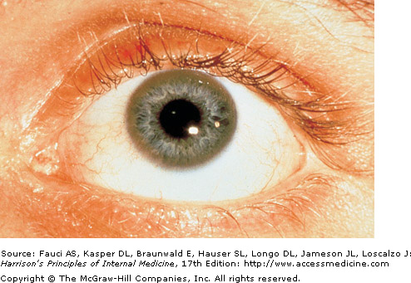
    - Other
Kayser-Fleischer ring - brownish-yellow ring in the outer rim of the cornea of the eye; here clearly visible to the naked eye, but usually confirmed by slit-lamp exam.
      - ♀: spontaneous abortions, most amenorrheic prior to diagnosis.
      - ↑risk cholelithiasis and nephrolithiasis.
      - Knee OA
      - Urine: microscopic hematuria (common), ↑excretion of phosphates, amino acids, glucose, or urates may occur.
      - Sunflower cataracts and Kayser-Fleischer rings
- Laboratory findings:
  - Investigations: LFTs
FBC
Serum ceruloplasmin (>85% have <200 mg/L)
Slit lamp (Kayser-Fleischer rings)
24h basal urinary copper (>40μg or >600nmol)
→ Kayser-Fleischer + <200 mg/L serum ceruloplasmin = Wilson’s
→ If nonspecific Sx, <50 mg/L = highly suspicious for Wilson’s
→ Confirm with biopsy if
Abnormal LFTs with ↑urinary copper
Kayser-fleischer rings with normal ceruloplasmin
  - Liver biopsy:
    - Copper stains (consistent histology) and copper quantitation (Cu >250 mcg/g dry weight)
  - Genetic testing
    - May confirm Dx, but a specific mutation not identified in all patients.
- Management:
  - Lifelong therapy, otherwise develop fulminant hepatic failure.
  - Treatment in two phases:
    - removing accumulated tissue copper
    - prevent reaccumulation.
  - Rx: chelating agent (penicillamine or trientine), or with zinc.
  - Severity
    - Aymptomatic – Cu balance monitored regularly (24 h urine and by estimating nonceruloplasmin bound copper)
    - Symptomatic – treat until stable
    - Fulminant hepatic failure – transplantation, with plasmapheresis, exchange transfusion, haemofiltration or dialysis in the interim. Recovery with supportive therapy has been described.
    - First-degree relatives: screen with Hx, exam, LFTs, FBC, ceruloplasmin

10. Multiple Sclerosis

1. Describe the epidemiological and genetic characteristics of multiple sclerosis.
(a) female:male prevalence ratio
(b) latitudinal gradient
(c) monozygotic twin concordance rate of approximately 30%
(d) major known susceptibility allele HLA (Chromosome 6)

- Multiple sclerosis (MS) is a heterogeneous disorder of unknown cause, with variable clinical and pathologic features reflecting different pathways to tissue injury, with inflammation, demyelination, and axon degeneration as the major pathologic mechanisms.
  - Hypothesis that MS begins as a inflammatory autoimmune disorder mediated by autoreactive lymphocytes, which develops to be dominated by microglial activation and chronic neurodegeneration.
- Gender differences: incidence ♀:♂ = 2:1; mean age of onset ♀:23.5 ♂30
- Geographic differences
  - Prevalence increases at higher latitudes (i.e. ↑prevalence as approach the poles)
  - Person carries risk of the area in which they spent their youth, with lower protective effect of migration after 15 years old.
- Genetic components:
  - 1st degree relative = 15× risk
  - Monozygotic twin concordance ~30% (=150× risk)
  - ↑susceptibility linked to HLA-DR2 (Chr 6)
- Note: no association between vaccines and MS

2. Discuss the clinical features of MS.

- Presents as a young adult with ≥2 clinically distinct episodes of CNS dysfunction with at least partial resolution.
- No clinical findings are unique to MS, but some are highly characteristic
- Presentation is often polysymptomatic, often including:

  - Sensory symptoms in limbs or face
  - Acute or subacute motor weakness
  - Disturbance of gait and balance
  - Limb ataxia
  - Vertigo
  - Visual loss
  - Diplopia
  - Acute transverse myelopathy
  - Bladder problems
  - Pain
  - Lhermitte's sign*

*Lhermitte's sign – electric shock-like sensations that run down the back/limbs upon flexion of the neck
- Commonly characterized by relapse – acute or subacute onset of clinical dysfunction that usually reaches its peak from days-wks, followed by a variable degree of remission

3. Describe the typical MRI, CSF and evoked potential findings in MS.

- MRI
  - Characteristic lesion: cerebral or spinal plaque (discrete region of demyelination with relative preservation of axons). Usually multiple, asymmetric ovoid lesions. Loss of myelin (fat), ∴hypointense on T1, hyperintense on prototon and T2, and, when active, enhance with gadolinium.
    - periventricular region (Dawson’s fingers)
    - corpus callosum (at right angles as if radiating from CC)
    - centrum semiovale
    - (less common) deep white matter structures and basal ganglia.
  - Conventional T2 may underestimate plaque size and thus burden,
  - Diffusion tensor imaging and MR spectroscopy frequently reveal that normal appearing white matter is actually involved.
- CSF
  - Appearance and pressure is normal
  - Oligoclonal bands on isoelectric focusing (most important diagnostic CSF study)
  - Mononuclear pleocytosis (> 5×10⁶cells/L)
  - ↑ IgG index (common finding in CF – intrathecal synthesis)
  - Leukocyte count is normal in 2/3, though sometimes mildly elevated
    - >50 cells/µL should raise suspicion of another etiology
    - Lymphocytes predominate (mostly T cells)
  - Protein (or albumin) is usually normal, though albumin may ↑ with disruption of the blood-CSF barrier.
- Evoked potentials
  - Evoked potentials are the CNS electrical events generated by peripheral stimulation of a sensory organ.
    - Used to detect abnormal CNS function that may be clinically undetectable.
    - Define the anatomy of lesions in tracts not easily visualized on imaging (eg, optic nerves, dorsal columns).
  - The three most frequently used EPs are somatosensory (SSEP), visual (VER), and brainstem auditory evoked potentials (BAEP).
- Histology (not required by curriculum)
  - Active plaques reveals perivascular infiltration of lymphocytes (predominantly T cells) and macrophages with occasional plasma cells.
  - Perivascular and interstitial edema may be prominent.

4. Describe the natural history of MS and treatments of proven benefit

- Natural Hx:
85-90% Relapsing-remitting: clearly defined relapses with full recovery or with sequelae and residual deficit upon recovery. There is no disease progression during the periods between disease relapses. This type of MS accounts for approximately 85 to 90 percent of MS cases at onset. However, most patients with RRMS will eventually enter a secondary progressive phase.
→ Secondary progressive: initial relapsing-remitting followed by progression ± occasional relapses, minor remissions, and plateaus; may be the end-point for most initially with the relapsing-remitting pattern.
~10% Primary progressive: disease progression from onset ± occasional plateaus and temporary minor improvements, with a steady decline in function from the beginning and never have acute attacks.
<5% Progressive relapsing: progressive disease from onset, with clear acute relapses, ± full recovery. Progression continues during the periods between relapses.
  - Severity
    - Benign: patient remains fully functional in all neurologic systems 15 yrs post onset.
    - Malignant: rapid progressive course, leading to significant disability in multiple neurologic systems or death in a relatively short time post onset.
  - Progression of disability is highly variable, but is slow in most patients with MS, and the relapsing form of MS is generally associated with a better prognosis than progressive disease.
- Management
  - Acute
    - Acute exacerbation with acute neuro symptoms with disability or impairments in vision, strength, or cerebellar function.
      - Rule out infection
      - High dose glucocorticoids (e.g. IV methylprednisolone 1000mg/d for 5d)
      - Plasma exchange if poor response
    - Patients with relapsing-remitting MS who have current disease activity manifested by clinical symptoms or MRI lesions should be offered treatment with disease-modifying therapy, such as an interferon or glatiramer acetate.
  - Long-term
    - Disease modifying therapy of relapsing-remitting
      - Interferon-β drugs (Avonex, Rebif, Betaseron)
      - Glatiramer acetate (20 mg/d subcut)
      - Fingolimod (0.5 mg/d oral)
      - Natalizumab (monotherapy)
      - Mitozantrone (for rapidly advancing refractory to other Rx)
No consensus guidelines; reasonable to start newly diagnosed patients with relapsing-remitting on any of the above, but best to work down from top of list.
    - If a poor response to both beta interferons and glatiramer acetate, or intolerance of these immunomodulators, either:
      - add IV methylprednisolone intravenous monthly bolus
      - switch to natalizumab (though associated with risk of progressive multifocal leukoencephalopathy)

11. Dizziness and disorders of hearing

1. Assess dizziness

(a) define vertigo and contrast it with other types of dizziness

- Vertigo – a disabling sensation in which the affected individual feels that either he himself or his surroundings are in a state of constant movement. It is most often a spinning sensation but there may be a feeling that the ground is tilting. It is a symptom of disease either in the labyrinth of the inner ear or in the vestibular nerve or its nuclei in the brainstem, which are involved in the sense of balance.
- Features of vertigo versus other forms of dizziness
  - Spinning quality – notoriously unreliable; its presence does not confirm vestibular disease (presyncope due to vasovagal or cardiac disease may cause dizziness which patients also experience as a spinning sensation) nor does its absence exclude.
  - Time course: vertigo is never continuous. Even when the vestibular lesion is permanent, the central nervous system adapts to the defect ∴ vertigo subsides over weeks, though may have constant susceptibility to episodic dizziness for months.
    - If ever-present for months, think ψ.
  - Provoking factors: may be either spontaneous or precipitated by maneuvers that change head position or middle ear pressure (eg, cough, sneeze, or Valsalva).
    - Positional vertigo and postural presyncope – oft confused: both common, both associated with dizziness upon standing. To differentiate: can dizziness be provoked by maneuvers that change head position without lowering blood pressure/decreasing cerebral blood flow?
      - Lying down
      - Rolling over in bed = positional vertigo
      - Bending the neck back to look up
  - Aggravating factors: all vertigo is made worse by moving the head; an absence of this feature strongly suggests some other form of dizziness. Many patients in the midst of a vertiginous attack are petrified to move.
  - Associated signs and symptoms
    - Nystagmus – generally accompanies both central and peripheral vertigo, though not always readily visible.
      - Provocative maneuvers: head impulse test; Hallpike maneuver. The onset of nystagmus with these maneuvers establishes vertigo as the symptom if the sensation experienced is the same as the complaint.
        - Hallpike: diagnostic test for benign paroxysmal positional vertigo; ~80% sensitivity for this condition. NOT useful in diagnosing other vestibulopathies.
      - Electronystagmography
    - Postral instability – generally accompanies both central and peripheral vertigo

(b) recognize the pattern of presentation of acoustic neuroma

- What was known as an acoustic neuroma in the past is actually a vestibular schwannoma. Symptoms can be due to cranial nerve involvement, cerebellar compression, or tumor progression.
- CN Involvement
  - Cochlear: hearing loss and tinnitus; occasionally sudden sensorineural hearing loss
  - Vestibular: usteadiness while walking (typically mild to moderate) with fluctuating severity; true spinning vertigo uncommon because slow growth causes gradual rather than acute asymmetries in vestibular function.
  - Trigeminal nerve: involved in 17%; commonly numbness (paresthesia), hypesthesia, and pain.
  - Facial nerve: facial paresis and, less often, taste disturbances.
- Tumor progression
  - Cerebrellar compression (with very large tumours): ataxia.
    - Brainstem compression, cerebellar tonsil herniation, hydrocephalus and death can occur in untreated cases.
  - The functions of the lower cranial nerves can also become impaired: dysarthria, dysphagia, aspiration, and hoarseness.

(c) recognise the pattern of benign paroxysmal vertigo

- Benign paroxysmal positional vertigo: the most common form of positional vertigo, ~50% of peripheral vestibular dysfunction. It is most commonly attributed to calcium debris within the posterior semicircular canal.
- Symptoms:
  - Recurrent episodes of vertigo lasting ≤1 min
    - Each episode brief, but recur for weeks to months without therapy
  - Episodes provoked by specific types of head movements
- Signs:
  - Nystagmus during the Hallpike maneuver (solidifies the Dx if with a typical history)
    - Diagnosis is uncertain if no nystagmus is seen.
- Investigations: only indicated when atypical features/undetermined origin.
- Differential:
  - Postural hypotension
  - Chronic unilateral vestibular hypofunction
  - Migrainous vertigo
  - Central positional vertigo with downbeat nystagmus.
- Management: liberatory maneuvers.

2. Assess auditory responses
(a) define tinnitus

- Tinnitus – a perception of sound in proximity to the head in the absence of an external source.
  - Perceived as within one or both ears, within or around the head, or as an outside distant noise, often as a buzzing, ringing, or hissing.
  - Continuous or intermittent (not usually related to a serious pathology)
  - Pulsatile (raises suspicion of significant patholoty) or non-pulsatile.
- Pathology (not required by curriculum)
  - Most commonly due to abnormalities within the auditory system.
  - Aetiology often unexplained, though associated with:
    - Sensorineural hearing loss
    - Ototoxic medications
    - Infection
    - Vascular ischemia
    - Acoustic neuroma
- Evaluation (not required by curriculum)
  - Auscultate for bruits if vascular tinnitus possible
  - Complete head and neck examination in all patients.
  - Pulsatile tinnitus: otolaryngologic investigation and contrast CT, MRI and/or angiography.
  - Audiometric testing where suspected to be arising within the auditory system.

(b) discuss the difference between conductive and sensorineural hearing loss

- Sensorineural hearing loss – involving the inner ear, cochlea, or the auditory nerve.
  - Unilateral loss suggests an inner ear disorder such as Meniere's disease or a vestibular schwannoma (acoustic neuroma).
- Conductive hearing loss – involving any cause that in some way limits the amount of external sound from gaining access to the inner ear, e.g. cerumen impaction, middle ear fluid, or ossicular chain fixation (lack of movement of the small bones of the ear); indicative of external or middle ear disease.
- Determining the source of hearing loss:
  - Weber test – hit the tuning fork, and place in the midline on the forhead. “Can you hear this? Which ear is it louder in?”
    - Normal – heard evenly in both ears
    - Sensorineural loss – localises to good ear
    - Conductive loss – localises to bad ear
In the Weber test, the V of the tuning fork is facing up like the arches of a W
  - Rinne test – hit the tuning fork, and place on patient’s mastoid process. “Can you hear this? – tell me when it stops”. When patient reports that it has stopped, immediately hold the fork in front of the ear – “Can you hear it now”.
    - Normal – air conduction better than bone conduction
    - Sensorineural loss – air conduction better than bone conduction
    - Conductive loss – bone conduction better than air conduction
In the Rinne test, the V of the tuning fork is facing across like the curve of an R

12. Disorders of higher cognitive function and communication

1. Be aware of the social impact of disorders of cognitive function

- Dementia
  - >¼ million Australians with dementia, >1300 new cases per week.
  - 3rd largest cause of death after heart disease and stroke.
  - The single largest cause of disability in Australians aged ≥65
    - Responsible for 1/6 of the years of disability burden for this group.
  - Cost estimated at $5.4 billion per annum in 2008.
  - Will become the third greatest source of health and residential aged care spending within two decades, costing ~1% of GDP.

2. Assess disorders of higher cognitive function
(a) Define and differentiate acute confusional state (delirium) and dementia.
- Delerium – a clinical syndrome caused by a medical condition, substance intoxication or withdrawal, or medication side effect that is characterized by a disturbance of consciousness with reduced ability to focus, sustain, or shift attention. Visual hallucinations, tremulousness, and myoclonus/asterixis are variably present
- Dementia – a chronic and progressive deterioration of behaviour and higher intellectual function due to organic brain disease.
- Features
Delerium Dementia
Acute Chronic, insidious
↓level of consciousness Preserved consciousness
Attention impaired Attention intact
Drowsy/lethargic
Angry/confused
Hallucinations Hallucinations are a late feature
(exception – dementia with Lewy bodies)
Fluctuates throughout day Relatively stable
- Investigations
  - Labs:
TFTs EUC Glucose Urinalysis and culture
B12 MCP FBC
Also consider:
Drug levels Tox screen LFTs ABGs
  - Non routine
Imaging EEG LP

(b) List common examples of delirium and outline management principles.

- Delirium is a multifactorial disorder. Factors that increase the risk for delirium can be classified into those that increase baseline vulnerability and those that precipitate the disturbance.
  - May require weeks or months to fully resolve
  - May adversely affect the course of the disease in patients with Alzheimer disease
  - Short term and long term mortality is high.
- Common examples
  - Risk factors
    - Neurodegenerative disease (identified in 50%) – particularly when associated with cognitive impairment
    - Age and accompanying sensory impairment (hearing and vision loss)
    - Polypharmacy (particularly psychoactive drugs)
    - Multiple medical conditions (infection, metabolic disturbances, dehydration, immobility, malnutrition, bladder catheters)
    - Lack of orientation (increased number of room changes, absence of a clock or watch, and absence of reading glasses)
  - Precipitants
    - Malignancy – highly prevalent in advanced cancer, associated with opioid medication, hypoxic encephalopathy, metabolic disturbance, infection, and dehydration.
    - Postoperative setting – incidence may >50% for complex procedures such as cardiac surgery, hip fracture repair, or aortic surgery. Route of anesthesia (general versus regional) does not appear to influence the risk.
    - Pain – untreated pain and inadequate analgesia are strong risk factors for delirium. While undertreated or prolonged pain may cause agitation and confusion, opioid use for pain management itself can precipitate or prolong the duration of delirium.
- Prevention
  - Avoid causative or aggravating factors
  - Orientation protocols (natural light, calendars, clocks)
  - Environmental modification
  - Nonpharmacologic sleep aids
  - Early mobilization
  - Avoid physical restraints (last resort, as prolong delerium, pressure ulcers, ↓mobility…)
  - Visual and hearing aids.
  - Familiar person – reassurance, touch, and verbal orientation lessens disruptive behavior
- Medications:
  - Pharmacological prophylaxis – not useful
  - Specific therapy for underlying illness is the most effective method
  - Thiamine supplementation – consider in all delirium.
  - Psychotropic medication (low dose haloperidol e.g. 1 mg IM)
    - Cautious trial in severe agitation or psychosis with the potential for harm.
    - Avoid haloperidol in patients with parkinsonism (atypicals preferred)
  - Benzodiazepines – limited role; useful adjuncts to neuroleptics to promote light sedation and reduce extrapyramidal side effects.

(c) Assess dementia

i. List the common causes of dementia

Clinical Differentiation of the Major Dementias

Disease | First Symptom | Mental Status | Neuropsychiatry | Neurology | Imaging
AD | Memory loss | Episodic memory loss | Initially normal | Initially normal | Entorhinal cortex and hippocampal atrophy
FTD | Apathy; poor judgment/insight, speech/language; hyperorality | Frontal/executive, language; spares drawing | Apathy, disinhibition, hyperorality, euphoria, depression | Due to PSP/CBD overlap; vertical gaze palsy, axial rigidity, dystonia, alien hand | Frontal and/or temporal atrophy; spares posterior parietal lobe
DLB | Visual hallucinations, REM sleep disorder, delirium, Capgras' syndrome, parkinsonism | Drawing and frontal/executive; spares memory; delirium prone | Visual hallucinations, depression, sleep disorder, delusions | Parkinsonism | Posterior parietal atrophy; hippocampi larger than in AD
CJD | Dementia, mood, anxiety, movement disorders | Variable, frontal/executive, focal cortical, memory | Depression, anxiety | Myoclonus, rigidity, parkinsonism | Cortical ribboning and basal ganglia or thalamus hyperintensity on diffusion/flare MRI
Vascular | Often but not always sudden; variable; apathy, falls, focal weakness | Frontal/executive, cognitive slowing; can spare memory | Apathy, delusions, anxiety | Usually motor slowing, spasticity; can be normal | Cortical and/or subcortical infarctions, confluent white matter disease

- The most common in western countries:
1) Alzhemer’s disease (>50%)
2) Dementia associated with vascular disease (10–20%)
3) Dementia associated with Parkinson's disease, often dementia with Lewy bodies.
→ In patients <60, frontotemporal dementia rivals AD as the most common cause
→ Chronic intoxications (inc. Et-OH and prescription drugs) are an important and often treatable cause of dementia.
Other disorders listed in the table are uncommon but important because many are reversible.

ii. List the differential diagnosis, including treatable, non-degenerative causes of cognitive dysfunction (eg. B12 deficiency, hypothyroidism)

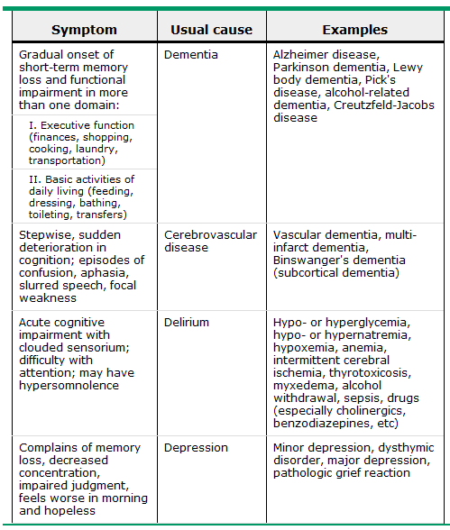

- Differentaial diagnosis of dementia

  - Hypothyroidism
  - Thiamine deficiency
  - B12 deficiency
  - Normal pressure hydrocephalus
  - Subdural haematoma
  - Chronic infection
  - Brain tumour
  - Drugs
  - Psych
    - Depression
    - Schizophrenia
    - Conversion disorder

- Differential diagnosis of memory loss:

Hypothyroidism
- Cognitive dysfunction is a common feature of clinical hypothyroidism or myxedema, manifest by:

    - Slowed mentation
    - ↓concentration
    - ↓short-term memory
    - Social withdrawal
    - Psychomotor retardation
    - Depressed mood
    - Apathy

Cortical features (aphasia, apraxia) usually absent.
  - Less commonly presents with other neuropsychological symptoms including psychosis, confusion, and disorientation, called "myxedema madness."
- Cognitive change in overt hypothyroidism is commonly accompanied or preceded by other clinical features (lethargy, fatigue, cold intolerance, dry skin, constipation, ↓exercise tolerance)
- Neuropsychological testing
  - Deficits most pronounced in attention and executive function.
  - Significan impairment of memory retrieval, learning, verbal fluency, and motor speed.
- EEG: may show generalized background slowing.

B12 deficiency
- Haematological: macrocytic anemia
- Neurological: usually in association with anaemia though may occur without
  - Most commonly produces a spinal cord syndrome (myelopathy) affecting the posterior columns (loss of position and vibratory sense) and corticospinal tracts (↑tendon reflexes with Babinski responses)
  - Also damages peripheral nerves → sensory loss, ↓tendon reflexes
  - Damage to cerebral myelinated fibers may cause dementia (mechanism unclear)
    - Possibly related to a deficiency of S-adenosylmethionine (required for methylation of myelin phospholipids) due to ↓methionine synthase activity or accumulation of methylmalonate, homocysteine, and propionate, providing abnormal substrates for fatty acids synthesis in myelin.
- Treatment: parenteral B12
  - 1000 g IM daily for a week, weekly for a month, and monthly for life for pernicious anemia
  - Stops progression of the disease if instituted promptly, but reversal of advanced nervous system damage will not occur.
- Role of subclinical vitamin B12 deficiency in dementia unclear.

HIV-associated
- Minor cognitive-motor disorder (= HIV-1-associated minor cognitive/motor disorder)
  - Patients with HIV who demonstrate mild cognitive, motor, or behavioral problems, but lack serious impairment in daily functioning.
- HIV-associated dementia
  - = cognitive dysfunction + (abnormal motor) or (Δemotional/behavioral) functioning
  - The patient has a clear level of consciousness, but the overall symptoms cause significant impairment in work or ADLs.
  - Typically presents with the classic symptoms of subcortical dementia:
    - memory and psychomotor impairment
    - depressive symptoms
    - movement disorders
Absence of higher cortical dysfunction helps distinguish classic "cortical" dementia (e.g. Alzheimer disease)
  - Pathology: unclear; brain macrophages and microglial are the key cells that are infected with HIV and likely to be involved.

iii. Distinguish dementia from pseudo-dementia secondary to depression

- In psychotic depression, some patients have significant cognitive impairment that develops after mood symptoms, a condition previously termed pseudodementia.
- Features
  - Subacute onset
  - Hx depression
  - FHx depression
  - Memory AND frontal executive dysfunction.
- Both cognitive and mood symptoms respond to antidepressants (cf depression secondary to AD, in whom antidepressants improve depression but not cogition)
- Possible higher risk of converting to an irreversible dementia syndrome (e.g. AD)

(d) Understand the impact of dementia on patients and their families the options for future care of dementia sufferers

3. Assess communication disorders
(a) Define the following:
i. aphasia

- Aphasia – the loss of ability to produce and/or understand language. This usually manifests as a difficulty speaking or understanding spoken language but reading and writing are also usually impacted. Aphasia can also impact the use of manual sign language and Braille.

ii. dysarthria

- Dysarthria – a motor speech disorder resulting from neurological injury, characterized by poor articulation (cf.aphasia: a disorder of the content of speech). Any of the speech subsystems (respiration, phonation, resonance, prosody, and articulation) can be affected.

(b) Define and localise Broca’s (non-fluent, motor) aphasia and Wernicke’s (fluent, receptive) aphasia

- Broca's aphasia (expressive aphasia)
  - Characterized by nonfluency with sparse output and agrammatism, with impaired repetition. Comprehension is relatively spared but is usually not completely normal, particularly for grammatically complex speech. Writing is generally affected in proportion to speech.
    - Often an associated right hemiparesis and oral apraxia reflecting injury to contiguous structures in the motor and supplementary motor areas.
  - Lesions affecting the frontal lobe (association with Broca's area is most consistently observed in acute rather than chronic stroke).
- Wernicke's aphasia (receptive aphasia)
  - Fluent aphasia with markedly impaired comprehension. Clasically, speech is voluminous but meaningless, containing paraphasic errors and neologisms ("word salad") though usually retains normal cadence and intonation. Comprehension and production of written language is similarly impaired. The patient appears unaware of the deficit.
    - Typically no motor deficit
    - Right superior visual field defect may be present
  - Associated with lesions in the posterior superior temporal gyrus (Wernicke's area).
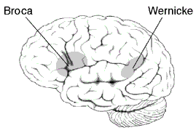

13 Disorders of altered consciousness
1. Define the following terms:
(a) Consciousness
- Consciousness – the normal mental condition of the waking state of humans, characterized by the experience of perceptions, thoughts, feelings, awareness of the external world, and often in humans (but not necessarily in other animals) self-awareness. This encompasses two different concepts: the notion of a self, and the feelings of which the self is aware, especially qualia — our raw sensory experiences.

(b) Coma

- Coma is defined as "unarousable unresponsiveness".
- Mechanisms of coma
  - Damage to the ascending reticular activating system
    - A network of neurons originating in the tegmentum of the upper pons and midbrain, believed to be integral to inducing and maintaining alertness.
    - Projections → diencephalon (thalamus and hypothalamus) → cortex.
  - Bilateral diffuse injury to the cerebral hemispheres (if unilateral, large enough to exert remote effects on the contralateral hemisphere/brainstem).
  - Toxic/metabolic/infectious/hypothermia – mechanism less well understood and to some extent is cause specific. Simplified, these conditions impair O₂/nutrient delivery, altering cerebral metabolism or interfering with neuronal excitability.

(c) Brain death

- Brain death – the permanent absence of cerebral and brainstem functions.
  - "brain dead" is often used colloquially and to extend to all those with severe brain damage and those in vegetative states, but in medical-legal terms its meaning is very specific.
  - As death is ‘an irreversible, biological event that consists of permanent cessation of the critical functions of the organism as a whole’ – allowing for survival of tissues in isolation, death of the brain therefore qualifies as death (as the brain is essential for integrating critical functions), although this is not universally accepted.
- The diagnosis of brain death (not required by curriculum)
  - Requires:
1) The underlying cause is understood
2) Confounding factors have been ruled out:
Drug intoxication Metabolic derangements
Poisoning Hypothermia
  - Diagnosis is then made by neurologic examination which must demonstrate:
1) Coma
2) No cerebral response to external stimuli
3) Absent brainstem reflexes.
  - An apnea test is performed in all patients meeting all other brain death criteria who are stable enough to undergo the test.
  - Ancillary tests are required when clinical criteria cannot be applied and to supplement in young children:
    - Brain blood flow (e.g. hypothermia and metabolic or drug confounders)
    - Electrophysiologic testing (e.g. hypotension, craniotomies, and ↓ICP)

(d) Persistent vegetative state

- Persistent vegetative state – a subgroup of patients who suffer severe anoxic brain injury and progress to a state of wakefulness without awareness.
  - May represent a transition between coma and recovery or between coma and death.
- Prognosis (not required by curriculum)
  - If a patient remains comatose, recovery, PVS, or death usually occurs within 2 weeks.
  - PVS is judged to be permanent after:
Nontraumatic brain injury: 3 months
Traumatic brain injury: 12 months
  - In patients who continue in PVS, life expectancy is 2-5 yrs.
- Diagnostic criteria (not required by curriculum)
  - No evidence of awareness of self or environment and an inability to interact with others
  - No evidence of sustained, reproducible, purposeful, or voluntary behavioral responses to visual, auditory, tactile, or noxious stimuli
  - No evidence of language comprehension or expression
  - Intermittent wakefulness manifested by the presence of sleep-wake cycles
  - Sufficiently preserved hypothalamic and brainstem autonomic function to permit survival with medical and nursing care
  - Bowel and bladder incontinence
  - Variably preserved cranial nerve reflexes and spinal reflexes

(e) Locked-in syndrome

- The locked-in syndrome – a rare catastrophic condition characterized by limb paralysis and loss of speech with retained consciousness, alertness, and cognition. Respiration is often affected.
  - Caused by destructive bilateral brainstem lesions affecting the corticospinal, corticopontine, and corticobulbar tracts.
  - Most common mechanism: ischemic infarction of the ventral pons.
- Supranuclear ocular motor pathways are spared, ∴ patients can move their eyes and blink.
  - Many retain some other voluntary movements such as horizontal gaze, facial expression, limb, head, or tongue movements.
    - May have involuntary ocular, oral, or limb movements.
- Diagnosis (not required by curriculum)
  - Observation and examination of eye movements during bedside interaction is the key.
  - DDx: coma, persistent vegetative state, akinetic mutism, catatonia, and psychogenic unresponsiveness.
- Management (not required by curriculum)
  - Securing and maintaining airway and oxygenation
  - Rapid identification and treatment of vascular causes.
  - Where due to acute ischemic stroke (<48h from onset or most recent deterioration) caused by vertebral or basilar artery embolism/thrombosis with persistent vascular occlusion → aggressive therapy aimed at recanalization, including thrombolysis.
- Prognosis (not required by curriculum)
  - Most survivors of remain chronically locked-in or severely impaired.
  - Many regain some motor function over time.
  - Minority have a good functional recovery.

2. Assess the comatose patient
(a) List the first three things you must do when confronted with a comatose patient (the ABCs)
(b) Outline the steps in the initial evaluation and empiric treatment of the comatose patient

- ABCs
- Vital signs
- Monitoring
  - 12 lead ECG
  - Pulse oximetry (SaO₂ <90% in a comatose patient → intubate)
- GCS: ≤8 → intubate (some exceptions)
- Recent vomiting, or poor cough or gag reflex → intubate
- ABGs, bloods and urine.
- Treat
  - Hypoxia – O₂ therapy
  - Hypotension (MAP <70 mmHg) – volume expanders and/or vasopressors
  - Hypertension (MAP >130 mmHg) – repeated doses of IV labetalol (5-20 mg boluses as needed)
  - Hypoglycaemia – give 25 g of dextrose (as 50 mL of 50% dextrose solution) while waiting for the blood tests if the cause of coma is unknown.
  - Thiamine (100 mg) should be given with or preceding the glucose where possible Et-OH or malnourished (to treat/prevent precipitating acute Wernicke's).
- Herniation syndrome?
  - Evident clinically or imminent (based on CT) – urgent mannitol (1g/kg IV) + hyperventilation.
- Hyperthermia (>38.5°C)
  - Contributes to brain damage in ischemia, ∴ lower fever with antipyretics and/or cooling blankets.
  - Infective?
    - Bacterial meningitis (ceftriaxone 2 g IV 12 and vancomycin 2 g/day IV in four divided doses)
    - Viral encephalitis (acyclovir 10 mg/kg IV every eight hours)
Continued until these conditions have been excluded
- Severe hypothermia (<33ºC)
  - Only treat severe as mild hypothermia has neuroprotective effect in cardiac arrest.
  - Search for and correct cause are more helpful than attempts to vigorously raise temperature.
- Seizure?
  - Phenytoin (15-20 mg/kg IV).

- Definitive therapy depends on establishing the precise diagnosis (sometimes more than one).
- Monitor of the course of the patient, looking for improvement, worsening, and complications, along with establishing a prognosis and communicating this to families.

(c) Discuss the techniques for eliciting and localising of the following findings on examination of a comatose patient:
i. Motor
(1) Decorticate versus decerebrate rigidity

- Purposeful movements: movements that include crossing the midline, approaching the stimulus, pushing the examiner's hand away or actively withdrawing from the stimulus. Acute structural disease decreases spontaneous or purposeful movement and usually produces decreased muscle tone or flaccidity. Flexion and extension movements usually represent reflex responses arising from subcortical structures.
- Decorticate posturing: upper-extremity adduction and flexion at the elbows, wrists, and fingers, together with lower-extremity extension, which includes extension and adduction at the hip, extension at the knee, and plantar flexion and inversion at the ankle. This occurs with dysfunction at the cerebral cortical level or below and may reflect a "release" of other spinal pathways.
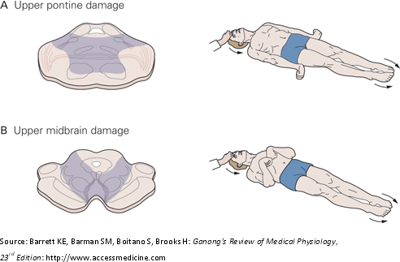

- Decerebrate posturing: upper-extremity extension, adduction, and pronation together with lower-extremity extension; traditionally implies dysfunction below the red nucleus, allowing the vestibulospinal tract to predominate.

- NB: deep metabolic coma may give reflex posturing.

(2) Conjugate eye deviation and its relationship to the side of the lesion

- Eye position
  - Large cerebral lesions: persistent conjugate deviation toward the side of the lesion (contralateral to limb paralysis if present).
  - Seizures: persistent deviation away from the side of the lesion (oft accompanied by nystagmus)
  - CN III nerve/nucleus: lateral and downward eye deviation (usually with pupillary involvement)
  - CN VI: medial deviation.

ii. Eye movements
(1) Intact versus absent oculo-cephalic response (doll’s eyes): see above

- Reflex testing
  - Intact brainstem: bilateral conjugate roving eye movements which appear full (further reflex testing is not required).
    - A good prognostic sign when seen early after ischemic insult.
  - Vestibuloocular reflexes (VROs):
    - Oculocephalic maneuver (or doll's eyes):
      - C-spine must be cleared to perform
      - The head is abruptly rotated from one side to the other in the horizontal plane. When the oculocephalic reflex is present (positive doll's eyes), the eyes do not turn with the head, but in the opposite direction, as if the patient is maintaining visual fixation on a single point in space.
      - This reflex is usually suppressed in conscious patients.
    - Caloric testing of the oculovestibular reflex
      - A stronger stimulus for reflex eye movements.
      - Head is inclined 30°. Inspecting the ears for obstruction or perforation, then syringe ≥50 mL of ice water into the ear canal. This stimulus has the same effect on the horizontal semicircular canal as sustained turning of the head in the opposite direction, and results in sustained deviation of both eyes toward the ear being stimulated. Five minutes should intervene before testing the other side.
      - Present in conscious people, but also produces nystagmus, severe vertigo, nausea, and vomiting.
        - ∴nystagmus→ confirmatory test for ψgenic cause
→ Profound toxic/metabolic pathology can also disrupt these reflexes – generally symmetric, equally affect aB & aDduction, and affect primarily the oculocephalic reflex.
→ Absent caloric responses with normal pupillary reflexes: suspect Wernicke's which selectively involves the VOR, sparing other brainstem reflexes.

iii. Pupillary response
(1) Unilateral fixed dilated pupil

- Normal pupils
  - 3-7 mm and equal
  - 20% have ≤1 mm difference in pupillary size.
- Disruption of the pupillary light reflex in comatose patients usually occurs because of either†:
  - Downward herniation of medial temporal structures from an expanding supratentorial mass
    - After initial dilation and loss of reactivity, pupils reduce size and remain midposition (4-5mm) and fixed.
  - Primary brainstem lesions
- Either may cause a unilateral or bilateral CNIII palsy.
  - Unilateral: ipsilateral pupil is dilated and unreactive (directly and consensually), but the contralateral pupil reacts to light shone in either eye.
  - Bilateral: symmetrically enlarged pupils without direct nor consensual response, with eyes deviated outward.
†Exceptions:
→ Metabolic/toxic conditions – usually spare pupils (except in certain toxic syndromes, which are associated with either miosis or mydriasis).
→ Severe sedative drug overdose or hypothermia: midposition and fixed (mimics brain death).
→ Pupils <1 to 2 mm with barely perceptible light reflex – may be produced by pontine tegmentum lesions (‘pontine pupils’) which selectively disrupt sympathetic outflow, or opiate overdose.

iv. Respiratory

(1) Cheyne-Stokes respiration

- Cheyne-Stokes respirations – periodic cyclic respiration, common in advanced HF and is usually associated with low cardiac output. Cheyne-Stokes respiration is caused by a diminished sensitivity of the respiratory center to arterial pCO₂
  - Apneic phase: ↓pO₂ and ↑pCO₂ (arterial).
  - Hyperventilation phase: the above stimulates the respiratory center → ↑RR and ↓pCO₂
    - This depresses the respiratory centre is followed in turn by recurrence of apnea.
- May be perceived by the patient or the patient's family as severe dyspnea or as a transient cessation of breathing.
- Also attributed to pontine tegmental lesions and in elderly patients during sleep phase or end-inspiratory pause.

3. Describe the diagnosis and management of increased intracranial pressure (ICP)
(a) List the symptoms and signs of increased ICP

- Symptoms:
  - Headache (probably mediated via the pain fibers of CN V in the dura and vessels)
    - Worse in morning, with valsalva, cough, defacation or strain
  - ↓consciousness – listlessness, irritable, drowsy, coma (local effect of mass lesions or pressure on the midbrain reticular formation)
  - Vomiting
  - Seizure
- Signs:
  - CN VI palsies
  - Pupillary changes (initial constriction followed by dilation later)
  - Papilledema (2° to impaired axonal transport and congestion)
  - Spontaneous periorbital bruising
  - Cushing’s reflex – a late, ominous finding requiring immediate intervention. Triad of:
    - Bradycardia
    - Respiratory depression
    - Hypertension
  - Cheyne-Stokes respiration
  - Focal symptoms – caused by
    - local effects in patients with mass lesions
    - herniation syndromes (develop when pressure gradient established between 2 regions of the cranial vault)
  - Kernohan's notch phenomenon – a combination of contralateral pupillary dilatation and ipsilateral weakness; a false localizing syndrome seen following neurologic injury.

(b) List the effects of uncal herniation on

i. level of consciousness
ii. motor activity
iii. extraocular movements
iv. pupillary reactivity

- Laterally directed compressive forces lead to asymmetric herniation of the temporal uncus, leading to (in order):
  - Ipsilateral CN III palsy (pupillary dilation, downward and outward eye deviation)
    - Can occur prior to diencephalic signs as the nerve is stretched over the clivus.
  - Unreactive contralateral pupil (usually reflects midbrain damage).
  - Hemiplegia (often follows immediately)
    - Due to compression of the cortical spinal tract in the midbrain.
  - ↓LOC

(c) List the indications for imaging prior to performing a lumbar puncture

- CT prior to LP where:
  - Fundoscopy reveals any of the following
    - Papilloedema
    - Haemorrhages
    - Loss of venous pulsations
  - Suspected meningitis:
    - All purulent meningitis is associated with ↑ICP
      - Herniation is <5% and CT is normal in most cases.
    - Do not delay antibiotics for CT+LP → take multiple blood cultures and give IV antibiotics prior to CT.
  - A prospective study indicates LP must preceed CT in case of:
    - Age >60
    - Immunocompromise
    - Hx malignancy
CNS disease/trauma
Seizure within 1 wk
↓LOC
Abnormal neuro exam
  - Suspected meningitis in absence of above risk factors should be diagnosed by LP alone.

(d) Distinguish between communicating and non-communicating hydrocephalus

- Obstruction:
  - Most common mechanism
  - Anatomic or functional obstruction to CSF flow at the foramen of Monro, the aqueduct of Sylvius, or the fourth ventricle and its outlets (foramina of Magendie and Luschka).
  - Dilatation of the ventricular system occurs proximal to the block; i.e. blockage of:
    - One foramen of Monrso → dilatation of the lateral ventricle on that side.
    - Aqueduct of Sylvius → lateral and third ventricles dilate (normal 4th ventricle)
- Communicating hydrocephalus - impaired absorption
  - Less common mechanism
  - Impaired venous absorption, typically due to inflammation of the subarachnoid villi.
  - Entire ventricular system is dilated.

14. Headaches and facial pain

1. Contrast the clinical features that distinguish between benign versus potentially serious underlying causes of headache.

- Headache symptoms that suggest a serious underlying disorder:
  - "Worst" headache ever
  - First severe headache
  - Subacute worsening over days or weeks
  - Abnormal neurologic examination
  - Fever or unexplained systemic signs
  - Vomiting that precedes headache
  - Pain induced by bending, lifting, cough
  - Pain that disturbs sleep or presents immediately upon awakening
  - Known systemic illness
  - Onset after 55
  - Pain associated with local tenderness, e.g., region of temporal artery
In basic terms migraine is headache with associated features, and tension-type headache is headache that is featureless. Most patients with disabling headache probably have migraine.

2. Describe the clinical features of migraine headache with aura versus without aura

- The second most common cause of headache (15% of ♀, 6% of ♂)
- Diagnostic criteria
  - Repeated attacks of headache lasting 4–72 h in patients with a normal physical examination, no other reasonable cause for the headache, and:
    - ≥2 of the following:
      - Unilateral pain
      - Throbbing pain
      - Aggravation by movement
      - Moterate/severe intensity
    - + ≥1 of the following
      - Nausea/vomiting
      - Photophobia or phonophobia
- Visual aura – accompanies in 25%. Typical attack (~20min):
  - Small central disturbance in the field of vision marches toward the periphery, leaving a transient scotoma in its wake
  - The expanding border of migraine scotoma has a scintillating, dancing, or zig-zag edge
Descriptions vary widely and can be confused with amaurosis fugax. Migraine patterns differ in that they usually last longer, are perceived in both eyes, remain visible in the dark or with the eyes closed, and recede with the onset of headache.

3. Describe the clinical features of trigeminal neuralgia

- Trigeminal neuralgia – sudden, usually unilateral, severe, brief, stabbing or lancinating, recurrent episodes of pain in the distribution of one or more branches of CNV
- Pain
  - Site:
    - Distribution of one or more branches of the trigeminal nerve (usually V2/3)
    - Usually unilateral; when bilateral, not simultaneous.
  - Onset: paroxysms, maximal at or near onset.
  - Character: electric, shock-like, lancinating, stabbing.
  - Radiation: confined to CNV distribution.
  - Alleviating factors: see management below
  - Timecourse:
    - Usually 1-7 sec, but may occur repetitively.
    - A refractory period of several minutes during which a paroxysm cannot be provoked is common.
    - Episodes may last weeks or months, followed by pain-free intervals.
    - Recurrence is common
  - Exacerbating factors
    - May have trigger zones in the distribution of the affected nerve
      - Often near midline
      - Lightly touch often triggers an attack, ∴pts protect these areas.
    - Other triggers of paroxysms: chewing, talking, brushing teeth, cold air, smiling, and/or grimacing.
  - Severity
    - Severe pain during attack
    - In longstanding, may have continuous dull pain between paroxysms
    - Does not typically wake from sleep
    - When severe may cause facial muscle spasms
- Management (not required by curriculum)
  - Options include carbamazepine, lamotrigene, phenytoin, gabapentin
- Secondary trigeminal neuralgia is not uncommon – MRI is justifiable. Secondary causes:
Aneurysm Zoster Chronic meningeal inflammation
Tumour MS Skull base malformation (eg Chiari)

4. Describe the clinical features of the following causes of headaches:

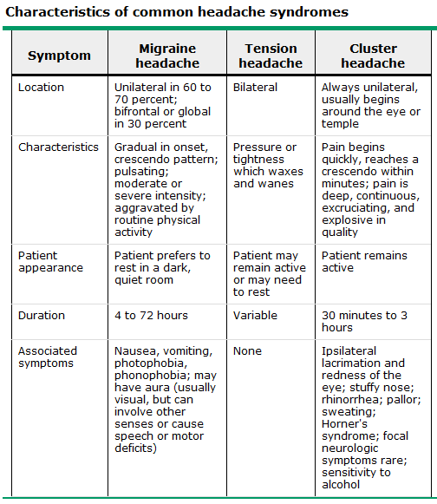

(a) subarachnoid haemorrhage

See section B.7.2(g)

(b) meningitis

See section B.1(a)
- Acute, severe headache + stiff neck + fever → suggests meningitis.
  - Other features
    - Photophobia
    - Nausea
    - Vomiting
  - Often striking accentuation of pain with eye movement.
  - Easily mistaken for migraine in that the cardinal symptoms are present.
- May be associated with symptoms of ↑ICP.

(c) increased ICP/mass

- Mass: ~30% of patients with brain tumors headache is the chief complaint.
  - Site: deep
  - Onset: nondescript
    - Sudden onset head pain after bending, lifting, or coughing can be due to a posterior fossa mass (or a Chiari malformation).
  - Character: dull aching
  - Radiation:
    - May have associated N&V; where precedes pain, think posterior fossa tumor.
    - Amenorrhea or galactorrhea → consider prolactinoma (or PCOS)
  - Alleviated: N/A
  - Timecourse: intermittent
  - Exacerbated: on exertion or change in position
  - Severity: moderate intensity, disturbs sleep in ~10% ain is usually
This pattern of symptoms results from migraine far more often than from brain tumor.
- ↑ICP: present in 50%
  - Variable pattern (oft generalized, gradually worsening – unless acute bleed) and severity, but worse
    - In the morning
    - Lying down
    - With valsalva, couching, defacation, urination
  - Accompanied by
    - Nausea and vomiting
    - ↓LOC (drowsiness)
    - Epilepsy
    - Focal signs
    - Papilloedema

(d) temporal arteritis

- Temporal (giant cell) arteritis – an inflammatory disorder of arteries that frequently involves the extracranial carotid circulation.
- Presentation
  - Demographics
    - Common in elderly (incidence is 3 in 4,000 per annum in those >50).
    - Average onset: 70
    - ♀:♂ = 13:9
  - Headache
    - Site: Unilateral or bilateral; temporal in 50%, though may localise anywhere
    - Onset: develops gradually to peak over a few hours; occasionally explosive.
    - Character
    - Radiation:
      - Scalp tenderness – often marked, to the degree that unable to brush hair or lie on a pillow
      - Temporal arteries:
        - Arteries themselves may be tender (occasionally occipital art.)
        - Red tender nodules or streaking of overlying skin
      - Malaise and weight loss
      - Muscle aches
      - Polymyalgia rheumatica
      - Jaw claudication
      - Fever
    - Alleviated: N/A
    - Timecourse: crescendo over a few hours
    - Exacerbated: at night and with exposure to cold.
    - Severity: crescendo from mild to severe
- Labs (not required by curriculum)
  - ↑ESR (normal does not exclude)
  - Temporal artery biopsy
- Management (not required by curriculum)
  - Untreated, 50% develop blindness due to involvement of the ophthalmic artery and its branches
    - The major cause of rapidly developing bilateral blindness in patients >60 years.
  - Treatment: glucocorticoids; prompt recognition & Rx effective for preventing blindness
    - Prednisone 80 mg/d for 4–6 wks – initiated if clinical suspicion is high.
      - Significant prevalence of migraine in the elderly is substantial (>GCA), and will often report improvement with prednisone

(e) intracranial haemorrhage

- Acute, severe headache with stiff neck but without fever → suspect subarachnoid hemorrhage.
- Ruptured aneurysm, AV malformation, or intraparenchymal hemorrhage may also present with headache alone.
- Investigation
  - Noncontrast CT
    - Rarely, if the small or below the foramen magnum, may have normal CT
  - LP – blood

(f) hypertensive encephalopathy
.
- Background
  - Secondary to malignant hypertension, which usually occurs on a background of long-standing uncontrolled hypertension.
  - Occurs as the final problem in a series of hypertensive insults, including:
    - Retinal hemorrhages and exudates (representing both ischemic damage and leakage of blood and plasma from affected vessels) and papilledema.
    - Malignant nephrosclerosis, leading to acute renal failure, hematuria, and proteinuria.
      - Leads to glomerular ischemia and activation of the renin-angiotensin system, possibly resulting in exacerbation of the hypertension
    - Neurologic symptoms due to intracerebral or subarachnoid bleeding, lacunar infarcts, or hypertensive encephalopathy.
- Presentation:
  - Headache (insidious onset)
  - Nausea, vomiting
  - ↓LOC (restlessness, confusion → seizure, coma)
- Investigation: MRI
  - Will exclude stroke or hemorrhage (not treated with aggressive BP reduction).
  - When reveals edema of the white matter of the parieto-occipital regions, especially on T2, termed reversible posterior leukoencephalopathy syndrome.
  - When reveals primarily pontine abnormalities, called hypertensive brainstem encephalopathy.

(g) sinusitis

- Symptoms of acute rhinosinusitis
  - Pain
    - Site: over maxillary or frontal sinus, or centrally at nose root
    - Onset: vague
    - Character: dull, constant, aching headache/pain/pressure
    - Radiation: tenderness of overlying skin ± maxillary teeth ± ear fullness
    - Alleviating: N/A
    - Timecourse: 1-2 weeks
    - Exacerbating: bending forward.
    - SeverityMaxillary tooth discomfort
  - Respiratory
    - Nasal congestion and obstruction with purulent nasal discharge
    - Hyposmia/anosmia
    - Fever
    - Cough
    - Hallitosis

(h) temporomandibular joint dysfunction

- Temporomandibular joint (TMJ) syndrome – chronic or acute musculoskeletal pain with dysfunction of the masticatory system.
- Headache or facial pain may be the presenting complaint, occasionally without awareness of a TMJ disturbance.
  - Site: unilateral ear or preauricular pain
  - Onset: chronic or acute
  - Character: deep, dull
  - Radiation: to the jaw, temple, or neck.
  - Timecourse: continuous
  - Exacerbated: worse in the morning.

5. Discuss the urgent and non-urgent indications for the following diagnostic tests used to evaluate a headache patient
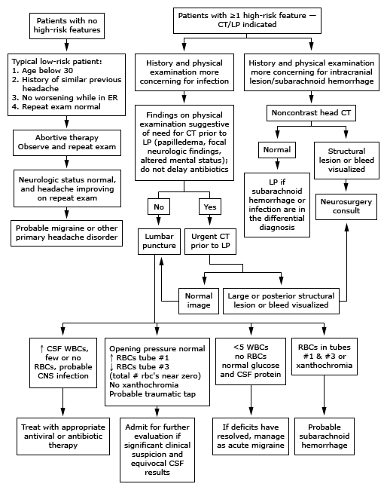

(a) CT

- The presence of one or more high-risk features in a patient with an acute headache
  - Yield of neuroimaging is very low if no high-risk historical feature is present and the neurologic examination is normal.
- Noncontrast head CT is most helpful for identifying intracranial lesions or bleeding.
- CT head before LP should be performed in adult patients with suspected bacterial meningitis if any of the following are present, to identify a possible mass lesion and other causes of ↑ICP:
  - Immunocompromised
  - History of CNS disease (mass lesion, stroke, or focal infection)
  - New onset seizure (≤1 week from presentation)
  - Papilledema
  - ↓LOC
  - Focal neurologic deficit

(b) Lumbar puncture – also list contraindications

- Lumbar puncture is most helpful for diagnosing infection, though may aid in diagnosis of other conditions.
- Urgent in:
  - Suspected CNS infection
    - Exceptions: brain abscess or a parameningeal process.
  - Suspected subarachnoid hemorrhage in a patient with a negative CT
    - Xanthochromia differentiates SAH from traumatic tap
- Nonurgent in:
  - Idiopathic intracranial hypertension (pseudotumor cerebri)
  - Normal pressure hydrocephalus
  - Carcinomatous meningitis
  - Tuberculous meningitis
  - CNS syphilis
  - CNS vasculitis
- Useful but rarely diagnostic in:
  - Multiple sclerosis
  - Guillain-Barré syndrome
  - Paraneoplastic syndromes
- Performed as therapeutic or diagnostic maneuver in:
  - Spinal anesthesia
  - Intrathecal administration of drugs (chemotherapy, antibiotics)
  - Injection of contrast (myelography or cisternography)
- Contraindications – there are no absolute contraindications, caution should be exercised with:
  - ? ↑ICP
    - CT first if:
Immunocompromised History of CNS disease
New onset seizure Papilledema
↓LOC Focal neurologic deficit
  - Thrombocytopenia or other bleeding diathesis (inc. anticoagulant therapy)
  - Infection of overlying skin or suspected spinal epidural abscess

(c) Erythrocyte sedimentation rate

- Acute: ESR is helpful in the diagnosis of 2 conditions only: temporal arteritis and polymyalgia rheumatica.
- Other: a nonspecific marker of inflammation.

(d) MRI

- In the acute setting, CT is preferred
- Indicated when:
  - Recent significant change in the pattern, frequency or severity of headaches
  - Progressive worsening of headache despite appropriate therapy
  - Focal neurologic signs or symptoms
  - Onset of headache with exertion, cough, or sexual activity
  - Orbital bruit
  - Onset of headache >40
- Considered in patients with nonacute headache and an unexplained abnormal finding on neurologic examination.
  - Usually not warranted for patients with migraine and a normal neuro exam
    - Lower threshold where atypical features or do not fulfill the strict definition of migraine.

6. Differentiate the CSF profiles of SAH and meningitis

- Meningitis:
  - ↑CSF pressure
  - ↑WBC: 1000-5000/μL
  - ↑Nøs: >80%
  - ↑protein: 1 to 5 g/L
  - ↓glucose : <40 mg/dL; CSF:serum glucose ratio of <0.4
  - RBCs may be present in viral encephalitis
  - Gram stain and culture – differentiate between bacterial and viral
- SAH
  - ↑CSF pressure
  - ↑WBC (allow 1-2 extra white cells for every 1×10³ RBCs in a blood-stained tap)
  - ↑protein:
  - RBCs:
    - Xanthochromia (pink or yellow tint)
    - clearing of blood in successive tubes only excludes SAH if final tube is clear

7. Discuss the treatment for common headache syndromes (migraine headache and tension headache), including symptomatic and prophylactic therapy

- Migraine
  - Acute
    - Initial Rx in ED: abortive therapy for severe migraine ± severe N&V
      - IV metoclopramide (10 mg) or prochlorperazine (10 mg)
        - most effective if given early and in a large single dose
      - Adjunctive IV or IM dexamethasone (10 to 25 mg) – ↓ early recurrence.
    - Begin specific migraine therapy with a triptan for outpatients with moderate to severe migraine (no agent clearly better than others).
      - Triptan treatment, in particular, should be given at the first sign of pain in patients susceptible to cutaneous allodynia.
  - Prevention:
    - Prophylactic treatment is indicated if the headaches fulfil one of the following:
      - Frequent (>4 per month)
      - Long lasting, (>12 h)
      - Significant disability
    - Additional considerations:
      - Contraindication to or failure of acute therapies
      - Cost of acute and preventive therapies
      - Patient preference
    - Options (choose based on patient situation and comorbidities)
      - β-blockers (eg, propranolol, nadolol)
        - Do not use β-blockers as initial agent in >60 or smokers due to ↑risk of stroke and cardiovascular events
      - Other antihypertensives (eg, lisinopril, candesartan),
      - Antidepressants (eg, amitriptyline, venlafaxine)
      - Anticonvulsants (eg, valproate, gabapentin, topiramate)
- Tension Headache
  - Acute management
    - Mild to moderate severity: simple analgesics (NSAIDs, paracetamol)
      - e.g ibuprofen 200 or 400 mg
    - Moderate to severe: IM ketorolac 60 mg
    - Combine with caffeine → ↑efficacy of simple analgesics
    - Limit acute therapy to max 9 days per month, with max 2 doses per day.
  - Prevention
    - Prophylactic treatment is indicated if the headaches are frequent, long lasting, or associated with a significant disability.
    - Pharmacologic options:
      - Tricyclic antidepressants (amitriptyline) – the mainstay.
      - SNRIs (mirtazapine and venlafaxine)
      - Anticonvulsants (gabapentin and topiramate).
    - Behavioral:
      - CBT
      - Relaxation
      - Biofeedback

15. Neck and back pain

1. Differentiate clinically between myofascial pain, radiculopathy and spinal cord compression

- Regional myofascial pain
  - Hyperirritable spots, usually within a taut band of skeletal muscle or in the muscle's fascia that is painful on compression and can give rise to characteristic referred pain, tenderness, and autonomic phenomena. No CNS or muscle abnormailities yet identified.
  - Pain:
    - Deep aching quality, occasionally accompanied by burning/stinging.
    - Occurs just in one body region (may lead to a chronic regional perplexing pain disorder)
    - Complain of restricted active movement in the involved area.
    - Trigger (pain) point(s)
      - Often feel indurated to palpation,
      - Palpation reproduces the pain in the "target zone" (oft some distance away).
      - Trigger points may result from acute trauma, repeated minor microtrauma of daily living, or from a chronic strain.
  - Injection of trigger points with local anesthetic often results in pain relief . This improvement in symptoms can be reversed by intravenous naloxone suggesting that the beneficial response is mediated by the endogenous opioid system.
  - Unlike a local form of fibromyalgia in that the tenderness can be cured (generally not the case with fibromyalgia).
- Radiculopathy
  - Nerve root injury leading to dermatomal/myotomal pattern of pain and weakness; a common cause of neck, arm, low back, and leg pain.
  - Anatomy:
    - Nerve root designation
      - Cervical nerve roots exit above their respective vertebral bodies
      - Thoracic, lumbar, and sacral nerve roots exit below their respective vertebrae.
    - All lumbar and sacral spinal nerve roots originate at the conus medullaris (T10 to L1 vertebral level).
  - Lumbosacral radiculopathy
    - Most commonly caused by a disc herniation or spinal stenosis due to degenerative arthritis (spondylosis) of the spine, and most commonly involves either the L5 or S1 root.
      - Congenital abnormalities (tethered cord, spina bifida), infection, inflammation, neoplasm and vascular disease may also cause.
    - Diagnosis is clinical; immediate diagnostic testing is not necessary for patients with suspected radiculopathy who are neurologically intact and not suspected of having underlying neoplasm, infection, or inflammation.
Levels
    - L1 – rare; Sx: pain, paresthesia, and sensory loss in the inguinal region.
    - L2-4 – most often in older patients with spinal stenosis; considered as a group because of marked overlap of innervation of the anterior thigh muscles. Sx: acute back pain; often radiating to anterior leg into the knee.
    - L5 – the most common; Sx: back pain that radiates down the lateral aspect of the leg into the foot; Signs: ↓strength in foot dorsiflexion, toe extension, inversion/eversion, usually with preserved reflexes.
    - S1 – Sx: back pain radiating down the posterior aspect of the leg into the foot; Signs: ↓strength in leg extension (gluteus maximus), plantar flexion, and toe flexion, ↓sensation on the posterior leg and lateral foot, with loss of AJ reflex.
    - S2-4 – radiculopathy due to structural etiologies are rare, but may be caused by a large central disc that compresses the nerve roots intrathecally at a higher level; Sx: sacral or buttock pain that radiates down the posterior aspect of the leg or into the perineum, minimal weakness, but urinary and fecal incontinence as well as sexual dysfunction.
- Spinal cord compression
  - Lumbar spinal stenosis
    - Most common cause: degenerative spondylosis, which typically affects >60 yo.
    - Features:
      - Neurogenic claudication – bilateral, often asymmetric pain, sensory loss, and/or weakness affecting the legs, which is produced or exacerbated by walking or prolonged standing in an erect posture, representing intermittent mechanical/ischemic disruption of lumbosacral nerve root.
      - Fixed nerve root injury may occur, causing lumbosacral radiculopathy, cauda equina syndrome, or conus medullaris syndrome. .
    - Diagnosis: MRI of the lumbosacral spine ± other tests to rule out differentials.
  - Neoplastic spinal cord compression
    - Recent onset persistent back pain (particularly thoracic spine –uncommonly involved by spondylosis), should prompt consideration of vertebral metastasis.
    - Most neoplasms in adults are epidural, i.e. metastases to the adjacent spinal bones.
      - Almost any malignant tumor can metastasize to the spinal column, though the most common are breast. lung, prostate, kidney, lymphoma, and plasma cell dyscrasia
        - 5 Bs met to bone: breast, bronchus, byroid, bidney, brostate
    - Usually involve the thoracic cord, except with prostate and ovarian primaries (favour L/S cord due to spread through Batson's plexus).
    - Retroperitoneal neoplasms (especially lymphomas or sarcomas)
      - Eenter the spinal canal through the intervertebral foramina, ∴ radicular pain and other signs of root involvement prior to cord compression.
    - Pain – usually the initial symptom
      - Either aching and localized or sharp and radiating
      - Worsens with movement, coughing, or sneezing
      - Awakens patients at night
  - Spinal epidural abscess
    - Clinical triad is distinctive:
      - Midline dorsal pain (almost always present)
        - Aching, either over the spine or in a radicular pattern.
        - Generally present fo 2 wks prior to presentation
      - Fever
        - Accompanied by ↑WCC & ↑ESR
      - Progressive limb weakness
        - Once present, progression may be rapid.
        - As the abscess expands, further cord damage results from venous congestion and thrombosis.
    - A chronic sterile granulomatous form of abscess may occur, usually after treatment of an acute epidural infection.
  - Spinal epidural hematoma
    - Hemorrhage into the epidural (or subdural) space causes acute focal or radicular pain followed by variable signs of a spinal cord or conus medullaris disorder.
    - Predisposing factors: hypocoaguable states, trauma, and tumor.
    - Rare complication of LP or epidural anesthesia.
  - Hematomyelia
    - Hemorrhage into the substance of the spinal cord.
    - Rare result of trauma, intraparenchymal vascular malformation, vasculitis (due to polyarteritis nodosa or SLE), bleeding disorders, or a spinal cord neoplasm.
    - Presents as an acute painful transverse myelopathy.
      - Large lesions may extend into the subarachnoid space → SAH.
    - Diagnosis: MRI or CT.
    - Management: supportive; surgical intervention generally not useful except where due to an underlying vascular malformation.

2. Discuss the significance of back pain in cancer patients

- See spinal cord compression above
- DDx includes:
  - Pathological fracture
  - Multifocal bone pain
  - Vertebral metastases
  - Neoplastic epidural spinal cord compression
  - “Sacral syndrome”: destruction of the sacrum due to metastases: severe focal pain radiating to the buttocks, perineum and posterior thigh
  - Leptomeningeal metastases

16. Brain tumours
1. Discuss the clinical presentation of a primary brain tumour in the following locations:
(a) cerebellopontine angle

- See vestibular schwannoma/auditory neuroma above

(b) pituitary region

- Sellar masses can present with
  - Neurologic symptoms
  - Hormonal abnormalities (undersecretion or oversecretion)
  - Incidental radiologic findings
- Neurologic symptoms
  - Visual defects
    - The most common presenting symptom in nonfunctioning adenomas (> 80% are gonadotroph adenomas)
    - Suprasellar extension → compression of chiasm → bitemporal hemianopsia
      - May affect one or both eyes, and if both, to variable degrees.
      - Severe compression may lead to ↓acuity.
    - Other patterns of visual loss may occur, ∴suspect intrasellar lesion whenever there is an unexplained pattern of visual loss.
  - Other neurologic symptoms
    - Headaches (no specific quality)
    - Diplopia due to CN III compression
    - Pituitary apoplexy – sudden hemorrhage into the adenoma causes excruciating headache and diplopia.
    - CSF rhinorrhea (extremely uncommon) due to inferior extension.
    - Parinaud syndrome
- Hormonal abnormalities
  - Deficiencies – most patients present with neurological symptoms, though will admit to symptoms of pituitary hormone deficiencies on questioning.
    - Most common: gonadotropin deficiency, resulting in hypogonadism in both men and women.
  - Hypersecretion (in order of frequency)
Adenoma Cell Origin | Hormone Product | Clinical Syndrome
Lactotrope | PRL | Hypogonadism, galactorrhea
Gonadotrope | FSH , LH , subunits | Silent or hypogonadism
Somatotrope | GH | Acromegaly/gigantism
Corticotrope | ACTH | Cushing's disease
Mixed growth hormone and prolactin cell | GH, PRL | Acromegaly, hypogonadism, galactorrhea
Other plurihormonal cell | Any | Mixed
Acidophil stem cell | PRL, GH | Hypogonadism, galactorrhea, acromegaly
Mammosomatotrope | PRL, GH | Hypogonadism, galactorrhea, acromegaly
Thyrotrope | TSH | Thyrotoxicosis
Null cell | None | Pituitary failure
Oncocytoma | None | Pituitary failure

(c) cerebral hemisphere

- Patients with primary or metastatic brain tumors may present with either generalized or focal signs and/or symptoms
- Generalized
  - Headaches – common manifestation of brain tumors (~50% primary symptom).
    - Dull and constant; occasionally throbbing
    - Infrequently severe, unless obstructive hydrocephalus or meningeal irritation
    - Early morning brain tumor headache – ‘classic’ but appears to be uncommon.
    - Tumour related headaches tend to be worse at night and may awaken the patient.
      - Nocturnal pattern thought to be due in part to transient increases in PCO2, a potent vasodilator, during sleep. Other possible physiologic explanations include recumbency and decreased cerebral venous return.
  - Seizures – among the most common symptoms of gliomas and cerebral metastases
    - Some who are seizure-free at diagnosis subsequently develop.
    - May cause status epilepticus.
    - Do not provide routine prophylaxis with anticonvulsants.
  - Syncope – significant ↑ICP can temporarily cut off cerebral perfusion → loss of consciousness.
    - Particularly susceptible to syncope in association with normal plateau waves.
    - Baseline ICP may be raised to a level that reduces brain compliance; thus, even a further small increase in cranial fluid volume can result in dramatic ↑ICP.
  - Cognitive dysfunction – includes memory, mood and personality change, and is common among patients with intracranial malignancy.
    - Most deficits are subtle – low energy, abulia, fatigue, an urge to sleep, and loss of interest in everyday activities.
- Focal
  - Muscle weakness – a common complaint; manifestations may be subtle, particularly in the early stages. UMN lesion weakness is generally greater in the naturally weaker muscle groups – those that act with gravty (upper limb extensors and lower limb flexors).
  - Sensory loss – cortical sensory deficits can develop where there is invasion of the primary sensory cortex (eg, graphesthesia or abnormalities in stereognosis).
  - Aphasia
  - Visual spatial dysfunction – the visual pathway has a long course through the brain, and thus can be affected by brain tumors that involve any of these areas.
    - Retina – must be examined where ?brain tumour, particularly the optic discs
      - The optic nerve head can be a good measure of ICP
        - Papilledema is often absent in the elderly despite ↑ICP
        - When evolving, papilledema can be difficult to recognize. Early signs are
          - Blurring of the medial portion of the disk
          - Venous engorgement
          - Absence of venous pulsations
    - Fields – compression of the optic chiasm may lead to
      - Bitemporal hemianopsia
      - Unilateral hemianopsia with a central scotoma in the contralateral eye in the early stages, particularly when compression is on one side.
    - Postchiasmatic lesions – the somatotopic representation of the visual pathways leads to more anterior lesions presenting with more asymmetric hemianopsias.

(d) Cerebellum

- Clinical manifestations:
  - Most important
    - Dizziness (81% )
    - Nystagmus (50%)
    - Vertigo (44%)
    - Lack caloric responses (30%)
    - ‘posterior fossa’ syndrome: lethargy, headache and vomiting
  - Other common:
    - Tinnitus
    - Hearing loss
    - Headache
    - Nausea or vomiting
    - Ataxia
    - ↑ICP (cerebellar gliomas may be silent until they obstruct CSF or compress the brainstem)
- Tumour types (not required by curriculum)
  - Gliomas
  - Teratomas
  - Hemangiomas
  - Hemangioblastomas

2. Differentiate metastatic from primary brain tumour by

(e) clinical features
(f) imaging: CT or MRI

- Metastatic
  - DDx (not required by curriculum):
    - Primary brain tumour
    - Incectious process
    - Progressive multifocal leukoencephalopathy
    - Demyelination
    - Paraneoplastic phenomena
    - Cerebral infarction/bleeding
    - Treatment SEs (e.g. radiation necrosis)
  - Clinical features: variable
    - Suspect in any cancer patient who develops neuro or behavioural symptoms
    - Common: symptoms due to mass and its associated edema.
    - Less commonly: intratumoral hemorrhage, obstructive hydrocephalus, or embolization by tumor cells
  - Imaging: useful, but biopsy necessary in some for definitive Dx.
    - Contrast MRI is preferred for the diagnosis of brain metastases: more sensitive than either nonenhanced MRI or CT in detecting lesions and in differentiating metastases from other CNS lesions.
    - Radiographic features that can help differentiate mets from primaries and other CNS lesions - mets tend to have:
      - Multiple lesions
      - Localization at the junction of the grey and white matter
      - Circumscribed margins
      - Large amounts of vasogenic edema compared to the size of the lesion
  - Pathology (not required by curriculum):
    - Biopsy whenever the diagnosis is in doubt, especially where a single lesion.
      - In one study, the diagnosis of metastasis was changed by biopsy in >10% of patients with a single lesion (primary tumor, infection or inflammation).
    - Breast cancer patients have an increased incidence of meningiomas, ∴ single dural-based lesion in BrCa patient poses a diagnostic dilemma, since imaging studies are often inconclusive. Biopsy or surgical resection may be required.

3. List the most common metastatic tumours to the brain in adults

- Primaries that metastasise to the brain
  - Adults: carcinomas (Luck Coping with Killer Brain Metastases)
Lung Colorectal Kidney Breast Melanoma
Rarely met to brain: prostate, esophagus, oropharyngeal and non-melanoma skin ca.
  - Paeds: sarcomas, neuroblastoma, and germ cell tumors

17. Disorders of central sensation

For central sensory disorders, describe and discuss the localisation of:
(a) hemi-sensory disturbance

- Unilateral sensory loss: characteristic of brainstem, thalamus, or cortex lesions.
  - Brainstem: cranial nerves are usually also involved; unique in that there may be sensory loss of the face that is opposite that of the body.
  - Thalamus or cortex: may involve sensory loss of the face that is on the same side as sensory loss of the body.
    - Look for cortical signs and symptoms
      - Aphasia
      - Neglect
      - Agraphesthesia
      - Astereognosis
      - Two point discrimination abnormalities
      - Extinction abnormalities

(b) spinal sensory level

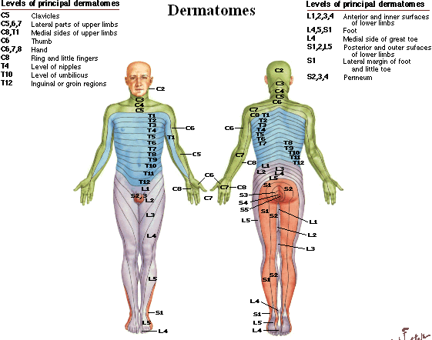
- Dorsal cord syndrome – bilateral involvement of the dorsal columns (light touch, vibration, joint position), the corticospinal tracts (motor), and descending central autonomic tracts to bladder control centers in the sacral cord.
  - Symptoms: bilateral
    - Ataxia and paresthesias (dorsal column)
    - Weakness (corticospinal tract)
      - Acute: flaccidity and hyporeflexia
      - Chronic: hypertonia and hyperreflexia.
    - Extensor plantar responses and urinary incontinence may be present
  - Causes (not required by curriculum):
    - MS (more typically the primary progressive form)
    - Tabes dorsalis
    - Friedreich ataxia
    - Subacute combined degeneration
    - Vascular malformations
    - Tumors (epidural and intradural extramedullary)
    - Cervical spondylotic myelopathy
    - Atlantoaxial subluxation
- Ventral (anterior) cord syndrome – includes all tracts except for the dorsal column (including corticospinal, spinothalamic, and descending autonomic tracts to the sacral centers for bladder control)
  - Symptoms: bilateral
    - Weakness and reflex changes (corticospinal tract)
    - Loss of pain and temperature sensation (spinothalamic tract)
    - Urinary incontinence is usually present
    - Tactile, position, and vibratory sensation are normal
  - Causes (not required by curriculum):
    - Spinal cord infarction
    - Intervertebral disc herniation
    - Radiation myelopathy

(c) Brown-Sequard syndrome

- Brown–Sequard syndrome – lateral hemisection of the cord, involving all tracts unilaterally: dorsal column, corticospinal tract, and spinothalamic tract.
  - Symptoms
    - Ipsilateral loss of vibration, proprioception and light touch (dorsal column)
    - Ipsilateral weakness (corticospinal tract)
    - Ipsilateral loss of pain and temperature in a small band from the site of the lesion to two levels below (spinothalamic tract – fibres that have not crossed)
    - Contralateral loss of pain and temperature further below (spinothalamic tract – fibres that have already crossed)
    - Unilateral involvement of descending autonomic fibers does not produce bladder symptoms
  - Causes (not required by curriculum): many
    - Common: ○ Rarer:
      - Knife or bullet injuries • Disc herniation
      - Demyelination • Infarction
• Infection

(d) dissociated sensory loss (as in syringomyelia)

- Central cord syndrome
  - Symptoms
    - Loss of pain and temperature in one or several adjacent dermatomes at the site of the spinal cord lesion (caused by the disruption of crossing spinothalamic fibers in the ventral commissure).
      - Dermatomes above and below the level of the lesion have normal pain and temperature – the so-called "suspended sensory level."
    - As a central lesion enlarges:
      - Weakness in the analgesic areas (encroaches on the medial aspect or the corticospinal tracts or on the anterior horn gray matter)
      - Loss of deep tendon reflexes in the analgesic areas (fibers mediating the deep tendon reflexes are interrupted as they pass from the dorsal to the ventral horn)
    - Vibration and proprioception often spared
    - Usually no bladder symptoms
  - Causes (not required by curriculum):
    - Most common: hyperextension injury with long-standing cervical spondylosis
      - Characterized by disproportionately greater motor impairment in upper compared with lower extremities (bad hands, good feet), bladder dysfunction, and variable sensory loss below the level of injury
    - Clasically: slow-growing lesions (e.g. syringomyelia or intramedullary tumor)

C. Trauma

1. Head trauma

1. Define each of the following sequelae of closed head trauma in terms of
(a) temporal profile, symptoms and treatment:
i. concussion

- Concussion – a trauma-induced alteration in mental status that may or may not involve loss of consciousness. This term is often used in the medical literature as a synonym for mild traumatic brain injury, but it probably describes a subset of milder brain injury.
- Temporal Profile
  - Cause: direct blow to the head, face, neck, or elsewhere with an 'impulsive' force transmitted to the head.
  - Typically, rapid onset of short-lived neurologic impairment (±loss of consciousness) that resolves spontaneously.
    - Loss of consciousness is not required – the majority of concussions in sports occur without loss of consciousness and are often unrecognized
  - May result in neuropathological changes, but acute clinical symptoms largely reflect a functional disturbance rather than structural injury.
    - Typically associated with grossly normal structural neuroimaging.
- Symptoms
  - The hallmarks: confusion and amnesia, often without preceding loss of consciousness; may be immediate or delayed (minutes) following the head injury
    - Amnesia: almost always involves loss of memory for event, frequently also loss of recall for events immediately preceeding and following
      - e.g. unable to recall details about recent aspects of the game, well known current events, or the patient repeatedly asks a question that has already been answered.
    - Details regarding the presence and the duration of loss of consciousness, confusion, and amnesia are considered potentially important to understanding the severity of the injury and the risk of subsequent complications
  - Other signs and symptoms
    - Early (min to hours): headache, dizziness, vertigo or imbalance, lack of awareness of surroundings, and nausea and vomiting
    - Late (hours to days): mood and cognitive disturbances, sensitivity to light and noise, and sleep disturbance.
- Signs (not required by curriculum)
  - Vacant stare, befuddled expression
  - Delayed verbal expression and following of instructions
  - Inability to focus attention, easily distracted
  - Disorientation
  - Slurred or incoherent speech
  - Gross observable incoordination (stumbling, inability to walk tandem/straight line)
  - Emotionality out of proportion to circumstances
  - Memory deficits
  - Any period of loss of consciousness (coma, unresponsiveness to stimuli)
  - Occasionally, associated transient cortical neurologic deficits (e.g. global amnesia or cortical blindness)
    - Thought to be secondary to vascular hyperreactivity and may be trauma-induced, migraine-equivalent phenomena
  - Seizures
    - Early post-traumatic seizures: those that occur ≤1 wk after head injury; considered acute symptomatic events and not epilepsy (<5 percent of mild or moderate traumatic brain injury)
      - 25% within 1h
      - 50% within 24 h
    - Earlier seizure more likely:
      - To be generalized in onset: after the first hour >50% are either simple partial (pure motor) or focal with secondary generalization. Complex partial seizures are rare in this setting.
      - Associated with higher risk of post-traumatic epilepsy (4×, to >25%)
- Treatment
  - Patients with concusion should be medically evaluated. Simple orientation questions are inadequate to detect concussion.
    - Loss of consciousness or have persistent symptoms → ED
  - Repeated concussion:
    - Soon after an initial injury: may lead to acute life-threatening cerebral edema.
    - Later: may lead to chronic neuropsychological impairments.
  - Athletes with a single concussion with a loss of consciousness or who have symptoms of concussion lasting ≤15 min should NOT return to play until asymptomatic for ≥1 wk.
  - In those who have suffered repeated concussions that are associated with either loss of consciousness or symptoms ≥15 min should NOT return to play that season.
  - Other potential long-term sequelae: postconcussion syndrome (discussed later), epilepsy, and vertigo.

ii. anterograde and retrograde amnesia

- Head trauma patients will often have a degree of both anterograde and retrograde amnesia
- Temporal profile
  - Post-traumatic amnesia (PTA) – the period of time from the injury to the return of conscious recall (anterograde amnesia); events during this interval are essentially lost to the patient. It is due to impairment of information encoding and therefore does not resolve.
    - PTA is a better predictor of injury severity and eventual outcome than the duration of retrograde amnesia or GCS.
  - Grading traumatic brain injury
Mild No LOC, PTA < 30 min, GCS 14-15
Moderate LOC < 5 min, confusion, PTA > 30 min, GCS 9-13
Severe LOC > 5 min, PTA > 24 hr, GCS ≤8
- Symptoms
  - Impaired memory, confusion
- Treatment
  - None; PTA > 2 months is a poor prognostic factor for independent living

iii. diffuse axonal injury

- Diffuse axonal injury – refers to extensive lesions in white matter tracts – one of the major causes of unconsciousness and persistent vegetative state after head trauma. It occurs in ~50% of severe head trauma, but also occurs in moderate and mild brain injury. It is one of the most common and devastating types of traumatic brain injury.
- Temporal profile
  - Results from traumatic shearing forces that occur when the head is rapidly accelerated or decelerated, or exposed to rotational forces:
    - When the brain is accelerated, parts of differing densities and distances from the axis of rotation slide over one another, stretching axons that traverse junctions between areas of different density – especially at junctions between white and grey matter (the site of 2/3 of these lesions).
  - Causes
    - Motor vehicle accidents (most common cause)
    - Falls
    - Assaults, including child abuse (e.g. shaken baby syndrome)
- Symptoms
  - Axonal damage is largely a result of secondary biochemical cascades, ∴ delayed onset, so a person with DAI who initially appears well may deteriorate later. Thus injury is frequently more severe than is realized, and medical professionals should suspect DAI in any patients whose CT scan appears normal but who have symptoms like unconsciousness
    - The outcome is frequently coma: >90% with severe DAI never regain consciousness.
    - Those who do wake up often remain significantly impaired.
- Signs (not required by curriculum)
  - Imaging:
    - Difficult to detect since it does not show up well on CT scans or with other macroscopic imaging techniques, as the damage is predominantly microscopic.
    - Typical characteristics may or may not show up on CT
      - Presence can be inferred when small bleeds are visible in the corpus callosum or the cerebral cortex.
    - MRI is more useful than CT in the subacute and chronic time frames.
      - Diffusion Tensor Imaging may demonstrate the degree of white matter fiber tract injury even when the standard MRI is negative.
      - MRI is more sensitive than CT, but still may miss diffuse axonal injury as it identifies the injury using oedema, which may not be present.
    - White matter lesions which vary in size from about 1–15 mm, distributed in a characteristic way.
      - Commonly affected areas include the brain stem, the corpus callosum, and the cerebral hemispheres (particularly the frontal and temporal lobes) the superior cerebral peduncles, basal ganglia, thalamus, and deep hemispheric nuclei.
- Treatment
  - No specific treatment beyond what is done for any type of head injury (e.g. stabilizing the patient, trying to limit ↑ICP).
  - Polyethylene glycol may be a future treatment – this acts as a membrane sealant, and may prevent damaging calcium influx. Rat trials showed no cytotoxic edema on diffusion weighted MRI at 7 days.

iv. subdural haematoma

- Subdural hematoma – caused by bleeding in the potential space between the dura and the arachnoid membranes; usually due to tearing of the bridging veins that drain from the surface of the brain to the dural sinuses, but arterial rupture accounts for ~25%.
- Temporal profile
  - Causes
    - Common: head trauma (MVAs, falls, assaults)
      - Trauma may also cause epidural hematoma, subarachnoid hemorrhage, cerebral contusion, diffuse brain swelling, and fractures – any of these may coexist and may be difficult to differentiate clinically.
    - Unusual: bleeding from a variety of sources (aneurysm, AV malformation, meningioma, dural metastases, coagulopathy), CSF hypotension.
  - Risk factors:
    - Incidence of acute traumatic SDH is highest among middle-aged men.
    - Significant cerebral atrophy (elderly, Hx chronic Et-OH abuse, past traumatic brain injury)
    - Antithrombotic agents
- Symptoms
  - Acute
    - 50% Coma present from the time of injury
    - 38% Transient "lucid interval" followed by a progressive decline to coma
  - Chronic
    - Insidious onset of headaches, light-headedness, cognitive impairment, apathy, somnolence, and occasionally seizures.
- Signs (not required by curriculum)
  - CT head – the imaging study of choice for acute head trauma (fast, accurate, available)
    - High-density crescentic collection across the hemispheric convexity (isodense to hypodense in chronic)
    - Poor prognostic indicators: ↑thickness and volume, degree of midline shift and reduced patency of the basal cisterns.
  - Brain MRI – more sensitive than CT detecting subdural haemorrhage, particularly for those that are small or those located adjacent to the tentorium or the interhemispheric fissure.
  - Age and neurologic status, as assessed with the Glasgow coma scale (table 1), are important prognostic indicators. Head CT findings that correlate with
- Treatment
  - Urgent surgical hematoma evacuation is necessary for patients with acute or chronic subdural haematoma where there is neurologic deterioration since the time of injury and potential for recovery, or where clot thickness ≥10 mm or midline shift ≥5 mm on initial CT.
    - Mortality in acute subdural haemorrhage requiring surgery: ~50%
      - Prognostic factors: age, neuro status, GCS, CT findings.
  - Nonoperative management for patients not meeting the above, e.g. those who are
      - Comatose at presentation
      - Clinically stable or improving
      - No signs of brain herniation
      - Clot thickness <10 mm and midline shift <5 mm
    - Observe in ICU with ICP monitoring and serial CT heads
    - If patient goes on to develop clinical signs of neurologic deterioration, or if ICP persistently >20 mmHg → surgical evacuation within 2-4 h.

v. epidural haematoma

- Epidural hematoma – caused by bleeding in the potential space between the dura and the skull, usually as a consequence of traumatic injury (acute nontraumatic is rare).
  - Arterial in 85%: often rupture of the middle meningeal artery following trauma to the sphenoid bone (haemorrhage in the middle cranial fossa)
  - Venous in 15%
- Temporal profile
  - Incidence highest among adolescents and young adults (rare >50 yrs)
- Symptoms: variable
Cranial

  - ↓LOC
  - Headache
  - Vomiting
  - Drowsiness
  - Confusion
  - Aphasia
  - Seizures
  - Hemiparesis

→ Some patients experience a transient loss of consciousness followed by a “lucid interval”, followed by deterioration due to hematoma enlargement.
Spinal

  - Back pain
  - Paraparesis
  - Sensory loss with a discernible level
  - Bowel/bladder incontinence

- Signs (not required by curriculum)
  - Head CT: fast and accurate method for the detection of acute intracranial hemorrhage.
    - Epidural blood produces a lentiform (lens-shaped) appearance.
  - Brain MRI has a higher sensitivity than CT (useful when diagnostic uncertainty exists)
  - As for subdural haemorrhage, trauma may cause multiple injuries which frequently coexist.
- Treatment
  - Nonoperative management for adults who are awake, without focal deficits, and have a small (<30cm³) hematoma with clot thickness <15mm and midline shift <5mm.
    - Close observation and serial imaging (6-8h after the initial) to detect enlargement or neurological deterioration.
      - Where deteriorate, surgical evacuation within 90min
  - Most patients with focal neurologic signs or symptoms attributable to acute extradural haemorrhag require emergent surgical hematoma evacuation to prevent irreversible brain injury or death caused by hematoma expansion, ↑ICP, and herniation.
    - Even in patients who are comatose on admission or have early signs of brain herniation, surgical intervention is indicated due to potential for recovery
  - Mortality in acute epidural haematoma is 10% in adults and 5% in paeds
    - Prognostic factors: severity of neurologic deficits (GCS), pupillary abnormalities, hematoma volume, the degree of midline shift, and the presence and severity of associated trauma.

2. Describe the evaluation and management of a patient with a closed head injury admitted for altered consciousness or focal findings.

- Patients with severe traumatic brain injury are optimally managed in a specialized neurotrauma center with neurosurgical and neurocritical care support and the use of guidelines-based standardized protocols.
- Acute
  - Priorities:
    - Prevent hypoxia (PaO₂ <60 mmHg) hypotension (systolic BP <90 mmHg)
    - Frequent clinical neurologic assessments
    - Where suspect impending herniation, aim to ↓ICP
      - Elevate the head of the bed
      - IV mannitol
        - Normal saline to maintain euvolemia (mannitol is a diuretic)
If refractory to initial therapy, consider
      - Hyperventilation
        - avoid in the 1st 24-48h; do not reduce PaCO₂ below 30 mmHg)
      - Barbiturate coma
      - Induced hypothermia
      - Decompressive craniectomy
    - CT head
  - Surgical evacuation of epidural, subdural, and intracerebral hematomas
    - Performed based upon imaging in conjunction with the patient's neurologic status.
    - Ventriculostomy placement with ICP monitoring for patients with severe traumatic brain injury and mass effect on CT.
      - Target pressures <20 mm Hg
        - Initial measures: removal of CSF through the ventriculostomy (in addition to those already described).
  - Cerebral perfusion pressure (CPP = MAP – ICP) should be continuously assessed
    - Target 50 to 70 mmHg
    - Optimize ICP first (as above) and then MAP (with volume expansion, pressors)
- Short term
  - Antiepileptics (phenytoin, valproate) to prevent early seizures.
  - Avoid fever and hyperglycemia (exacerbate secondary neurologic injury)
  - Thromboprophylaxis to prevent of venous thromboembolism (balance risks of pharmacologic measures between repeat haemorrhage/expansion versus DVT/PE)
  - DO NOT USE GLUCOCORTICOIDS
  - The use of sedative medications (barbiturates, propofol, fentanyl, benzodiazipines, morphine) should be individualized.
    - BP, ICP, and CPP monitoring, as these are unpredictably affected by the above medications.

3. Describe the individual and social cost of closed head injury

Could waffle forever on this topic, but of note in mild injury:
- Postconcussion syndrome – refers to a common constellation of symptoms reported by patients after mild traumatic brain injury.
- Symptoms

  - Headache
  - Dizziness
  - Cognitive impairment
  - Psychological symptoms

- Risk factors
  - ♀, ↑age
  - Severity of the brain injury does not clearly correlate with either the risk of developing postconcussion syndrome or the prognosis for recovery.
- Pathogenesis
  - Various theories, including structural, biochemical and psychogenic mechanisms; each may play a role at different times in the course of the disorder.
- Management
  - If persistent and disabling complaints, and no MRI during acute evaluation, this should be performed (exclude other causes)
  - Reassurance and education
    - Most patients recover quickly, within several weeks.
    - Minority have prolonged disability - litigation and comorbidity may play a role
  - Symptomatic treatment, e.t. migraine medications, analgesics, psychological counseling, and/or psychotropic medications

D. Paediatric

Develop the skills required to undertake a basic developmental assessment in a child

Describe the common Paediatric presentations of:
(a) Epilepsy

Discussed earlier, but, in brief:
- Seizure – the clinical expression of abnormal, excessive, synchronous discharges of neurons residing primarily in the cerebral cortex. This abnormal paroxysmal activity is intermittent and usually self-limited, lasting seconds to a few minutes.
- Epilepsy – when seizures recur over a period of time without obvious precipitants. Epilepsy is not a specific disease, but rather a condition arising from a variety of pathological insults involving the cortex, such as tumors or genetic channelopathies.
  - Serial seizures caused by hyponatremia, hypocalcemia, high fever, toxic exposure, intracranial bleeding, or bacterial meningitis are not classified as epilepsy unless they become recurrent beyond the acute illness.
- Seizures are usually:
  - Stereotyped (each one is like the previous one)
  - Random (occur at any time of the day or night)
    - Exceptions: some only experience seizures during sleep, on waking, or during menstruation (catamenial seizures).
  - Rarely precipitated by specific environmental, psychological, or physiological events.
    - Exceptions: may be experienced following specific stimuli e.g. flashing lights, stubbing foot, or being tapped on the shoulder (reflex seizures) – though these sensory-provoked siezures are rare.
- Some individuals have several different types of seizures, but most have one type that expresses itself in partial or complete form.
- Close questioning of the patient and witnesses will uncover the valuable localizing information:
  - Aura: the first stages of the ictus; may differentiate suspected “grand mal” by revealing a focal onset. Aura and or postictal phenomenae are more likely to have precise localizing value than the more dramatic ictal events.

(b) Developmental anomalies

Covered in paeds core curriculum

(c) Acquired fixed neurological disorders (cerebral palsy)

- Cerebral palsy syndromes are characterized by abnormalities of motor activity and posture. In affected patients, a voluntary movement that should be complex, coordinated, and varied is instead uncoordinated, stereotypic, and limited.
- Classification: based upon the type of motor abnormalities (spastic, dyskinetic, or ataxic) and their distribution. There may be substantial overlap among the clinical features.
  - Spastic: upper motor neuron syndrome, with findings including spastic hypertonia, hyperreflexia, extensor plantar responses, and clonus. Patients also have slow effortful voluntary movements, impaired fine-motor function, difficulty in isolating individual movements, and fatiguability.
  - Dyskinetic: typically affects term infants and usually results from severe, acute perinatal asphyxia.
    - Neonatal presentation: encephalopathy, characterized by lethargy, ↓spontaneous movement, hypotonia, and suppressed primitive reflexes.
    - Later: develop involuntary movements – athetosis, chorea, and dystonia.
  - Ataxic: characterized by ataxic movements and speech, usually associated with widespread disorders of motor functiob; multiple causes, including early prenatal events and genetic defects.
    - Diagnosis of exclusion – rule out other causes of weakness, spasticity, dystonia, or choreoathetosis, including progressive neurodegenerative disorders.
- Cerebral palsy is often accompanied by other disorders of cerebral function:
  - Intellectual disability or specific learning disabilities
  - Behavioral and emotional disorders
  - Seizures
  - Impaired vision and speech
- Secondary consequences: poor growth and nutrition, orthopedic problems (eg, joint subluxations and dislocations and hip dysplasia), osteopenia, and urinary disorders

E. Investigations
Describe the indications, techniques, normal and abnormal results, contraindications, and risks of the following diagnostic tests:
(a) Lumbar puncture (LP)

Discussed earlier

(b) Computed axial tomography (CT)

- Indications
  - CT remains the investigation for the diagnosis and management of many central nervous system diseases.
    - Pros: low cost, fast, readily available
    - Cons: radiation
  - CT is superior to MRI in the assessment of head injury.
For a more comprehensive list of indications, see:
http://www.patient.co.uk/doctor/CT-Head-Scanning-Indications.htm
- Techniques
  - See pages 43-44 and 49-50 of the imaging core curriculum
- Contraindications
  - Pregnant (avoid scanning due to radiation, still perform if critical and risks discussed)
  - Many scanners unable to accommodate weight >220kg or diameter of >70cm
  - Contrast – required for CT angiograms or most abdominal and chest scans.
    - Allergy to the IV contrast
    - Renal impairment (check creatinine and eGFR prior to referral).
    - Hyperthyroidism or goitre may (may induce thyrotoxic crisis)
    - Avoid with phaeochromocytoma (may induce hypertensive crisis).
    - Myasthenia gravis (small increased risk of worsening of their myasthenia)
- Risks
  - Radiation
    - Brain CT dose of ~2200µSv (CXR = 20µSv), which is slightly less than the average annual dose from background radiation
    - Estimated to give an additional lifetime risk of radiation induced fatal cancer of 1 in 9000 (background risk without radiation is 1 in 4); equivalent to
      - Smoking 175 cigarettes
      - Travelling 8800 km in a car
  - IV iodinated contrast is generally safe but can be associated with:
    - Allergic reaction (including anaphylaxis)
    - Contrast induced renal impairment in susceptible people
      - ≥25% increase in serum creatinine after contrast is administered
      - Usually improves in 48-72h, but may persist and cause renal failure (usually in those with preexisting renal disease)
      - Occurs in 1-2% of those receiving contrast
      - Up to 60% in those with diabetes/renal impairment
        - ↓risk with hydration and ↓contrast dose
    - Worsening or precipitation of thyrotoxicosis
    - Difficulty with metformin (usually withhold for 48h prior to contrast)

(c) Magnetic resonance imaging (MRI)

- Indications:
  - MRI is superior in the posterior fossa and parasellar region and for the assessment in multiple sclerosis, epilepsy and tumours.
  - Goo
- Techniques
  - See pages 43-44 and 49-50 of the imaging core curriculum.
- Contraindications
  - Absolute:
    - Pacemaker, defibrillator, wires other than sternal wires
    - Metallic foreign body in the eye
    - Deep brain stimulator
    - Swan-Ganz catheter
    - Bullets or gunshot pellets near great vessels or vital organs such as lungs, heart or brain
  - Relative
    - Implants including
      - Cerebral aneurysm clip
      - AAA stent
      - Stapes or cochlea implant
      - Implanted drug infusion device
      - Neuro or bone growth stimulator
      - Surgical clips, wire sutures, screws or mesh
      - Ocular prosthesis
      - Penile prosthesis
      - Joint replacement or prosthesis
      - Other implants, in particular mechanical devices
    - Various stages of pregnancy
- Risks
  - There are no known side effects of an MRI, providing the patient doesn’t have a contraindicated implant in situ.
  - Scanning whilst the patient is in the first trimester of pregnancy is generally avoided, although the risks are theoretical, unestablished and probably small.
  - Gadolidium contrast
    - Avoided in pregnancy
    - Allergy/anaphylaxis
    - With poor renal f^{n}, risk of nephrogenic fibrosing dermopathy ∴test renal f^{n}

(d) Carotid ultrasound

- Indications
  - Screen patients for blockage or narrowing of their carotid arteries, especially in patients with vascular risk factors
  - Locate haematomas
  - Detect dissection
- Techniques:
  - Carotid duplex ultrasound
  - Colour Doppler flow (may improve efficiency, but not accuracy)
- Abnormal results:
  - Peak systolic velocity is usually used to gauge the severity of the stenosis
    - ↑velocity = ↑stenosis
  - End-diastolic velocity, spectral configuration, and the carotid index provide additional information
- Contraindications
  - Nil
- Risks
  - Nil

Kernig sign – flexion of the hip 90 degrees with subsequent pain with extension of the leg Brudzinski sign – involuntary flexion of the knees and hips after passive flexion of the neck while supine
Antibodies against GQ1b, a ganglioside component of nerve, are present in the vast majority of patients with Miller Fisher syndrome (MFS).
Binocular diplopia – double-vision that is present only with both eyes open
Red glass test – place a transparent red piece of plastic or glass in front of one eye and ask the patient (who is observing a small light source such as a penlight or white object) which image is red, the inside or outside, lower or upper, depending on whether the diplopia is maximum in the vertical or lateral field of gaze.
Light-near dissociation also called Argyll-Robertson (AR) pupil, in which the pupil accommodates but does not react. Also called prostitute’s pupil, due to the association with neurosyphillis (and that a prostitute ‘accommodates but does not react’)
Delirium tremens – an acute confusional state often seen as a withdrawal syndrome in chronic alcoholics and caused by sudden cessation of drinking alcohol. It can be precipitated by a head injury or an acute infection causing abstinence from alcohol. Features include anxiety, tremor, sweating, and vivid and terrifying visual and sensory hallucinations, often of animals and insects. Without medical treatment severe cases may end fatally.
While the NHMRC now recommends that no alcohol be consumed during pregnancy, the recommendations at the time were that if women choose to drink, over a week they should have <7 standard drinks AND on any one day no more than 2 standard drinks (spread over at least two hours).
Lipohyalinosis – a destructive vessel lesion characterised by a loss of normal arterial architecture, mural foam cells and, in acute cases, evidence of fibnnoid vessel wall necrosis.
Skew deviation – a neurological condition of the eyes in which one eye turns down while the other turns up. It is seen in disorders of the cerebellum or brainstem.
Blepharospasm – involuntary tight contraction of the eyelids, either in response to painful conditions of the eye or as a form of dystonia.
Strict bedrest not required if aneurysm has been excluded
Clonic – repetitive flexion/extension movements
Automatism – n. behaviour that may be associated with epilepsy, in which the patient performs well-organized movements or tasks while unaware of doing so. The movements may be simple and repetitive, such as hand clapping and lip smacking, or they may be so complex as to mimic a person’s normal conscious activities (emotional display, running).
Friedreich's ataxia – an inherited disorder appearing first in adolescence. It has the features of cerebellar ataxia, together with spasticity of the limbs.
Abulia – a deficit of will or motivation, often leading to an inability to make decisions or plans.
Akathisia – n. a pattern of involuntary movements induced by some antipsychotic drugs, such as phenothiazines. An affected person is driven to restless overactivity, which can be confused with the agitation for which the drug was given.
dyskinesia – n. a group of involuntary movements that appear to be a fragmentation of the normal smoothly controlled limb and facial movements, including chorea, dystonia, athetosis, and those secondary to levodopa and the phenothiazines
Meige's diseas – hereditary lymphedema praecox, is an inherited, autosomal dominant disorder characterized by lymphedema with onset in the first or second decade, often presenting with inflammation, and may have a number of associated related anomalies including distichiasis, extradural cysts, vertebral anomalies, cerebrovascular malformation, yellow nails, and sensorineural hearing loss.
Blepharospasm - n. involuntary tight contraction of the eyelids, either in response to painful conditions of the eye or as a form of dystonia .
Dystonia – n. muscle dysfunction characterized by spasms or abnormal muscle contraction.
Interferon β – mechanism in the treatment of MS is unknown. Differs from naturally occurring human protein by a single amino acid substitution and the lack of carbohydrate side chains; alters the expression and response to surface antigens and can enhance immune cell activities. Properties of interferon beta that modify biologic responses are mediated by cell surface receptor interactions.
Glatiramer acetate – mixture of random amino acid polymers made up of L-alanine, L-glutamic acid, L-lysine, and L-tyrosine monomers. This produces a mixture is antigenically similar to myelin basic protein. It is thought that this induces and activates T-lymphocyte suppressor cells specific for a myelin antigen, it is possibly interferes with the antigen-presenting function of certain immune cells opposing pathogenic T-cell function
Fingolimod – Sphingosine 1-phosphate receptor modulator. Blocks the capacity of lymphocytes to egress from lymph nodes, causing a redistribution, rather than depletion, of lymphocytes. This redistribution reduces the infiltration of pathogenic lymphocyte cells into the central nervous system where they would be involved in nerve inflammation and nervous tissue damage.
Natalizumab – Recombinant humanised monoclonal antibody to alpha-4 integrins. Exact mode of action unknown; thought to inhibit leucocyte migration from blood into CNS, thus reducing inflammation and demyelination.
Mitozantrone – cell cycle nonspecific. Inhibit DNA and RNA synthesis by intercalation of DNA base pairs and prevent DNA repair by inhibiting topoisomerase II. Free radical production may also contribute to cytotoxicity. Mitozantrone, an anthracenedione, is structurally related to anthracyclines.
Hallpike (Barany) maneuver involves moving the patient rapidly from the sitting to the lying position with the head tilted downward off the table at 45º and rotated 45º to one side.
Inability to see fundi should not be grounds for CT
This resembles the bastions of a fortified city, hence the term fortification spectra.
Amaurosis fugax – a condition in which loss of vision (complete or incomplete) is transient
Xanthochromia – pink or yellow tint of the CSF supernatant which represents hemoglobin degradation products. This takes at least two hours to develop, and thus is a highly sensitive marker of subarachnoid hemorrhage when the lumbar puncture is performed at least twelve hours after the onset of symptoms.
Biofeedback - a technique whereby a person learns to control a normally involuntary autonomic response (such as blood pressure, heart rate, or alpha wave EEG activity) by attending to the output of a device that monitors the response continuously (such as a blood pressure monitor, an electrocardiograph, or an electroencephalograph, respectively). It is sometimes used to treat stress disorders such as migraine headaches, hypertension, and attention-deficit/hyperactivity disorder.
Batson's plexus – a network of veins along the anterior epidural space in the lubosacral region of the cord.
Parinaud syndrome – a constellation of neuroophthalmologic findings, most often paralysis of upward conjugate gaze, that result from ectopic pinealomas.
Plateau waves – sustained pressure waves that normally occur within the brain and are caused by activities that transiently raise the ICP; e.g. any Valsalva maneuver (eg, coughing, sneezing, vomiting) that increases the intrathoracic pressure can impede jugular venous drainage, leading to a transient increase in ICP.
Retrograde – loss of ability to retrieve old memories; anterograde – loss of ability to make new memories
Carotid index – peak internal carotid artery velocity-to-common carotid artery velocity ratio

